ENGLISH READER
CLASS 8
सत्र 2019-20
 | DIKSHA एप कैसे डाउनलोड करें? | 
विकल्प 1: अपने मोबाइल ब्राउज़र पर diksha.gov.in/app टाइप करें।
विकल्प 2: Google Play Store में DIKSHA NCTE ढूंढ़े एवं डाउनलोड बटन पर
tap करें।
मोबाइल पर QR कोड का उपयोग कर डिजिटल विषय वस्तु कैसे प्राप्त करें
DIKSHA को लांच करें —> App की समस्त अनुमति को स्वीकार करें—> उपयोगकर्ता Profile का चयन करें

पाठ्यपुस्तक में QR Code को Scan करने के लिए मोबाइल में QR Code tap करें। | मोबाइल को QR Code पर केन्द्रित करें। | सफल Scan के पश्चात QR Code से लिंक की गई सूची उपलब्ध होगी

डेस्कटॉप पर QR Code का उपयोग कर डिजिटल विषय-वस्तु तक कैसे पहुँचें
  1- QR Code के नीचे 6 अंकों का Alpha  Numeric Code दिया गया है। | 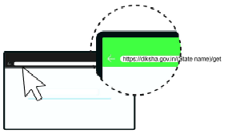  ब्राउजर में diksha. gov.in/cg टाइप करें।
  सर्च बार पर 6 डिजिट का QR  CODE टाइप करें। |   प्राप्त विषय-वस्तु की सूची से चाही गई विषय-वस्तु पर क्लिक करें।
राज्य शैक्षिक अनुसंधान और प्रशिक्षण पारिषद छत्तीसगढ़, रायपुर
निःशुल्क वितरण हेतु

Publication Year 2019

© S.C.E.R.T.C.G., Raipur

Advisor

Rtd. Prof. Ramakant Agnihotri, Deptt. of Linguistics, Delhi University

Co-ordinator
Ms. S.N. Ali, S.C.E.R.T.C.G., Raipur

Writers
Ms. S.N. Ali, Ms. I. Sandhya Rani, Ms. Jessy Kurian, Dr. Sisirkana Bhattacharya, Shri Ram Bandaru, Kiran Prasad

Academic Assistance
Shri Mukesh Dadsena, Shri Venugopal, Shri K.K. Sahu, Shri Tribhuwan Kumar Parihar, Ms. Swati Dwivedi, Zakiya Kausar

Editors
Ms. S.N. Ali, Ms. Jessy Kurian
Ms. I. Sandhya Rani, Kiran Prasad, Archana Verulkar, Valsa John,
Ali Mohammad, Kamlesh Kumar Sahu, Annapurna Patkar, Nandini Bajpai

Illustrations
Shri Sameer Shrivastava

Cover Page
Rekhraj Chouragadey
Assistance
Mukund Sahu, Suresh Sahu
Photograph
Sanskriti Vibhag, Raipur

Published by
Chhattisgarh Textbook Corporation, Raipur Printed by

Preface
English Reader Class VIII is an innovative course book for the students of class-8 of Chhattisgarh State. It is the third book, linked with the class VI and class VII textbook. The book is an attempt to provide good and authentic material in English language with focus on learning the language for use in real life situations.
It is hoped that after finishing 7 years of learning English as a second language, students will start reading the text with a sense of joy and fulfillment. The exercises are so designed as to provide training in all the skills and sub skills of the language.
The material used in the content has been adapted from different original texts. We are thankful to all those who have allowed us to use their material. Texts have been drawn from a variety of sources: Newspaper items like ‘A Place Fit for God's to Marry’ from the Hindu; ‘Every Day Heroes’ from the Reader's Digest; ‘Nothing But the Target’ adapted from the interviews published on websites such as www.rediff.com and www.badmintonmania.com is an attempt to expose learners to good reading material available in media. Similarly, the lesson ‘Sayani’ captures advertisements as an important source of awareness and we are thankful to the Department of Consumer Affairs for the advertisements used in the lesson. ‘Beats in Memoir’ is a lesson on Devdas Banjare whose commitment to Panthi dance helped place Chhattisgarh on the international cultural map. ‘Dancing On’ adapted from the works of Shailaja Ganguly is an inspiring story about Sudha Chandran who manages to beat the odds inspite of her handicap.
We are thankful to the Children's Book Trust for the story ‘Measure for Measure’ from stories of Tenali Raman, edited by C.L.L. Jayaprada; The Oxford University Press for the poem ‘Fog’ by W.M. Davies; Penguin for ‘The Photograph’ by Ruskin Bond; Ratna Sagar for the poem ‘Water's for...’ by Judith Nicholls and Nu Lite Books for ‘Children Ask Kalam’.

Every attempt has been made to get in touch with the persons concerned for the copyright for the lessons ‘The Shoemaker and the Elves’ and ‘The Tree that Never Stopped Giving’. Suggestions from teachers received during ‘Training Programme for Experimental Book’ has been included. We take this opportunity to thank all the participant teachers, whose suggestions have helped shape the textbook.
ETB ( Energized Text Book)is an innovative effort by the Department of school Education and State Council of Educational Research and Training Chhattisgarh for the capacity building of teachers and students by providing extra text book related content that can be accessed both online and off line( after downloading). The objective of ETBs is to offer extra topic related content (in interesting audio- video and animated formats), assessments and teacher reference material on the same platform.
The Council would be grateful to all those who send in suggestions to improve this book. Any suggestions from teachers, parents, students, writers and publishers to improve the book would be welcome. We wait eagerly for feedback from the users of the book.

DIRECTOR
S.C.E.R.T. CHHATTISGARH RAIPUR

शिक्षकों से ...

अंग्रेजी भाषा कक्षा-8 का प्रायोगिक संस्करण आपके हाथ में है। पुस्तक का प्रयास अंग्रेजी भाषा के शिक्षण को सरल-सुगम बनाने एवं बच्चों को अपने दैनिक जीवन में भाषा का प्रयोग करने योग्य बनाना है। इस हेतु भाषा के क्षेत्र की विभिन्न साहित्यक विधाओं एवं रुचिकर सामग्री का चयन किया गया है। भाषा की विधाओं एवं व्याकरण सम्मत विषयों को क्रमबद्ध नहीं किया गया है, बल्कि उनका चयन दैनिक जीवन में उनके उपयोग पर निर्भर है। यह अपेक्षा की जाती है कि सात वर्षों तक अंग्रेजी भाषा से परिचित होने के बाद बच्चे भाषा सीखने में रुचि लेंगे। पाठ्य पुस्तक में केवल 23 पाठों को रखा गया है। आरंभ के पाँच पाठों का उद्देश्य भाषा सीखने में बच्चों की रुचि एवं पढ़ने की आदत को विकसित करना है। ये पाठ बच्चों की दुनिया से जुड़े हुए रोचक पाठ्यसामग्री की सहायता से तैयार किये गये हैं जिनके माध्यम से नए शब्दों एवं वाक्यों से उनका परिचय हो सकेगा, आशा की जाती है कि इन पाठों को वे स्वयं ही पढ़ने को उत्सुक होंगे और अंग्रेजी भाषा का अनायास प्रयोग करना सीखेंगे।
कक्षा 8वीं के स्तर पर अंग्रेजी भाषा शिक्षण के समय शिक्षक निम्नांकित बिंदुओं को ध्यान में रखें -
- भाषा का आनंद उठाने में छात्रों की सहायता करना।
- बच्चों में शिक्षक एवं साथी छात्रों द्वारा बोली गई भाषा को सुनकर समझने की दक्षता को विकसित करना।
- Pre reading activity एवं while reading activity पाठ में सम्मिलित किए गए हैं। Activities को मौखिक कार्य के रूप में करना।
- बच्चों में शिक्षक एवं अपने सहपाठियों को सुनकर सरल अंग्रेजी में अपने विचारों की अभिव्यक्ति करना।
- बच्चों में पठन सामग्री को पढ़कर समझने की दक्षता विकसित करने के लिये अभ्यास प्रश्न करना।
- बच्चों में भाषा की अभिव्यक्ति लिखित रूप में करने की दक्षता विकसित करना।
- बच्चों में ई-मेल, मैसेज, दूरभाष से सम्प्रेषण जैसे आधुनिक संचार कौशल का विकास करना।
- भाषा की विभिन्न विधाओं से बच्चों को परिचित करवाना एवं उनका आनंद उठाने की क्षमता विकसित करना।
- बच्चों को भाषा के व्याकरण, शब्द संरचना, वाक्य विन्यास आदि से परिचित करवाना। किसी भी प्रकार की दृश्य सामग्री को पढ़कर समझना एवं आवश्यक जानकारी प्राप्त करने की क्षमता विकसित करना।
- भाषायी कौशलों के साथ-साथ Study Skill (अध्ययन कौशल) एवं Reference Skill (संदर्भ कौशल) को विकसित करना।
- इंटरनेट को उपयोग संदर्भ स्रोत के रूप में करना।

इन उद्देश्यों की पूर्ति के लिये निम्नांकित बिंदुओं को पाठ्य पुस्तक में स्थान दिया गया है -
- कक्षा में छात्र केन्द्रित शिक्षण का वातावरण निर्माण।
- शिक्षक बच्चों को सीखने में मदद करें।

- पाठ्य पुस्तक के पीछे दी गई Glossary का उपयोग शब्दों के अर्थ एवं उनके निकटतम उच्चारण जानने के लिये करें।
- पाठ्य पुस्तक के अंत में Lesson wise Syllabus को पाठ पढ़ाने के पूर्व अवश्य देख लें।
- पुस्तक के Appendix-1 में Listening Passages हमे दिये गये हैं जिनका उपयोग Listening Exercises करवाने में करना है। परंतु कक्षा में ये अभ्यास करवाने के पूर्व शिक्षकों को एक-दो बार ज़ोर से पढ़ने का अभ्यास अवश्य कर लेना चाहिए।
- प्रत्येक पाठ के बारे में Appendix-2 में About the Lesson (हिन्दी/अंग्रेजी) के अन्तर्गत जानकारी उपलब्ध करवाई गई है। पाठ पढ़ाने के पूर्व एक बार पाठ के संदर्भ की जानकारी अवश्य ले लें।
- प्रत्येक पाठ के पीछे दिये गये अभ्यास कार्य कक्षा-गत क्रियाओं पर आधारित है अतएव प्रत्येक अभ्यास में दिये गये निर्देशों का पालन अवश्य करें।
- पाठों के पीछे दिये गये Project के अन्तर्गत बच्चों में स्वअध्ययन करने की रुचि जाग्रत हो, संदर्भ को समझकर पाठ्य सामग्री एकत्र करने की दक्षता विकसित हो एवं अपने स्थानीय परिवेश को जानने में अभिव्यक्त करने में भाषाई कौशल का उपयोग कर सकें, ऐसे अभ्यासों को स्थान दिया गया है।

The learner-
Outcomes for Class-8

responds to instructions and announcements in school and public places viz. railway station, market, airport, cinema hall, and act accordingly.
  - introduces guests in English, interviews people by asking questions based on the work they do.
  - engages in conversations in English with people from different professions such as bank staff, railway staff, etc. using appropriate vocabulary.
  - uses formulaic/polite expressions to communicate such as 'May I borrow your book?', 'I would like to differ' etc.
  - speaks short prepared speech in morning assembly.
  - speaks about objects / events in the class / school environment and outside surroundings.
  - participates in grammar games and kinaesthetic activities for language learn- ing.
  - reads excerpts, dialogues, poems, commentaries of sports and games speeches, news, debates on TV, Radio and expresses opinions about them.
  - asks questions in different contexts and situations ( e.g. based on the text / beyond the text / out of curiosity / while engaging in conversation using appropriate vocabulary y and accurate sentences)
  - participates in different events such as role play, poetry recitation, skit, drama, debate, speech, elocution, declamation, quiz, etc., organised by school and other such organizations;
  - narrates stories (real or imaginary) and real life experiences in English.
  - interprets quotations, sayings and proverbs.
  - reads textual/non-textual materials in English/Braille with comprehension.
  - identifies details, characters, main idea and sequence of ideas and events while reading.
  - reads, compares, contrasts, thinks critically and relates ideas to life.
  - infers the meaning of unfamiliar words by reading them in context.

- reads a variety of texts for pleasure e.g. adventure stories and science fic- tion, fairy tales, also non-fiction articles, narratives, travelogues, biogra- phies, etc. (extensive reading)
- refers dictionary, thesaurus and encyclopedia as reference books for mean- ing and spelling while reading and writing.
- prepares a write up after seeking information in print / online, notice board, newspaper, etc.
- communicates accurately using appropriate grammatical forms (e.g., clauses, comparison of adjectives, time and tense, active passive voice, reported speech etc. )
- writes a coherent and meaningful paragraph through the process of drafting, revising, editing and finalising.
- writes short paragraphs coherently in English/Braille with a proper begin- ning, middle and end with appropriate punctuation marks.
- writes answers to textual/non-textual questions after comprehension / infer- ence; draws character sketch, attempts extrapolative (predictive) writing.
- writes email, messages, notice, formal letters, descriptions/ narratives, per- sonal diary, report, short personal/ biographical experiences etc.
- develops a skit (dialogues from a story) and story from dialogues.
- visits a language laboratory.
- writes a Book Review.

The book aims to:
Salient Features of the Book

  - help the learners to communicate and express themselves in English in day to day life.
  - develop in them the essential skills of the language–LISTENING , SPEAKING, READING AND WRITING .

promote interest in learning the language and widening learner's experi-
ence.
  - develop 21st century skills i.e. collaboration, creativity, critical thinking and problem solving.
To meet the aims of language learning, the book has the following features:
  - Learning with fun
  - Learner—centred approach
  - Task /activity based learning
  - Focus on developing language skills
  - Challenging themes and exercises
  - Focus on learner's day to day experiences
  - Variety of the text forms : picture story, comic—strip, letter, folk story, news item, informative text etc.
  - Authentic material—taken from classics, newspapers, magazines etc.
  - Illustrations to help better understanding of the text
  - Enough place to develop study skills
  - Glossary—(English to Hindi)
  - Language Syllabus
The book has its layout in the following setup:
Part A —
  - Lessons/poem (content)
    - Word meanings
    - Reading comprehension
    - Vocabulary
    - Grammar
    - Writing
    - Activity (A) Listening (B) Speaking
    - Project
Part B —
- Appendix - 1. Listening passages for listening exercises given in the lessons
- Appendix-2. About the lessons
- Appendix-3. Glossary
- Syllabus-lesson wise

CONTENTS
S.No.
Lessons
Page No.

- Water's for... 1-6
- The Shoemaker and the Elves 7-12
- Measure for Measure 13-17
- The Tree that Never Stopped Giving 18-23
- Alice in Wonderland 24-26
- From a Railway Carriage 27-33
- Everyday Heroes 34-40
- At School 41-47
- Beats in Memoir 48-53
- A Place Fit for Gods to Marry 54-59
- Sympathy 60-64
- Children Ask Kalam 65-71
- Sayani 72-82
14. Craze 83-92
- The Bird-man of India 93-99
- The Mountain and the Squirrel 100-104
- Nothing but the Target 105-109
- Dancing On 110-116
- Dear Daddy-Long-Legs 117-122
20. Fog 123-129
- Flavours of Thailand 130-136
- The Photograph 137-141
- Where the Mind is Without Fear 142-146
Appendix-1 147-156
Appendix-2 157-161
Glossary 162-170
Syllabus 171-174

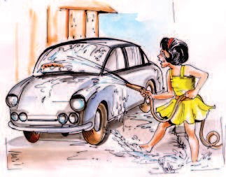

Water's for . . . washing, drinking making tea, cleaning the bath or scrubbing me; shining a car
or rinsing a shirt watering tomatoes, shifting the dirt
... my Mum says.
What would happen if water disappeared from the earth?
1. Water's for ...
But I say . . .
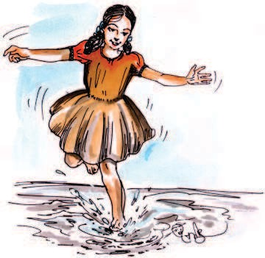
Paddling in wellies or just in feet (puddles are good but sea's a treat) squirting at brothers, splashing Dad, soaking my sister
to make her mad! Mixing with mud to bake a pie, spraying the dog or catching a fly. bath or puddle, sleet or rain,
let's all play
a WATER game!
- JUDITH NICHOLLS

Word Meanings
to make completely wet
soak
to rub hard for cleaning
to wash with water
dust, an unclean substance to move on water
a small muddy pool on the side of the road to move noisily through water
force out liquid in very small drops under pressure snow-fall with rain
puddles
to hit with a stream of liquid
to scrub
to rinse dirt
to paddle puddle to splash spray sleet wellies
squirting

Reading Comprehension

Complete the table, ‘‘What’s water for?’’ according to the child and the mother:
Mother | Child

  - Given are some situations. Imagine yourself as a 5 year old child. Tick some of the situations that you would enjoy doing:
    - Waking up some one by pouring water. ( )
    - Watering plants. ( )
    - Jumping in rain water. ( )
    - Washing clothes. ( )
    - Throwing water on someone. ( )
    - Floating paper boats in tub or bucket. ( )
    - Filling an empty bottle with water. ( )

    - Pouring out water from one glass to another. ( )
    - Put a paper in the water and stick it on walls or door. ( )
    - Playing with water. ( )

Complete the table with your own rhyming words. Pick up one from the poem:

shirt
feet
mad
fly
tea
  - Make a list of hobbies for which water is necessary:


Vocabulary

- Given are some pictures with words. Encircle those that you come across in the poem:

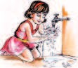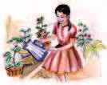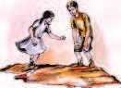

scrubbing
watering plants
mixing mud

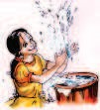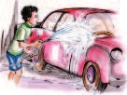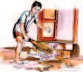

splashing shining a car shifting water

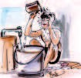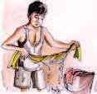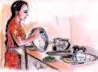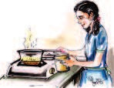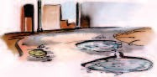
washing utensils
making tea
taking bath
drinking
paddling
rinsing a shirt

Complete the word map. What is water used for?
use
of water
washing

Activity
See Appendix-1 Lesson-1
  - Task-1
Look at the faces carefully. Listen to the poem and encircle the faces that occur in the poem:

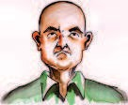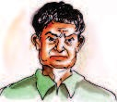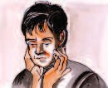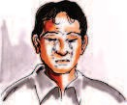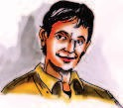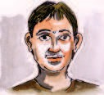

Task-2
Listen to the poem. Number the pictures as they occur in the poem in the boxes. Task-3
Complete the table:
What did the child paint and how was it?

What? | How was it?
face
 | upside down

Speak five sentences about your friend.

Use the following proverb in your sentence. Meaning is given.
Proverb Meaning
Union is strength. People can get greater things by working together.



2. The Shoemaker and the Elves

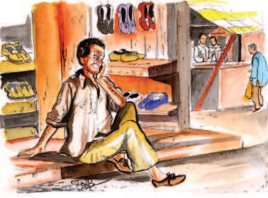Most of you will know the story of the sad woodcutter who had lost his axe. Who helped him?
Once there was a very poor shoemaker. He and his wife lived in a little house on the edge of a wood. There were not many people who would buy shoes from the shoemaker. Each day his store of leather became less and less. He did not have money to buy more leather. Day by day the shoemaker and his wife grew poorer. At last there was leather for only one pair of shoes. The shoemaker cut out the last
pair of shoes. He said to his wife, "Tomorrow I will sew them."
What are the problems that the shoemaker faced?
Next morning the shoemaker got up and went into his shop. He was surprised at what he saw. There he saw a pair of shoes. He had never seen a better pair of shoes. The shoes were perfect; the stitches were fine. They were so very well made that they were sold at once.
Who, do you think, kept the shoes in the shop?
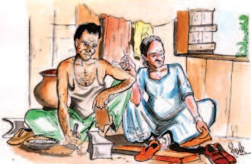
The shoemaker went to the market with the money. He bought leather for two pairs of shoes. The shoemaker cut out the two pairs of shoes and said to his wife. "Tomorrow I will sew them."
Next day when the shoemaker went into his shop he was again surprised to see two pairs of shoes beautifully finished. The shoes were very well made with very fine stitches. He was surprised. He showed them to his wife who was also surprised to see
such fine pairs of shoes. She said, "These shoes are very fine and the stitches are excellent; they will bring good money."

English-8
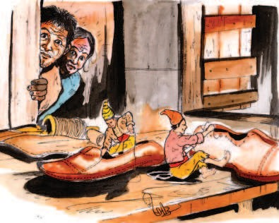
The shoemaker went to the market at once and sold the two pairs of shoes for a good price. With the money he bought leather for four pairs of shoes. He cut out the leather and said to his wife. "Tomorrow I will sew them."
The shoemaker got up the next morning and went to his shop. What did he find? Once again he found that his work had already been
done. Four pairs of beautiful shoes were lying ready-made on the table. They were perfectly made with very fine stitches and were sold very quickly in the market.
Every day the shoemaker would get up and go into his shop. There he would find his work already done for him. The shoes were always very nicely made. The shoemaker became very famous. Soon everybody wanted to buy shoes from him. His shoes were so very well made that even the queen of the country wore them. She was very pleased with the shoes. She called the shoemaker and gave him one hundred gold pieces.
'The shoemaker remained poor.' Give your opinion.
The shoemaker grew very rich. One day he and his wife made up their minds to find out who made the shoes. They said to each other, "We must find out who makes the shoes." So, when night came, they went into the shop. There they hid themselves behind the curtains. From there they could watch the bench on which the leather for shoes was kept.
What, do you think, they saw?
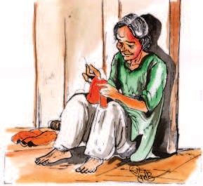
They waited for a long time. Nothing happened. They got very tired of waiting for something to happen. Just

The Shoemaker and the Elves
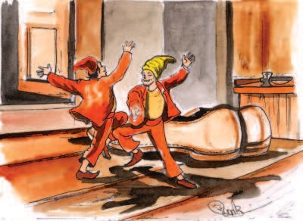
then the clock struck twelve. What do you think happened next? Two little elves jumped into the shop from the window. The elves wore pointed caps and wore only rags.
They went dancing and skipping up to the table. With a hop and a skip they jumped on to the table.
The elves sat cross- legged and took up the
leather left there by the shoemaker. They began to work. Their needles flew in and out, in and out of the leather. Their little hammers went rap-a-tap, rap-a-tap on the leather. The elves worked very fast. Almost in no time the work was complete.
Then the two elves started dancing. They jumped up and down, up and down. They raced in and out and around the shoes. Before the shoemaker and his wife had time to think, they were gone.
Next morning the husband and wife made up their minds to do something for the little elves. The shoemaker said to his wife, "What can we do for the nice little elves ?" His wife said, "The elves did not have good clothes. They wore only rags. I shall make them little coats and trousers to wear." "That will be very nice," said the shoemaker, "I will make tiny shoes for the good elves. Their little feet were bare."
So the shoemaker and his wife worked and worked. When the clothes and shoes were ready they were put on the table. The shoemaker and his wife again hid behind the curtains. They waited silently. Once again when the clock struck twelve the elves jumped into the shop from the window.
They danced and jumped on to the table to do their work. There they saw little coats, trousers and neat little shoes left for them by the shoemaker and his wife. The elves were very happy. They clapped and laughed with joy. What do you think the elves did next? They put on their little clothes and skipping and dancing went out of the window.
The little elves never came back again. But the shoemaker and his wife always had good luck. They grew richer and richer and lived happily ever after.

Word Meanings
to rub hard for cleaning
a little fairy like creature with pointed ears without fault or defect
wonder
to complete
of very high quality
a piece of cloth hung up at a door or window old and torn clothes
in place of something
sitting with one leg placed across the other without clothes or covering
to scrub
elves (plural of Elf) perfect
surprise to finish excellent curtain rags instead
cross legged bare
Reading Comprehension

A. | Tick the correct answer:
i. | The shoemaker wanted to sew shoes -
 | (a) early in the morning | (b) | next day
 | (c) at midnight | (d) | previous day
- When the shoemaker saw a better pair of shoes, he was -
  - annoyed (b) surprised
(c) very sad (d) happy
- The elves wore -

(a) over coat | (b) | rain coat
(c) old and torn clothes | (d) | dress
- The beautiful shoes were made by -
  - elves (b) magician
(c) joker (d) fairies
- How many gold pieces were given to the shoemaker ?
  - one hundred (b) two hundred
(c) three hundred (d) four hundred
- Say whether the following statements are true or false:
  - The shoemaker was very poor. ( )
  - The shoemaker was surprised when he saw a ( ) better pair of shoes.
  - The shoes were made by the elves at night. ( )
  - The elves wore beautiful clothes. ( )
  - The shoemaker and his wife made little coats and ( ) trousers for the elves.

Answer the following questions:
  - Where did the shoemaker live ?
  - Why was the shoemaker poor ?
  - What did the shoemaker do when he saw a better pair of shoes ?
  - How did the shoemaker become rich ?
  - What did the shoemaker and his wife give the little elves ?
  - Why did the little elves never come back ?

Vocabulary
- Fill in the blanks choosing appropriate words given below:
stitches, rags, excellent, curtains, elf
  - A fairy-like creature with pointed ears is called .
  - Beggars usually wear .
  - are hung at doors and windows.
  - He is an cricket player.
  - The on these trousers are very fine.

Some words are given in the box. Make sentences using these words. The first one is done for you:
store
rag
tiny struck
excellent
edge
Example :- There is a hut at the edge of the forest.

The words given below have more than one meaning. Consult the dictionary and write their meaning:

Example: Wood forest
hard substance of a tree used for fuel .
1. fine ....................................... .........................................
2. present ....................................... .........................................
3. object ....................................... .........................................
4. match ....................................... .........................................

Make some words using the following suffixes:
–ian, –er, –ist

Examples: | Music | Music–ian (musician)
 | Cricket | Cricket–er (Cricketer)
 | Art | Art–ist (Artist)

Activity
A Listen to a story and give the information:
See Appendix-1 Lesson-2
- (i) Who said :
  - "Why not forget your work and have fun with me instead,"
.
  - "But I've food for today," .
  - "I am storing food for winter," .

Fill in the blanks.
- One summer's day, a grasshopper was and .
- An ant was dragging .
- It was so heavy that he could hardly it.
- The grasshopper had no food and was of hunger.

(i) Imagine that you are one of the elves. What would you say if you got a new dress ? Say it in one word or a phrase or a sentence.
(ii) Here is some interesting pair work for you. Imagine that one of you is an elf and the other person is the shoemaker's wife:
After the elf puts on the new clothes and shoes, the shoemaker's wife asks the elf what else he wants. The elf asks for things that the shoemaker's wife cannot give. She is sorry and she refuses. Play the role of the elf and the shoemaker.
Given below is an example :
The elf : Would you please give me a belt made of gold ?
Shoemaker's wife : I am sorry dear. How could I buy so much gold ?
- Present the story 'the shoemaker and the Elves' in the form of a skit. Remember to write the dialogues, learn them and practise the skit before presenting it. You can use the dialogues in the lesson.
Project
There are many describing words in the lesson.
Example: poor, little, perfect, fine.

Make a list of describing words. You can refer to any book or lesson.

Use the following proverb in your sentence. Meaning is given.
Proverb Meaning
Tomorrow never comes. Don’t put something off for
tomorrow.



All of us have scissors and blade at home. Yet we go to the barber to get a haircut. Why? Discuss.
3. Measure For Measure
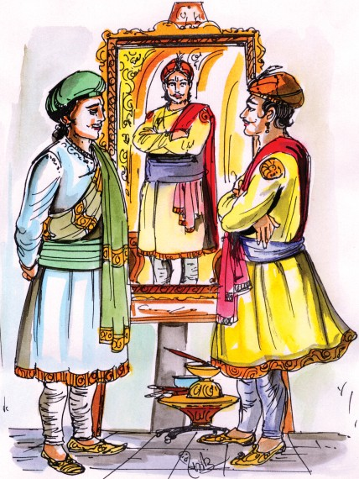
Krishna Devaraya was known for his patronage of poets and scholars. He was equally fond of fine arts. Once he came to know about a brilliant artist named Raja Varma. He invited Raja Varma to the court and asked him to draw his portrait.
The king was very pleased with the artist when his portrait was ready. In the portrait, the majestic and handsome king seemed to have come alive within the frame.
Do you think that the
king rewarded him?
Apart from this portrait, Raja Varma
drew images of famous characters from Puranas, of men and women, and so on. He became well known for his skills. He became close and dear to the king.
Overwhelmed by joy, Krishna Devaraya called the artist and asked him what he wanted. When Raja Varma did not reply, the king, on the spur of a generous impulse, rewarded him with chief ministership.
Raja Varma will prove to be a very good Chief Minister." Give your comments.

Though Raja Varma was a good man and a brilliant artist, he had no experience whatsoever, of administration. Soon everything was thrown into disorder because of his hasty decisions and bad management of the state affairs. Though people were unhappy about his administration, they did not dare to complain to the king because the king was very fond of him.
The elders of the town finally approached and sought Tenali Raman's help in getting rid of the new and inept Chief Minister.
Tenali Raman assured them, "I shall soon find a harmless way to remove the artist from the chief ministership."
After a few weeks, Tenali Raman invited the king, the queens and some courtiers to his house for lunch. Meanwhile, he found a very good carpenter and put him on the job of preparing a grand feast for the king.
The king and others sat for lunch and at Tenali Raman's order, the carpenter began serving them. As soon as they put the first morsel of food in their mouths, the people began to request for water again and again.
Soon after tasting the food, the king realized that the food was badly cooked and was unbearably hot. He was angry.
"Raman, who has cooked this food? Do you want us all to suffer and die by eating this horrible food?"
In his usual humble way Tenali Raman said, "I beg Your Majesty's forgiveness." Then he showed the carpenter to the king. "I have never come across such an excellent carpenter and I have put him on the job of cooking the lunch for today's feast."
The king began laughing loudly. "Have you lost all sense, Raman? A good carpenter should be employed to work on wood but not on food. How did you get this funny idea?"
Tenali Raman asked the king, "Lord! If an artist can become a Chief Minister, can't a carpenter become a cook?"
Did the king become angry when he heard this?
The king at once understood that Tenali Raman got a carpenter to cook the food to make him realize his error in making Raja Varma the Chief Minister.
The king was saved from the embarrassment of removing Raja Varma from the post because when Raja Varma came to know about the awkward incident at Raman's house, he immediately resigned from his post.
Later Raja Varma told Tenali Raman that he was happy to remain an artist!

Word Meanings

brilliant extremely good / highly intelligent
portrait picture or sketch
majestic royal, very grand
prominent famous/noticeable, easily seen impulse sudden wish to do something
reward an award or a prize in return for services disorder confusion or mess
hasty quick
fond of liking somebody or something very much assure promise
grand impressive
morsel a small quantity of food
horrible unpleasant, feeling of dislike
humble simple
courteous polite
awkward uncomfortable
genius great powers of thought, skill and imagination spur an event that encourages action
chaos disorder, confusion
approached came near sumptuous grand, expensive
generous readiness to give, kindness
inept unable to do work properly, unfit, unsuitable

Reading Comprehension

Tick (√) the correct answer:
    - Who was invited to draw the King's Portrait ?
      - Tenali Raman (b) Carpenter
(c) Raja Varma (d) Elders of the town
    - What did the artist get as a reward ?
      - Money (b) Praise
(c) Chiefministership (d) Kingdom
    - The artist's administration made the people of the kingdom :-
      - Happy (b) Unhappy
(c) Satisfied (d) Pleased

Answer the following questions:
    - Why were the people unhappy with Raja Varma's administration?
    - What was Tenali Raman's plan to remove the artist from his new job ?
    - Why did Tenali Raman ask a carpenter to cook food for his feast ?
    - What does the title 'Measure for Measure' mean ?

Vocabulary

Choose the most suitable phrase that will help to complete the sentence:

all senses, come across, close and near, suffer and die, unbearably hot


  - Raja Verma became to the king.
(ii) The food was ................... .
- Do you want us to ................... by eating this horrible food.
- I have never such an excellent carpenter.
- The king asked Raman whether he had lost ......................

Match the following:

A | B
- A king's support to someone.  - Things are in a mess.  - When a person is not doing his job well.  - Something that you would want when you are hungry  - A word you would want to use for someone who is very good at studies.  - A person who looks after the administration of a state. | - chief minister  - brilliant  - patronage  - incompetent  - morsel  - disorder
- Frame your own sentences using these words:
brilliant prominent horrible
portrait reward grand

Activity

(A) Listen to the passage and do the exercise:
See Appendix-1 Lesson-3
- Put (√) or (X) in the boxes:
  - Sheikh Mohammad was a clerk at the Mumbai Churchgate railway station
  - Hanif saw a purse lying at the gate.
  - He opened the bag in his house.
  - The bag contained the following things :-
    - Cheques worth $ 25000
    - Cash of $ 50,000
    - Dubai passport
    - camcorder
    - cellphone
(p) two watches
  - Ashraf wanted to give a reward of $ 40,000

Write the names of the places that you listened to :
(1) (2)
B. Work in groups. Complete the dialogue and discuss it with your group: Hints- (Why not/Sure!/I am sorry!/Me?/Oh!/ No!/Wow!/I can't believe it! No way! Pardon me, sir...)
Tenali Raman : Somu, you are indeed a very good carpenter. I am sure you will cook equally well. I want you to prepare a great feast for the king.
Somu : ..............................................................

..............................................................
..............................................................

4. The Tree that Never Stopped Giving
What do trees give us?
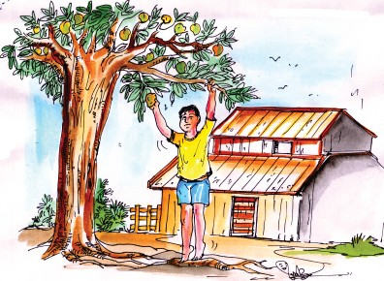
There lived a naughty boy in a village. Each day the boy spent hours playing
near the large, old mango tree. He would make a crown of its leaves and then proudly declare, "I am the king of the forest !" The tree loved to have the boy visit it and play in its branches.
Time passed, the boy grew to be a man, but to the tree he would always be a boy. Gradually he stopped coming to the tree.
Then one day, to the tree's
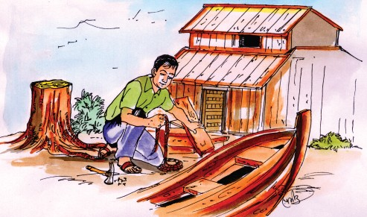
great delight he saw the boy approaching. The boy said he needed money, for without money he couldn't marry. "Take my mangoes, they are the best variety, sell them and you will have more than enough money" offered the generous tree. The boy didn't wait another minute.
For what did the boy not wait?

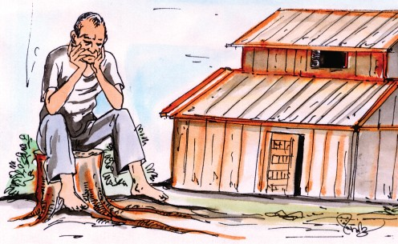
The boy stripped the tree of every single mango, sold them and got married. After a lapse of time,the boy came back again, sullen and complaining, "I need a house, can you give me a house?"
"Take my strong branches and build yourself a house and make your furniture too," said the loving tree. So the boy hacked down all the branches leaving the tree with just its trunk. Slowly the tree aged without its branches and leaves. It felt lonely and sad. It missed the boy.
Years went by. The lonely old tree often thought of the boy and then one day the boy came again not quite as young as before. "I need a boat," he said to the tree, "I want to travel, to see something of the world."
"Take my trunk, it's all I have left, but it will make you a sound boat," said the
tree.
The thoughtless boy took the trunk made his boat and sailed away without even
once thinking about the tree and what he had done to it.
Finally the boy became a tired old man, and now all he could think of was his faithful friend, the tree, "Come, boy", called the tree. "Rest here on my stump, it makes a good seat, we can be happy together." And the boy gratefully, for once sat down in the warm sunshine on the tree stump. And the tree was happy.
Why was the tree happy?

(Adapted from "The Giving tree" by Shel Silverstein)

Word Meanings
to say publicly or to announce
pleasure, a feeling of sheer happiness. slowly, over a long period of time
a period of time between two events that happen.
stupid, not caring about the possible effects of one's own or actions on other people.
different kinds of the same thing to remove by pulling
willing to give freely
silent and bad tempered to cut roughly
declare
delight gradually lapse
thoughtless words variety
strip (ped) generous sullen
hack down
Reading Comprehension
- Tick (√) the correct answer:
  - The boy made a crown
    - of the tree's bark (b) of the tree's leaves
(c) of the tree's flowers (d) of the tree's stump
  - Everyday, the boy spent hours
    - near the big and tall mango tree
    - near the large and huge mango tree
    - near the large and old mango tree
    - near the long and huge mango tree
  - The boy stripped the tree of every single mango and sold them to
    - get married
    - make a house
    - traveled
    - buy a car
  - The boy who came back after a lapse of time was
    - very sad and worried (b) injured and defeated
(c) very happy and delighted (d) very bad tempered
  - The boy came back
    - playing and singing (b) happy and satisfied

(c) sullen and complaining (d) running and dancing
  - Finally, the boy became
    - young and handsome man (b) a thoughtful person
(c) a tired old man (d) a generous old man
  - The boy sat down in the warm sunshine on
    - grassy ground (b) the tree stump
(c) a bench (d) the branch of the tree

- Read the lesson again and make a list of the problems of the boy and solutions provided by the tree. An example is done for you:
N. | Problems | Solutions
1. | The boy needed money | The tree gave the boy
 |  | fruit to sell.
2. | ---------------------------- | -----------------------------
3. | ---------------------------- | -----------------------------
4. | ---------------------------- | -----------------------------
- Answer the following questions:
  - Make a list of the things that help a tree to live.
  - List all the things the boy said he needed.
  - The boy looked sullen and complaining. Why ?
  - What happened at last ?
  - How did the boy spend his time ?
  - Who was more loving - the boy or the tree? Why?

Vocabulary
- Find out the correct word with the help of the clues given below. One is done for you:

  - People and animals rest under trees.
It is cool during day time. s h a d e
  - It is used in our daily life. t _ _ _ We get wood for furniture from it.
  - It is a stage after flowering. People eat it. _ _ _ i _

  - The part of the tree that helps it to stand firmly.
  - We can't live without it. It helps plants grow.
  - The part of the tree that remains after cutting it down.
_ _ _ t
_ _ _ e _

_ _ u _ _

Arrange the letters and make meaningful words. Clues are provided:
  - nwroc ...................(the king wears it)
  - tsofer (where wild animals live)
  - lgitedh ................ (very happy) (iv) nsilge ................. (one, only)
(v) mupts (what remains after the trunk is cut of a tree.)

Give one word related to the following family of words that occur in the text. First one is done for you:
  - leaves fruit branches trunk T R E E
  - crown rule kingdom palace
  - tears worry cry sorrow
  - sailor across river travel
  - hour day week month

Arrange these words in alphabetic order:
Grow, Great, Generous, Gradually, Crown, Complain, Courage, Declare, Delight, Approach, Aged, Stump, Enough, Sullen, Trunk
Activity
- Listen to the lines carefully and answer the questions given below:
See Appendix-1, Lesson-4

- Encircle the word that you come across by listening to the poem .
free see me plant hot
tea sea we he sun
key
see
she cross me
bee
shade


Use the following proverb in your sentence. Meaning is given.
Proverb Meaning
Early to bed and early to rise, Always be punctual in makes a man healthy, wealthy, your work.
and wise.
- What do we plant when we plant a tree ?

we plant :- (a) (b)
(c) (d)

- "A thousand things that we daily see" what does this mean ?

"Three year old Pappu does not like to take anybody's help in doing any work."
Work in pairs:

One person in the pair will be Pappu. The other will be a person who wants to help him. An Example is given-
  - May I help you with your homework ?
  - No, thank you. I will do it myself.

Use the situations given in the box to frame your sentences:
has not brought his water bottle. is not able to open the door.
does not know what time the bus leaves. has fallen down and hurt himself .
has lost his way in the mela/fair.

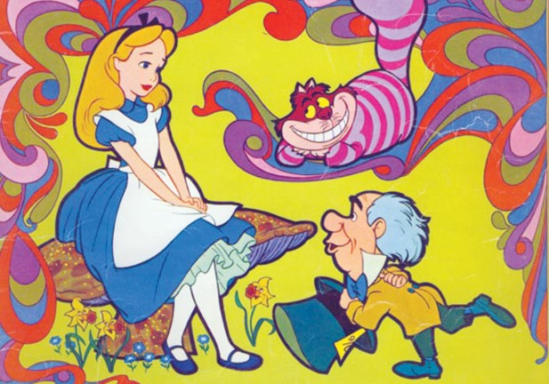

You have read the story of 'Alice in Wonderland' in class 6 and 7? Recollect the story in groups.
Share one of your dreams with your classmates.
5. Alice in Wonderland

Did you hear how the Queen of Hearts made the tarts? And can you tell what became of them?
The song tells you about it :
The Queen of Hearts, she made some tarts All on a summer day
The knave of Hearts, he stole the tarts.
Why was Alice called as a witness?
And took them clean away.
Just because there was a little song about the knave, they had taken him as a prisoner. They put chains on his wrists and brought him before the King of Hearts, so that there might be a regular trial.
The king looked very grand with a big crown on the top of his wig. But he had to wear them both, so that people might know he was a judge as well as a king.
The queen looked cross for she had taken trouble to make the tarts and the bad knave stole them away.

The white rabbit stood near the king, read out the song, to tell everybody what a
bad knave, he was and to decide whether he was ‘guilty’ or ‘not guilty’.
Alice was sitting close to the jury box and she was called as a witness (a person who, has seen the prisoner do whatever he's accused of or knows something that's important in a trial).
Who stole the tarts?
But Alice didn't know anything about it. “Why in the world did they want her to be a witness”,? she thought.
The rabbit blew his trumpet and shouted out Alice! And Alice jumped up in great hurry. And her skirt, oh! it caught against the jury box and tipped it over, and all the poor little jurors came tumbling out of it!
Alice picked them all up again very carefully.
The king wanted the jury to settle whether the knave of hearts was guilty or not guilty. The Queen wanted to punish them. The Knave first of all. But Alice....
So Alice said, “stuff and nonsense”. The Queen said, “Off with her head” (just what she always said when she was angry) .So Alice replied, “ Who cares for you, you are nothing but a pack of cards!''
So they were all angry, and flew up into the air, then they all came tumbling down again, all over poor Alice just like a shower of rain.
The next thing - Alice woke up out of her curious dream., and she found that the cards were only some leaves of the tree that the wind had blown down upon her face. Wouldn't it be a nice thing to have a curious dream, just like Alice? To have a curious dream like Alice, lie down .... shut your eyes tight... Good bye, Alice dear,
good bye.

Word Meanings
a sweet dish
a playing card between 10 and queen / a dishonest man covering of hair (not natural)
hearing a court case
one who has done something wrong the place where the jury sits member of jury
a group of people chosen to judge make something fall
tarts
knave (J) wig
trial guilty jury box jurors jury
tip
Reading Comprehension
- Answer the following questions:
  - Why was the knave of Hearts taken as a prisoner?
  - Why did the king wear the wig and the crown?
  - How many members were there in the jury?
  - What did the queen say when she was angry?

  - Is this a real story or a dream? Read out the line that justifies your answer.
  - Why did the cards become angry?
  - Did the cards really tumble down on Alice? Read out the line from the story to support your answer.
Vocabulary
A. List out the words from the story that are related to a trial:

............................ ............................
............................ ............................
............................ ............................
............................ ............................

Activity
- I. Read the words in the box carefully and encircle as you listen to them.
See Appendix-1 Lesson-5

antakshri cricket chess ice-cream
puri basket-ball volley-ball rasgulla hockey halwa jalebi tennis noodles nadi-pahad potato
samosa roti carroms gilli-danda alu-poha kabaddi paratha badminton cream-roll

- Categorise the encircled words in Ex.1 in the table given below:

Games | Food
Speaking Exercise (Include the whole class)
- Q. 1. Which game do you like the most?

Q. 2. Why do you like it ?

6. From a Railway Carriage

Have you ever travelled in a train? If yes, share your experience with your classmates.

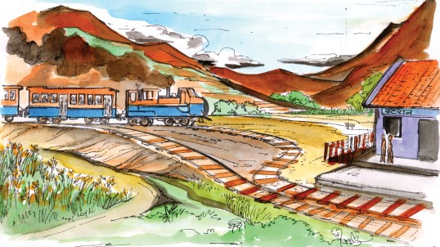


Faster than fairies, faster than witches, Bridges and houses, hedges and ditches; And charging along like troops in a battle
All through the meadows the horses and cattle: All the sights of the hill and the plain
Fly as thick as driving rain;
And ever again, in the wink of an eye, Painted stations whistle by.
Here is a child who clambers and scrambles, All by himself and gathering brambles;
Here is a tramp who stands and gazes,
And there is the green for stringing the daisies; Here is a cart run away in the road
Lumping along with man and load; And here is a mill and there is a river: Each a glimpse and gone forever!
- ROBERT LOUIS STEVENSON

Word Meanings
coach in a train
(plural of fairy) small imaginary being with supernatural powers
(plural of witch) with magical powers row of bushes forming a boundary narrow trench to hold water
(plural of troop) soldiers, especially in large groups climb with difficulty
to make a quick dash or run rough prickly shrub
a homeless person who moves around aimlessly. adjusting without complaint
sight of somebody/something for a very short time thread
flowers
carriage
fairies

witches hedges ditch troops clamber scramble bramble tramp lump glimpse string daisies
Reading Comprehension

Answer the following questions:
  - What does the railway carriage (train) move faster than ?
  - What do the fast moving bogies look like ?
  - What does the train pass through ?
  - What do the sights of the hill and plain look like from the fast moving railway carriage ?
  - Have you ever been in a fast moving train ? Make a list of things that you see from the train ?

Write true or false in brackets:
  - The train is faster than fairies and witches. ( )
  - There is no bridge or river on its way. ( )
  - The child clambers and scrambles. ( )

Vocabulary

- Pickup the rhyming words from the poem and add more:

(1) road -------------------, ---------------------
(2) river -------------------, ---------------------
(3) witches -------------------, ---------------------
(4) cattle -------------------, ---------------------
(5) rain -------------------, ---------------------

Find out the describing words : (one is given)
Example: painted

Fill in the blanks with the given words:
wink, battle, fairies, glimpse, through

- are imaginary things or person.
- Once I was passing the dense forest.
- After a long we got freedom.
- The thief went out of sight in the of an eye.
- We saw a of the moon on a cloudy night.

I. Make words adding "ing" and write in your own sentences:
swimming
cut
run
ing
get
sit
put

Separate the root word from the given words:

S.No. | Word | Root word
1. | charging | charge
2. | fairies
3. | driving
4. | stringing
5. | daisies
6. | gathering

  - Frame your own sentences using the words given in exersise II.
- Given below are sentences that describe some actions. Choose the words from the box that match the description and write them in the space provided.
sew, darted, toured, lead, frozen
  - A cat suddenly crossed the road in front of me.
  - It's so cold that even the water has become solid.
  - If you show the way, I'll follow.
  - Leela's mother taught her how to use a needle and thread to make stiches.
  - She travelled around the country promoting her book.

Select the words from the poem related to the columns and write in the space given below:

living non-living | moving stationary

- Pick up words from the box and write them with the correct vehicles:

compartment | berth | runway | engine | gears
carriage | cock-pit | steering wheel | nose | tyres
airport | wheels | sleeper | platform | station
tail  petrol | whistle  brakes | wings  bogies | bonnet | pantry-car
Train : Aeroplane : Car/bus :


Grammar
Look at the following phrases occuring in the poem:
Faster than fairies, faster than witches as thick as driving rain

A. Read the following passage carefully :
‘Shiny’ and ‘Timmy’ are birds and they are best friends. Timmy always wants to be No 1. So, if Shiny has a clean nest, Timmy has a cleaner nest than Shiny. Shiny and Timmy have another friend called ‘Tricky’. Tricky also wants to be No. 1. Now, her nest is the cleanest nest.

Now look at the description given below and write about the nests of each bird in your notebook.

Shiny | Timmy | Tricky
clean | cleaner | cleanest
big | bigger | biggest
strange | stranger | strangest
soft | softer | softest
warm | warmer | warmest
beautiful | more beautiful | most beautiful

→→→→
Example: Shiny has a clean nest, but Timmy's nest is a cleaner nest. Tricky has the cleanest nest of them all.

Frame as many sentences as you can with the following transport and animal words:
Example: A bicycle is faster than a bullock cart.
- Transport words :
( fast)

a bullock cart →a bicycle
a train
a plane.

- Animal words :
(big)

a dog a horse
an elephant
a whale

Writing

- I. Some pictures are given below showing how people travel. Look at the pictures and write whether you like/dislike travelling by the ‘means’ of travel given below:

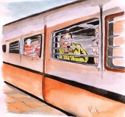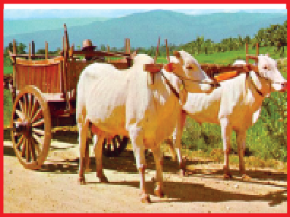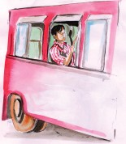

II. Write a letter to your friend describing the preparation you have made for your picnic trip to Chitrakoot falls.

- Describe three small plants you find in your basti/village/street/town, using the table given below:

Name  of the Plant | Appearance |  |  |  | Part of the plant used | Used for:
 | Height | Shape of leaf | Colour of leaf | Flowers
Activity
- Listen to the passge carefully. Sheela came across things/ places on her way. Order the pictures as they occur in the passage:
See Appendix-1 Lesson-6
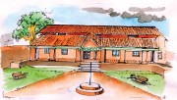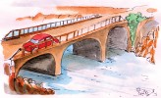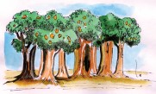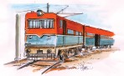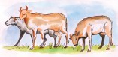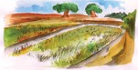Task -1

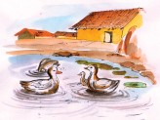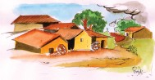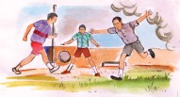
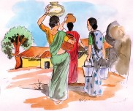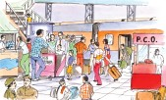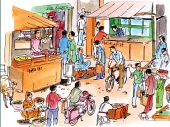

Role play (pair work) :
(student 'A' will ask information and 'B' will answer). Students can exchange roles.

Use the clues :
Where ..................
When ..................
How .....................
Which ..................
Why ......................
What .....................
Example:
Student 'A' : May I know, where you come from ? Student 'B' : Oh! yes, I am from Bilaspur.
Project
Make a list of the words describing places.

Use the following proverb in your sentence. Meaning is given. Proverb Meaning
A bird in the hand is Something in your hand is valuable than worth two in the bush. more in other’s hand.

Tell the class about a member in your family, who you think is really great.
7. Everyday Heroes

The Peacock Doctor
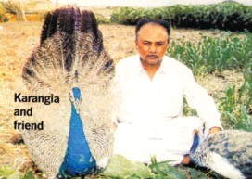

N A R A N B H A I KARANGIA, a, 43-year-
old farmer from Jamnagar,
Gujarat is a devoted guardian of our national bird. If he learns that a peacock within 200 kilometres of his village is ill or injured, he rushes to the bird on his motorcycle with vitamin drops, medications and bandages. And if, after he has treated it, the bird can't be left in the wild, Karangia brings it home.
What do you think Karangia does after bringing the peacocks home?
Every year, after the harvest, when food for wild peacocks is scarce, Karangia sets up centers in villages where the birds are looked after and fed. And during a flood, a few years ago, Karangia spent two days looking for peacocks marooned on treetops. He saved a dozen.
"I love peacocks," says Karangia, "I want to help as many as I can."
The Noteworthy Singer
Abhijeet Bhattacharya a Hindi playback singer was returning home in suburban Mumbai late one evening when he saw people gathered around a man lying in a pool of blood. Asking his driver to stop, Abhijeet found the injured man unconscious and bleeding heavily.
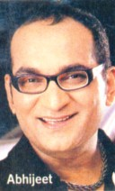
A young, well-dressed couple in the crowd told Abhijeet that their car had hit the man. "They were upset and didn't know what to do," recalls Abhijeet. Taking charge, he told his chauffeur to drive the couple to the nearest hospital. Then, with the help of
bystanders, he carefully placed the injured man in the couple's car and drove to the same hospital. Although required by law to treat accident victims immediately, doctors at the hospital were reluctant to admit the injured man. It took 10 minutes of wrangling for Abhijeet to get them to agree.
Only after making sure that the man was being attended to and that his relatives had been contacted did Abhijeet leave for home at around 1 a.m.
"Don't hesitate to help road accident victims," Abhijeet says. "You can save a
life!"

The Kind Heart

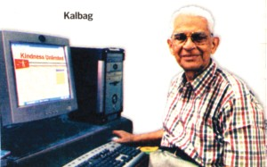
VASANT KALBAG, a 79-year
old retired businessman, encourages people to be kind. Doing small selfless acts, he believes, not only helps others-it boosts our health and longevity.
Kalbag realized this after he came across two websites- globalideas-bank.org and actsofki- ndness.org, both of which promoted the message that if only
people were kind to one another, the world would be a much better place.
Inspired by this simple but powerful idea, Kalbag started his own organization- Kindness Unlimited (KU) and built the kindness unlimited.tripod.com website. Through it, Kalbag has built a net-work of KU members who keep in touch with him via e-mail and phone. And Kalbag e-mails all of them his bimonthly newsletter, recounting the kind deeds of the members.
Why does Vasanta Kalbag write about the kind deeds of people?
Kalbag also lectures school and college students on the importance of kindness. Swapna Hawaldar, a young software engineer says, “Thanks to Vasant Uncle, I no longer think twice about helping strangers.”
“There's nothing as truly fulfilling as kindness,” says Kalbag.
The Tidiness Expert
Rajkumar Sharma a Mumbai businessman always bemoaned the squalid condition of the lane he lived in. The garbage bins overflowed;
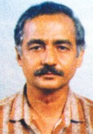
streetlights never worked; the lane was full of potholes.
One day Sharma learnt of a Mumbai municipality beautification programme called Advanced Locality Management, which required all the residents of a street or colony to separate their wet and dry garbage. While the wet garbage was turned into compost to grow plants, ragpickers were hired to take away the dry variety. In return, the municipality gave priority to the street's problems. Sharma implemented the programme in his street with 600 odd residents. Today, his green and lovely lane is a model project that attracts urban experts
from around the world. Sharma has also helped residents of many other areas in the city to start similar programmes.
Who is the tidiness expert in your family?

Everyday Heroes
The Life Saver
AMALA MARY, a 48-year-
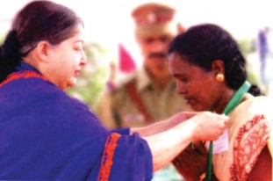
old Tamil Nadu beedi worker, was at home cooking when she heard a deafening sound. She ran out to find that a part of the embankment on which her hut was built on, had collapsed, covering the rail tracks below with a huge mound of mud and debris. Just then she heard a train's whistle.
That meant a passenger train had left the station, two kilometres
away. In a few minutes it would smash into the landslide.
What happened next? Guess.
Amala started running on the embankment towards the train. Then, scrambling down a muddy pathway onto the tracks, she continued to run. Luckily, she was wearing a red sari. She lifted its pallu and began waving it as she ran. When the engine driver saw Amala waving a red cloth, he slowed down. As the train neared her, Amala shouted, "Land-slide!" The driver applied the emergency brakes and stopped the train.
"There was a curve ahead," says driver B. Prabhakar, "so the landslide wasn't visible. Had it not been for Amala's warning, many people would have died."
"I'm happy I was able to prevent a tragedy," says Amala, who was given the Kalpana Chawla Award for Courage and Daring Enterprise.
Word Meanings
important
damage, a person who is physically hurt in an acci- dent
a driver of a car unwilling to do, hesitant
to jump high across a long distance loud, piercing cry
to improve long life
to create a positive feeling in a person very loving or loyal
rarely found
to express sorrow or sadness
noteworthy
injured

chauffeur reluctant leapt scream to boost longevity inspire devoted scarce bemoan

extremely dirty
domestic waste
shallow holes in a road surface extremely loud
to fall apart
stuck in a place with no chance of escape to argue angrily and usually for a long time a slope made of stone used as road
a large pile of earth
pieces of wood, metal,bricks etc. that are left after some building has been destroyed
to do something with difficulty
squalid
garbage potholes deafening collapse marooned wrangling embankment mound debris

scrambling
Reading Comprehension

Answer the following questions:
  - Why is Naranbhai Karangia called the “Peacock Doctor”?
  - What is the Advanced Locality Management Programme?
  - How has Sharma helped clean up his street?
  - How did the singer ‘Abhijeet’ help the couple and the accident victim?
  - What message do you get from the story “The Noteworthy Singer”?
  - Why does Vasant Kalbag promote ‘kindness’ among people?
  - How was Amala Mary able to prevent the rail tragedy?
  - What is the Kalpana Chawla award given for?

Some acts of the ‘heroes’ in the lesson are given below. Explain the result of their timely action:
Sr. No. | Step taken | Result
1. | Setup centres in villages for birds | .........................................
2. | Instructed driver to take the | .........................................
 | injured man to hospital
3. | Encouraged people to be kind | .........................................
4. | Implementation of | .........................................
 | Area Locality Management
5. | Stopped the train | .........................................

Vocabulary

- Complete the following sentences:
  - When Karangia that a peacock was ill or injured,
he to the bird on his motorcycle. (learnt/rushed)

  - Abhijeet was ................ home when he saw people around a man.
(gathered/returning)
  - After making sure that the man was being ................ to he took. for
home at 1 am. (attended/leave)
  - If only people were kind to one another, the world would be a place.
................... by this simple but powerful idea, he started his own organisation. (inspired/better)
  - The garbage bins ..................., street lights never , the lane was
full of potholes on Sharmas street. (overflowed/worked)
  - Amala started .............. on the embankment towards the train. Then, .............
down a muddy path onto the tracks, she continued to run. (running/ scrambled)

Write one word that describes the profession after reading the clues:
(1) One who heals is a ....................................
(2) One who runs a business ....................................
(3) One who takes care of a business ....................................
(4) One who sings for films ....................................
(5) One who designs an internet site ....................................
(6) One who cooks in a hotel ....................................
(7) One who collects waste ....................................
chef, playback singer, businessman, manager, webmaster, rag-picker, doctor

Grammar


Select the phrases from the box and write what you enjoy/ do not enjoy doing:
Example: I enjoy playing with dolls.

playing with dolls, making kites, flying paper planes, floating paper boats,climbing up trees, teasing puppies, plucking flowers, drinking milk, painting picture, making faces, miming, pulling tails of cats, taking bath in cold water, studying, going to school, cleaning house, polishing shoes, doing home work, writing, painting, cooking food.

Change the sentences formed in exercise ‘A’ as given in example:
I enjoy playing with dolls.
Example: I enjoy to play with dolls.

Writing

Work in groups and write a story based on the details given below and give a Title to the Story.
Charu Sharma (age 10) and Chinmay (age 6) Neha (mother) board ladies compartment Mumbai local train.
Two stations later men enter compartment one of them threatens mother handbag knife in his hand.
Charu, Chinmay learnt karate do not allow thief
to take away the bag Charu bites thief thief injures Chinmay in face train slows down thieves jump out of train without bag Charu, Chinmay receive bravery awards. Mother thinks children need to be cautions. Children feel they would repeat if incident happens again.

The newspaper article given below has some errors, which have been underlined. Write a formal letter to the editor of the newspaper
pointing out the errors.
India Wins the World Cup
India won the Prudential World Cup after facing the West Indies in an exciting final match. India was all out for 217 and it looked like it would lose the finals. In an extraordinary display of team work, the Indian team bowled out the West Indies for 128 runs.
Amarnath, the Indian captain accepted the World Cup on behalf of his team members in the brightly lit Lords Stadium.
The errors are :
    - India was bowled out for 217. (Actual score 183)
    - Amarnath, the Indian captain. (Kapil Dev was the captain)

Now write a letter to the Editor:
The Editor Chhattisgarh Daily, Raipur
Sir/Madam,
Through your reader's opinions page, I would like to point out errors
...............................................................................................
.........................................................................................................
.........................................................................................................

Yours truly
..........................

Activity

- I. Complete the table.
See Appendix-1 Lesson-7

Hudson's Eating Habits
Breakfast
Lunch
Dinner
II. 1. When was Walter Hudson born?
    - What is special about Hudson?
    - At what age did Hudson die?
    - What happened to Hudson & the motor car when the family moved to Hampstead.

Read sentence aloud. Use clues given and speak in a sentence:
  - White colour, long tail, Eats mice
What am I? ...........................................
  - Tallest mountain, very cold Situated in Nepal
Who am I? ...........................................
  - Ship of the desert, can
live without water for up to a month
Who am I? ...........................................
  - Small in size, music comes out of it. Children like listening to it.
What is it? ...........................................
  - I go from house to house and deliver letters.
Who am I? ...........................................
  - Cure animals, wear a white coat, Work in a Hospital.
Who am I? ...........................................


Project

Try to find a student in your school having some qualities you have read in the lesson and write about her/him in your note book.

8. At School
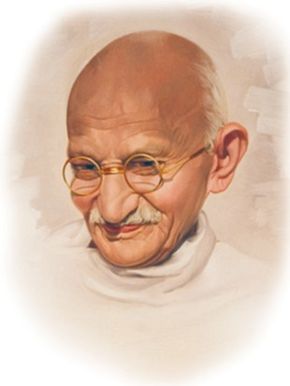What do you like best about your school? Tell your classmates about it.
I must have been about seven when my father left Porbandar for Rajkot to become a member of the Rajasthanik Court. There I was put to a primary school, and I can well recollect those days, including the names and other particulars of the teachers who taught me. As at Porbandar, so here, there is hardly anything to note about my studies. I could only have been a mediocre student. From this school, I went to the suburban school and then to the High School, having already reached my twelfth year. I do not remember having ever told a lie during this short period, either to my teachers or to my school-mates. I used to be very shy and avoided all company. My books and my lessons were my sole companions. To be at school at the
stroke of the hour and to run back home as soon as the school closed-that was my daily habit. I literally ran back, because I could not bear to talk to anybody. I was even afraid lest anyone should poke fun at me.
" Gandhiji was always the topper in his school ." Do you agree? Give reasons.
Two incidents belonging to this period have always clung to my memory. As a rule I had a distaste for any reading beyond my school books. The daily lessons had to be done, because I disliked being taken to task by my teacher as much as I disliked deceiving him. Therefore I would do the lessons, but often without my mind on them. Thus when even the lessons could not be done properly, there was of course no question of any extra reading. But somehow my eyes fell on a book purchased by my father. It was Shravana Pitribhakti Nataka (a play about Shravana's devotion to his parents). I read it with intense interest. There came to our place, about the same time,

travelling showmen. One of the pictures I was shown was of Shravana carrying his blind parents on a pilgrimage. The book and the picture left an indelible impression on my mind. ‘Here is an example for you to copy,’ I said to myself. The agonized lament of the parents over Shravana's death is still fresh in my memory. The melting tune moved me deeply and I played it on a concertina, which my father had bought for me.
There was a similar incident connected with another play. Just about this time, I had secured my father's permission to see a play performed by a certain dramatic company. This play–Harischandra–captured my heart. I could never be tired of seeing it. But how often should I be permitted to go? It haunted me and I must have acted Harischandra to myself several times. ‘Why should not all be truthful like Harischandra?’ was the question I asked myself day and night. To follow truth and to go through all the ordeals Harischandra went through was the one ideal which inspired in me. I literally believed in the story of Harischandra. The thought of it all too often made me weep. My common sense tells me today that Harischandra could not have been a historical character. But for me, both Harischandra and Shravana are living realities and I am sure I should be touched as before if I were to read again those plays today.
Name the two plays mentioned in this lesson.
There was another such incident during the time when I was in the seventh standard. Dorabji Edulji Gimi was the headmaster then. He was popular among the boys, though he was a disciplinarian. He was a man of method and a good teacher. He had made gymnastics and cricket compulsory for the boys of the upper standards. I disliked both. I never took part in any exercise, cricket or football, before they were made compulsory. My shyness was one of the reasons for this aloofness, which I now see was wrong. I then had the false notion that gymnastics had nothing to do with education. Today I know that physical training should have as much place in the curriculum as mental training.
Why is sports important for everyone?
But though I was none the worse for having neglected exercise, I am still paying the penalty of another neglect. I do not know from where I got the notion that good handwriting was not a necessary part of education, but I retained it until I went to England. I then saw that bad handwriting should be regarded as a sign of an imperfect education. Let every young man and woman understand that good handwriting is a necessary part of education.

Word Meanings

mind the part of a person that makes them able to think
recollect to remember
mediocre average, not very good
suburban an area where people live which is outside the city sole single
literally (here) actually
poke fun at make fun of
memory ability to remember
distaste dislike
taken to task scolded
deceive to cheat
prilgrimage a journey to a holy place for religious reasons indelible unremovable
impression an idea, feeling, an opinion about somthing agonised lament a strong expression of grief and sorrow concertina an instrument on which music can be played
haunt keeps coming to your mind so that you cannot forget it ordeal severe test of character
gymnastics a sport in which flexibility of the body is tested aloofness keep oneself away
piteous desiring or causing pity
clung stuck to
false notion wrong idea
physical training sports exercise that is taught in school
disciplinarian person who believes in strict training of mind and body benefit advantage
curriculum framework on which lessons are based

Reading Comprehension

Answer the following questions:
- Gandhiji's sole companions at high school were his books and lessons. Why ?
- What made Gandhiji do his lessons though his mind was not on them ?
- How did the book and pictures of Shravana affect Gandhiji ?
- Which ideal did the play Harischandra inspire in him ?
- Why did Gandhiji weep piteously ?
- What was the wrong notion that he had ?

Vocabulary
- Think of the name- ‘Mahatma Gandhi’. As you read his name, some other words come to your mind. List some of those words:
Example: Non-violence

Look at the word Recollection in column 'D' the word is made up of prefix 're' root word 'collect' and suffix 'ion'. Put prefix in column A, root word in column B, Suffix in column C and the word in the last column D. Use any of the two columns or all three columns. Column B is compulsory.

A | B | C | D
Prefix | root-word | suffix | word
Eg. | Re | Collect | ion Recollection

- Consult a dictionary and frame sentences using the following words:
Suburban, mediocre, pilgrimage, rebuke, indelible, false notion.


Grammar
- Look at the sentences:

  - Gandhiji used to be shy and avoided all company in his childhood.
It means that he was shy in his childhood.
  - It used to be a hospital before 2000, Now the building is used as the “secretariat.” This means that before 2000, the place was a hospital. Now the bulding is used as the “secretariat” office instead.

Now think of some things which you used to do in your childhood that you don't do now. Write sentences with "used to".
- Fill in the blanks using the clues:

  - Govinda late to class. (come)
  - Last year, we cricket every Saturday. but now we have classes on Saturdays. (play)

  - In the past years, people to theatres for watching movies. Now they view movies through CDs. (go)
  - When I was a child, I never tea or coffee, but now I take both. (drink)
  - He music when he was young. (learn)

Look at the sentences:

  - Gandhiji enjoyed the affection of his teachers.
  - He wept piteously.
  - He never took part in any physical activity.

Now frame questions for each sentence.
Example: What did Gadhiji enjoy ?

Here are some sentences. Frame questions, select the words from the list given below. One is done for you:
(What, Where, When, Why, How,)
- I left home at 8 pm.
When did you leave home ?
- I arrived at Bastar at 9 am. Where
- The match began at 11 am.
- The class for the day ended at 5.30 pm.
- We bought a gift for my friend's birthday at 6 pm.
- We went to the market by taxi.
- The taxi-man charged Rs 1000/- for finding a hotel.

Writing
A write-up is a written account giving an opinion of an event, performance or product.

Read the given write-up based on the lesson 'At School'
Gandhiji was a very shy child. His books and his lessons were his sole companions. He read a book named "Shravana Pitribhakti Nataka" and was highly influenced by the book. So, in my opinion, children should be given good books to read because they help to develop good habits and positive thoughts in children.

A. Read the extract given below.
School Life

'How many days is it since you have touched your book?' father asked as he blew off the fine layer of dust on Swaminathan's books, and cleared the web that an industrious spider was weaving between a corner of the table and the pile of books.
Swaminathan viewed this question as a gross breach of promise. ‘Should I read even when I have no school ?’
‘Do you think you have passed B.A.?’ Father asked.
‘I mean, father, when the school is closed, when there is no exam, even then should I read?’
‘What a question ! you must read.’
‘But father, you said before the examinations that I needn't read after they were over. Even Rajam does not read'.

Now, prepare a write-up on the above extract. Remember to include the main thoughts given in the extract and your opinion on the extract.
Activity
- Listen to the passage carefully and complete the table:
See Appendix-1 Lesson-8
Subhash Chandra Bose
Place ...................................................

Birth
Year ...................................................

Educated in universities ...................................................
................................................... 1920
Arrested by the British ...................................................
................................................... 1938
................................................... 1940
Advanced from Rangoon to ...................................................
India with Japanese support but ...................................................
was defeated. ...................................................
Believed to be killed in a ...................................................
plane crash ...................................................
Popularly known ...................................................

- Narrate to your classmates any interesting incident / event from your school life. You could use words/phrases like ‘then’, ‘after that’, ‘suddenly’, ‘so’, ‘hence’, ‘finally’, in the end. This will help the listener to understand the narration better.

Project

Frame some phrases with the help of the given words. An example is given: Examples: Clear Stream
----- Sky
----- Voice

bright

beautiful

huge

little


Use the following proverb in your sentence. Meaning is given.
Proverb Meaning
An apple a day keeps the doctor Eating an apple / any fruit every away. day will keep you in good health.

9. Beats in Memoir
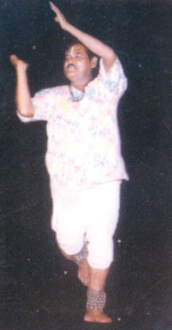What do you know about Panthi Dance ? Share it with your classmates.
Chhattisgarh's Panthi Dance form is famous all over the world and has brought much acclaim to Indian folk art. The credit for popularizing Panthi Dance goes entirely to Devdas Banjare. Banjare has showcased the cultural heritage of his community, state and country and won several awards for his performance on the platforms of the world through his commitment.
What was Devdas Banjare's contribution towards Panthi Dance ?
Devdas Banjare was born on 1st January 1937
in Sakra Village in Dhamtari District. His father's name was Bodhram, but Phool Singh Banjare, whose surname he adopted, raised him. The boy was exposed to Panthi by a twist of fate. As a youth, Banjare was a gifted Kabaddi player. As a result of an injury sustained during a match, he had to stop playing the game. Banjare then shifted his attention to Panthi dance. He had to practice hard and
strengthen his body because the dance required strength and vigour.
Why did Devdas Banjare stop playing kabaddi ?
The Bhilai Steel Plant (BSP) where Banjare worked as a dance teacher in the
education department encouraged him to pursue his interest. Banjare brought much fame and honour to the BSP over a span of two decades.
The Panthi dance form belongs to the Satnami community in Chhattisgarh. The Satnamis consider Guru Ghasidasji as their Guru. Panthi dance is the medium through which they honour their Guru. Banjare had said in an interview, "It is the prime responsibility of individuals to maintain their body and health so as to properly use god's gift to do good and discharge their responsibilities in a correct manner"
According to Banjare, what is the most impotant responsiblity of any person ?
In Panthi, the dancers perform various Mudras such as 'Jai Sthamb', 'Dharti
Pranam' (invocation to the land) and 'Phool Arpan' (offering flowers). The rich culture and legacy of the Satnami community is displayed through traditional costumes and more importantly the dancer's energy. The 'Ghungroo', the 'Dhoti & Kurta' and the 'Kanthi' (garland made of Tulsi) comprise the costume of the dancer. Indigenous instruments such as the 'Mandar' (Dhol) accompany the artists in their performance.

The artiste had worked with Habib Tanvir's New Theatre and had toured several countries for performances. His role in ‘Charandas Chor’ a film by Shyam Benegal, had received critical acclaim. Banjare had performed in many of the Bharat Utsav festivals as a folk art representative of India. He had toured over 60 countries in his career spanning 30 years. He had received the Chief Minister's gold medal in 1972, the President's gold medal in 1975 and countless other felicitations.
Name a film in which Banjare acted.
Tragically, Devdas Banjare died in a car accident in 2005. His legacy however continues as several disciples trained by him continue to stage Panthi performances all over the country and abroad. Banjare's commitment to Panthi was unparalleled and he dedicated his life to popularise the rich traditions and customs of his community
and state.
- Writers' group
Word Meanings
to display something
buildings, cultural traditions of the past that we see today
dedication main
to perform one's duty prayer to god
something handed over by the ancestors something done in the local environment to receive appreciation from experts time duration
an action that has never been done before
showcase
heritage

commitment prime discharge invocation legacy indigenous critical acclaim span unparalleled

Reading Comprehension
- Answer the following questions:
  - What is Devdas Banjare famous for?
  - How did Banjare get exposed to Panthi?
  - Which community is famous for its Panthi tradition?
  - Why does the community cherish the dance form so much?
  - Name some popular ‘Mudras’ in Panthi.
  - Explain in detail the costume of a Panthi dancer.

Vocabulary

Complete the table with information given in the lesson. Your answer must be in phrases: (two or three words)
Sr. No. | Question | Answer
1. | What is Panthi? | ............................................
2. | Who was Devdas Banjare? | ............................................
3. | What is a ‘Mudra’? | ............................................
4. | To which community does
 | panthi belong? | ............................................
5. | Which film did Banjare act in? | ............................................


- I. Add '-d', '-ed', '-n' or '-en' to the words and write them in the table.

Sr. No. | word | word + suffix
1. | Acknowledge | ............................................
2. | Discharge | ............................................
3. | Expose | ............................................
4. | Sustain | ............................................
5. | Raise | ............................................
6. | Strength | ............................................
7. | Play | ............................................
8. | Encourage | ............................................
9. | Enthrall | ............................................
10. | Display | ............................................
11. | Fright | ............................................
12. | Haste | ............................................
13. | Awake | ............................................
14. | Start | ............................................
15. | Surprise | ............................................
16. | Fix | ............................................
II. Make any five sentences, using any five words given above.

- Fill in the blanks selecting words given in the box:
Energy, Mandar, Charandas Chor, Shyam Benegal, Guru Ghasidasji, Phool Singh Banjare

(1) Devdas Banjare has acted in the film .......................... by ........................
- Instruments such as the ...................... accompany the artistes in their performance.
- The dancers'............................ is very important in Panthi.
- The Satnamis regard .......................as their Guru. (5) ........................... raised Banjare as a child.

Grammar

- Select the phrases given in the box and frame your sentences as given in the example: (Note that the sentences are about the challenges that some people faced in their childhood.)

I had to help my father in the fields.

... help my father in the fields.
... work in a shop to earn some money.
... work hard to get through the board exam.
... go on foot for six km. to get to school.
... help my mother to cook food.
... take care of my youngest sister at home.
... arrange flowers for my grand mother for worship.
... fetch water from long distance.
... study in dim light of earthen lamp in my hut.
... take animals to jungle for grazing.
- Rewrite the sentences you framed for exercise ‘A’ as given in the example. Example: When I was a child I had to help my father in the fields.

Writing

We regard some people as great dancers. Try and identify some qualities of a good dancer:

1. ...........................................................................................................
2. ...........................................................................................................
3. ...........................................................................................................
Now, write a paragraph using the qualities listed above which would make a good dancer.
.................................................................................................................
.................................................................................................................
.................................................................................................................
.................................................................................................................
.................................................................................................................
.................................................................................................................
  - Complete the Bio-data of Devdas Banjare:
    - Name
    - Father's name
    - Date of Birth
    - Place of Birth
    - Work-experience
    - Awards received

Activity

Listen carefully and answer the following:
See Appendix-1 Lesson-9
(a) Albert Einstein was born on ....................... in .....................
    - Children found Einstein .................... as a child and he prefered to play
..................
    - Einstein did not like ........................... of his school.
    - His first job was .............. He later secured a job in a company.
(e) He developed the ................................ and ........................... and won
the ................................ prize for ..........................

Read the passage about ‘Teejan Bai’. Discuss in groups what you find similar and dissimilar between Teejan Bai and Devdas Banjare.
Here is the story of the struggle of a village girl who dared to dream.
Teejan Bai belonges to Paridhan adivasi community. She could hardly get two meals a day. As a child, her grandfather's music fascinated her. But her

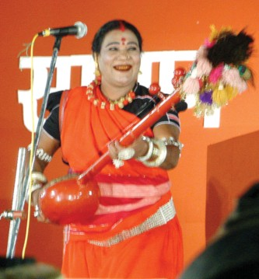
mother was ashamed because it was not considered good for a girl to sing and dance in that community. She often beat Teejan to stop her from singing. But this only made her more adamant. The wide gap between what she wanted to do and what others expected her to do disturbed her. However, her father supported her. Her first concert, the one most memorable for her was at Chandrakhuri. Later she gave performances all over the world. She was honoured with
Padmashri and Sangit Natak Acadamy Award. She is employed in the Bhilai Steel Plant. She has many students. She hopes that they will spread Pandvani to all corners of the world.
Teejan Bai owes her success to God. The other force behind her success, she says was her mother. Teejan's mother's resistance only made her more determined to pursue her interest.

Project

Describe any dance form of your local area. Write about:
- Costume
- Mudras
- Musical Instruments used in the Dance performance.


10. A Place Fit for Gods to Marry
Name your favourite temple. Why is this temple your favourite ?
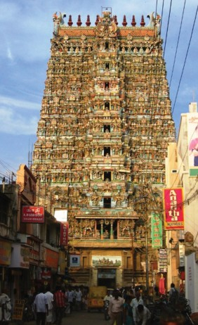
‘The City of Nectar’ or Madhurapuri is none other than Madurai, the
oldest city of Tamil Nadu.There are hundreds of stories about Madurai. It is believed that some venom had fallen on Madurai, from Lord Shiva’s snake. So he put some nectar from his crescent moon to neutralize the poison.
One of the other myths about Madurai is that it is surrounded by a snake with its tail in its mouth. When someone comes to attack Madurai, the snake changes them into stone.
Mention two myths about Madurai.
The melodious sound of Madurai,
the sweet-smelling jasmine strands, the windy entrances to huge temples, the politeness of the people - all these make Madurai a city of sweetness and nectar.
And it is in this ancient town that Goddess Meenakshi and Lord Sundareswara decided to marry. The wedding festival of the two is celebrated in the month of Chaitra (April-May) for
twelve days. Huge royal umbrellas, fans, pipers, drummers, large lights, jewellery, silk, elephants are all summoned for this grand wedding ceremony.
Idols of some of the Gods from nearby temples are also brought to attend this wedding. Following the wedding, Idols of Meenakshi and Lord Sundareswara are taken out. Meenakshi is taken out in a palanquin while Lord Sundareswara is taken on a silver elephant.
The Meenakshi temple has a magnificient structure. It is filled with wonderful sculptures. There are dance halls and a thousand pillar-mandapam with musical pillars.
What do you like about madurai ?
A visit to Madurai would take you to the times of kings, queens, legends,
festivity, thundering drums, chariots and nadaswaras and splendorous temples. Madurai is indeed a place fit for Gods to marry.
Writers' group

Word Meanings
amrit
not allow something to happen (to make something ineffective)
curved shape of the moon substance causing illness or death music
flower-string to wear on hair gate, door
very old story (Pauranik Gatha) change
to be on every side statue
palaki wonderful stambh
activities of festival
rath
a musical note of a musical instrument beauty
poison
nectar
neutralize

crescent poison melody strand entrance myth turn surround idol
palanquin magnificient pillar festivity chariot nadaswara splendour venom
Reading Comprehension

Answer the following questions:
  - What was Madurai earlier known as?
  - Why is Madurai called the city of nectar?
  - Why did Shiva put nectar on Madurai?
  - How many legends about Madurai have you read in the lesson?
  - Which of the legends about Madurai do you find the most interesting? Why?
  - What do you like most about Madurai?

Fill in the blanks:
  - After the wedding Meenakshi is taken on a --.
  - Lord Sundareshwara is carried on a --.
  - Goddess Meenakshi’s husband is --.
  - The people of Madurai speak language.
  - Madurai is in state.
  - The moon on Shiva’s head is shaped.

Vocabulary

Given below are words followed by four meanings. Tick the meaning used in the text:
  - melodious
    - sad (b) musical
(c) merry (d) happy
  - neutralize
    - to be filled with nectar (b) to make something harmless
(c) finish the value (d) to make something look beautiful
  - venom
    - poison (b) blessing
(c) money (d) honey
  - nectar
    - beauty (b) bright light from heaven
(c) poison (d) drink of Gods
  - attack
    - to harm some one (b) to argue with some one
(c) to be friendly with some one (d) to be angry with some one
  - ancient
    - attractive (b) huge
(c) new (d) old
  - summon
    - tell someone to come (b) tell someone to salute
(c) tell someone to speak (d) tell someone to sum up
  - magnificient
    - grand (b) interesting
(c) ordinary (d) bright
  - sculpture
    - statue (b) tombs
(c) design (d) pillars

Pick out adjectives from the text and change them to nouns by adding ‘- ness’:
- Match the adjectives in ‘A’ with their opposites in ‘B’:
A B

polite beautiful
sweet rude
bright dull
neat bitter
white dirty
ugly black

Grammar

Study the price tags carefully and ask each other the following questions and answer them as in the example:
Work in pairs.
Example: Which item is cheaper than the chess-board?
Answer: A Ludo is cheaper than the chess-board.

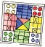Pictures:
bat
hockey
racquet
Rs.200
Rs.120
Rs.120
football
ludo
chess-board
Rs.120
Rs.55
Rs.70


  - Which item is the cheapest ?
  - Which is the costliest item?
  - Which items are cheaper than the bat?
  - Which items are as costly as the racquet?

Writing

Create an imaginary City. Write a proper noun next to each common noun:

city | ----------------------------
famous building | ----------------------------
river | ----------------------------
park | ----------------------------
mountain | ----------------------------
temple | ----------------------------

- Use the words given in the box to describe the city you have created:

You can add more words.

Begin your sentences as given.
big / small famous beautiful tallest magnificient old
highest.
The name of the city is --.
It has a -- .

Activity

Listen to the announcement and complete the chart.

Madai Mela Programme
Date | Name of Programme | Time | Group which will Perform

- Tick the right option:
  - Visitors at the mela should use dustbins for :
    - keeping the venue neat (b) throwing the waste
(c) (a) and (b) (d) only (a)
  - The vehicles should be parked at the:
    - parking street (b) shed
(c) parking space (d) outside the mela ground

Work in pairs:

See the following pictures. Choose your words from the table given below to describe the pictures:

beautiful | tall strange angry | huge | nice | sweet
horrible | wonderful
Example: How beautiful it is !
or
What a beautiful flower it is !
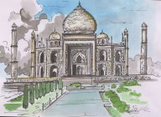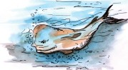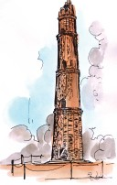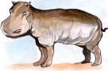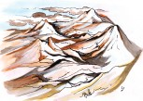

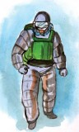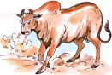Project


Make a list of old temples and tourist places of your area and collect their pictures.

11. Sympathy
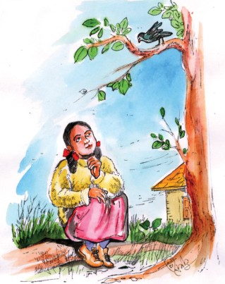
What do you see in the picture given below ? Discuss in pairs.

A plump little girl and a thin little bird Were out in the meadows together. 'How cold that poor little bird must be Without any clothes like mine, said she, 'Although it is sunshiny weather.'

'A nice little girl is that,' said he,
'But, Oh, how cold she must be, for see! She hasn't a single feather!'
So each shivered to think of the other poor thing, Although it was sunshiny weather.
-M. Johnson

Word Meanings
slightly fat
fields covered with grass
temperature and condition of heat, wind, rain etc soft covering on a bird's body
bright sunlight
plump
meadows weather feather
sunshine
Reading Comprehension

I | Tick (√) the correct sentences:
(i) | The little bird was covered with feathers | [ | ]
(ii) | They shivered due to the cold weather | [ | ]
(iii) | The weather was rainy and cloudy | [ | ]
(iv) | The girl is thin and the bird is plump | [ | ]
(v) | The little girl and the little bird were out in the meadows | [ | ]
II | Complete the table about the little girl and the bird:

Girl (1) Dress .....................
(2) Description .....................
(3) Feelings .....................
Bird
(1) Dress .....................
(2) Description .....................
(3) Feelings .....................

Now explain:
  - What was the little girl's feeling about the little bird ?
  - What did the little bird feel about the little girl ?


Vocabulary

Do you want to get inside the house ? If 'yes' identify a word and take one step up. Clues are given to help you.



  - birds have them
    - opposite of ' fat'
      - we wear it to cover our bodies
        - people use woolen clothes when it is...
          - second character in the poem
            - remove first letter of 'THERE'
              - first character in the poem
                - opposite of rich

Use the following words in your own sentences : →
( plump, thin, poor, sunshine, nice )


Grammar

Make a list of the describing words in the poem:
  - Look at the following phrases carefully:
A plump little girl, a thin little bird A nice little girl, a poor little bird

Now arrange the following words to get a meaningful phrase according to the hint given below:

[Age → Quality Type Shape Size Colour]
a big hill green/ a sea green/the beautiful blue sky wide. a new white aeroplane/ an old train blue.
a red new frock/a pink beautiful flower. a black ,little, nice girl.
a new pretty baby, pink/a red new ribbon.
a little poor old woman/a blue bright new star. a brown, beautiful, small packet.

Writing

Write a paragraph describing the following food items on the given points:
Kheer, Jalebi, Gulab Jamun, Samosa, Dahi Bada
  - Shape/size
  - Taste
  - Look
  - Colour
  - Your like/dislike

Arrange the words in alphabetical order and frame your own sentences:
meadows, sunshine, single, feather, plump, weather.

Activity

Listen to Bholu's routine and arrange the pictures according to sequence. Put the number under the pictures.
See Appendix-1 Lesson-11
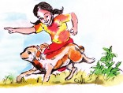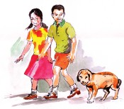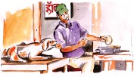

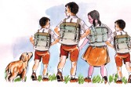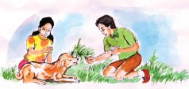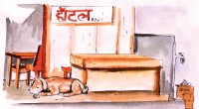

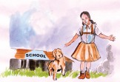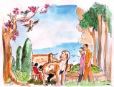

- Go around the class and find out who likes what ? Complete the table given below. Call out name of a child in your class and find out what he/ she likes/dislikes:
Example: Do you like ?
Answer: yes, I do the ........................................
No, I do not like ..................................

 | Name | Ice-cream | Kheer | Gulab Jamun | Jalebi | Lassi
(1)

(2)

(3)

(4)

Project

Make a list of the things you find interesting to see when it is raining.

Use the following proverb in your sentence. Meaning is given.
Proverb Meaning
Actions speak louder than words. What you do is more important than
what you say.



12. Children Ask Kalam

Share with the class anything you know about Shri A.P.J. Abdul Kalam.
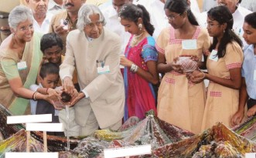
President Dr. Shri A.P.J.
Abdul Kalam spends hours every week connected with children across the nation, thinking about their future and thinking through their issues.
Here are Dr. Kalam's answers to the questions that some children have asked him. Dhanraj, Std. VIII, City: Kasargod.

Question: What is your full name and who was your best friend in school ?
Kalam: My full name is Avul Pakir Jainulabdeen Abdul Kalam. During my school days Pakshi Ramanatha Sastry was my best friend.
Joshi Bhoomi, Std XI, Institution Kotak Kanya Vinay Mandir, City: Rajkot
Question: How far is the ‘favour of fortune’ necessary?
Kalam: Hard work comes first. Fortune will favour you if you are persistent in hard work. There is a famous saying. "God helps those who help themselves. "There is another saying, that it takes many years of hard work to make an overnight success.
Devesh Ranjan, Institution NIC, City: New Delhi
Question: Please tell me, who would have been the first scientist in the world ?
Kalam: Science was born and survives only by questions. The whole foundation of science is questioning. And as parents and teachers know well, children are the source of unending questions, Hence, child is the first scientist.
B. Ishita, Std. VI, Institution St Bedes School, City: Chennai
Question: What is the secret behind remembering various formulas of science & maths.
Kalam: By constant application one can remember various formulas of science and maths.
Umang Dave, Std. IX, Institution Silken Academy, City: Mumbai
Question: Which has been the happiest day of your life ?
Kalam: I was once working with doctors to get light weight Floor Reaction Orthosis (FROs) for polio affected persons. After taking the measurement, when the

children were fitted with it, weighing 1/10th of the original weight which they were carrying, the children started running. walking and pedalling cycles. Their mobility brought tears of joy in the eyes of their parents. The sight of happiness on their faces was bliss to me.
R. Arovindh, Std. III, Institution St. Bedes School, City: Chennai
Question: Can you tell us any unforgettable incident from your childhood ?
Kalam: I am reminded of my class V teacher, Shri Sivasubramania Iyer. He taught us in his lectures how birds fly. He showed us real life examples at the seashore of Rameswaram. It is an unforgettable occassion which etched in my memory forever. It helped me to take up the study of science.
Abhilash Verma, Std. VIII, Institution Police Modern School, City: Etawah
Question: You are an ideal man. Please give us your suggestions to become good human beings.
Kalam: Hard work and scientific temper combined with spirituality will make you a good human being. Try to find good things in others.
Harsh Chandak, Std. VII, Dr. S. Radha Krishnan Vidyalaya, City: Malad, Mumbai.
Question: You give away bravery awards every year. What is your definiton of courage ?
Kalam: Saving others from disaster without minding about your own safety is courage.
Master Rahul Mehta, Std. VIII, City: Ahmedabad
Tejas Sawant, Std. IX, City: Bombay.
Question: What is your message to the citizens of India?
Kalam: My message to the youth is given in the 10 point Oath, which I normally administer, and is as follows -
- I will pursue my education or the work with dedication and I will excel in it.
- From now onwards, I will teach at least 10 persons to read and write, those who cannot read and write.
- I will plant at least 10 saplings and shall ensure their growth through constant care.
- I will visit rural and urban areas and permanently wean away at least five persons from addiction and gambling.
- I will constantly endeavour to remove the pain of my suffering brethren.
- I will not support any religious, caste and language differentiation.
- I will be honest and endeavour to make a corruption free society.
- I will work for becoming an enlightened citizen and make my family righteous.
- I will always be a friend of the mentally and physically challenged and will work hard to make them feel normal, like the rest of us.
- I will proudly celebrate the success of my country and my people.

Word Meanings

fortune fate, luck
persistent to keep trying with determination
foundation base on which knowledge can be constructed secret to keep hidden from others
application the act of doing something
peddling application of human energy (through legs) to run a
cycle
bliss happiness
seashore banks of the sea
etched to make designs on metal, wood
temper state of mind (anger, sweet-natured)
spiritually devotion, related to religion
bravery act of courage
disaster an event causing great damage
courage act of bravery
orbit to go around (eg. moon orbits the earth)
gravity the force of attraction that pulls on object to the ground (eg. apple falling to the ground)
dedication commitment to something
addiction bad habit which is difficult to give up
endeavour effort
corruption dishonest practice
ensure to allow work to be completed

Reading Comprehension

Answer the following questions:
    - What suggestion does President Kalam give to children for remembering formulas of science ?
    - Describe Kalam's happiest day.
    - Why does the President remember his class teacher so much?
    - What is ‘courage’ according to Dr. Kalam?
    - Which point do you like the most in the 10 point oath? Why ?

Look at the lesson and complete the sentences:
1. Kalam's full name is ....................................................
2. His best friend in school was ......................................
3. His favourite teacher was ...........................................
4. FRO's help persons.
5. Courage according to Kalam is ...................................

Vocabulary

Match the following. Clues are given to help you to complete the proverb.

Sr. A / Clues | B
1. Tiny drops make (search for water) | make more noise.
2. A stich in time (search for number) | mightier than the sword.
3. An apple a day (search for a profession) | do not bite.
4. Empty vessels (search for noise) | a mighty ocean.
5. The pen is (search for weapon) | saves nine.
6. Failure is the (search for achievement) | keeps the doctor away.
7. Barking dogs (search for what dogs do!) | is the best policy.
8. Make hay (search for planet) | stepping stone to success.
9. Honesty (end with ‘ey’) | while the sun shines.
10. A friend in need (rhymes with ‘friend’) | is a friend indeed.


- Make sentences using the proverbs given to you in exercise A:
Example: Shyam falls sick frequently. After taking him to the doctor, his mother encouraged him to have an apple by using the proverb, “An apple a day, keeps the doctor away”.

Select the appropriate word to complete the sentence:
  - Abdul Kalam is an to young people. (achievement/inspiration)
  - Teachers play an important part in children's interest in subjects.
(forcing/shaping)
  - The Defence Research and Development Organisation .............. a lot of scientists. (employs/arrests)
  - Kalam believes that children will help ...................... a strong nation. (citizens/build)
  - It is important for children to develop their (personalities/brains)

Grammar


Choose the answer from the box given below and answer as given in the example (Work in pairs):

Ask your partner:

“What will you do for the society when you grow up?” I will take care of old people

take care of old people. look after small children. help the needy.
try to establish peace.
work for education of girls . try to uplift the poor.
encourage people to keep this environment clean. work for removing superstitions
work for removing bad traditions try to stop child marriages.
raise awareness to save water encourage people to plant more trees

Writing

(I) If you were given a chance to ask President Kalam 3 questions - What would they be?
(i) .............................................................................................................
.............................................................................................................
(ii) .............................................................................................................
.............................................................................................................
(iii) .............................................................................................................
.............................................................................................................

(II) Now try to write what answers President Kalam would have given to the above questions:
Ans. (i) .......................................................................................................
.............................................................................................................
Ans. (ii) ......................................................................................................
.............................................................................................................
Ans. (iii) .....................................................................................................
.............................................................................................................

Read the dialogue given below:
The man : Where are you going?
The girl: I am going to super market.
The man : Please allow me to come with you. The girl : I don't mind
The man : What is your father?
The girl: My father is a businessman The man : What is your fortune?
The girl: My talent is my fortune. The man : Then I can't marry you.
The girl : I didn't ask you to marry me.

Complete the story with the help of the dialogues given above.
A man met a girl on the road. He asked her if he could ......................... The ---
--------agreed. So he walked along with her and asked and
............................... she replied that her father was a and
........................ . The man said that he could not .............................. She replied that she never asked him.

Present the story of the man and the girl in the form of a skit.
Activity
- Listen to the passage carefully and complete the table.
See Appendix-1 Lesson-12
Task-Sheet

Sr. No. | Plant/Spice/Fruit | Ailment | Process
1 | lemon | ................................ | ................................
 |  | ................................ | ................................
2 | .......................... | cold/slight fever | ................................
 | .......................... |  | ................................
3 | .......................... | ................................ | one centimetre of
 | .......................... | ................................ | fresh ginger to be
 |  |  | taken before
 |  |  | travelling
- 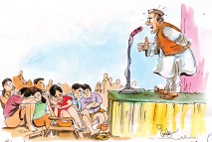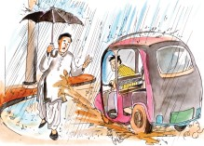Look at the cartoons given below. Speak a few sentences about what you like in the cartoons.

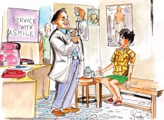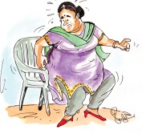

1. I like the cartoon because ............................................................................
- What do you understand from -
Cartoon 1 - ...................................................................................................
Cartoon 2 - ...................................................................................................
Cartoon 3 - ...................................................................................................
Cartoon 4 - ...................................................................................................

Project

Identify 10 proverbs in your local language.

 | Local language proverb | Meaning
1.
2.
3.
4.
5.

Use the following proverb in your sentence. Meaning is given.
Proverb Meaning
Cut your coat according to your Don’t try to live beyond your means. cloth.

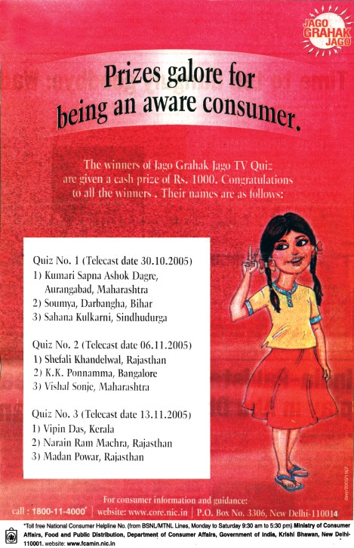
13. Sayani

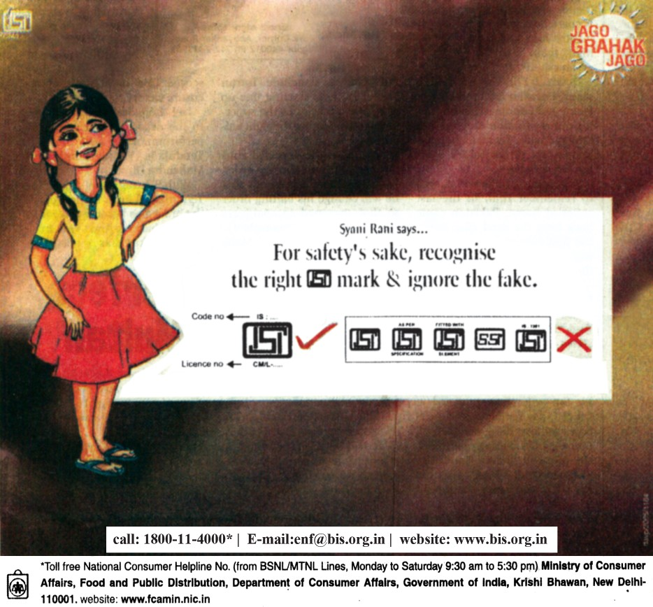

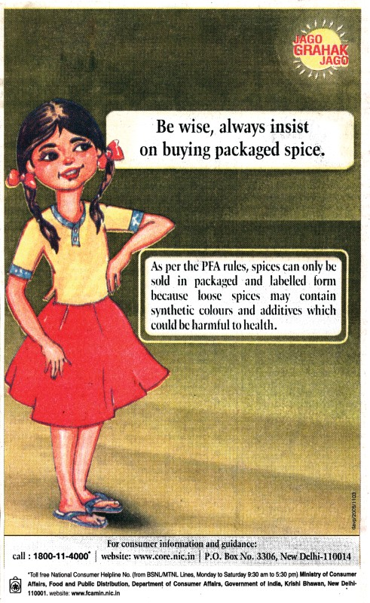





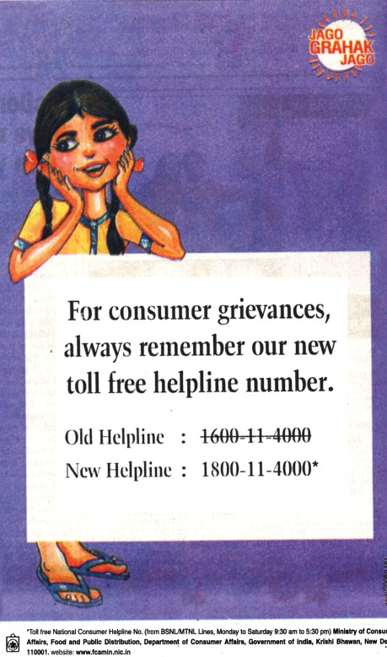

Word Meanings
plenty, a lot of things
to know, one who has knowledge about a thing a person who has purchased a product
form of greeting on success to show direction
to request artificial
colour/ingredient added to natural substance completely
symbol for proof of quality punishment given for wrongful act
one who produces goods for the market emergency number for the consumer great effort
many, several complaints
programme shown on T.V.
galore
aware consumer congratulations guidance
insist synthetic additives absolutely hallmark penalised manufacturer helpline rigorous array grcivances telecast
Reading Comprehension
- 1. Look at the first advertisement. What has the prize been given for?
  - What is the ISI mark used for?
  - Why should we buy packaged spice?
  - How can you know that the gold you are buying is pure?
  - What punishment is given to manufacturers who use ISI mark?
  - Why is the slogan ‘Jago Grahak Jago’ used?
  - What are the benefits of purchasing ISI mark.

Complete the paragraph:

  - The winners of
TV
Jago

. A cash prize of

was given to the winner.
  - Syani Rani asks consumers to recognise mark

from
for
sake.

  - As per PFA rules, spices can be sold in
form loose spices may contain
out

to health.
--------
which may be harmful

4.

Always look for
is used for measuring
. It is not the right test for

.
on gold.

5. For consumer complaints, the new helpline number is
.

Vocabulary


Given is the list of some words, use - ity at the end of each word and underline the rootword. Example is given:
suitable - suitablity
pure - ...........................
sure - ...........................
grave - ...........................
able - ...........................
capable - ...........................
comparable - ...........................
accountable - ...........................
acceptable - ...........................
teachable - ...........................

Pickup any five words from exercise ‘A’ and use them in your own sen- tences:
Grammar

- Look at the following sentences and rewrite them again as given in the example:
Example: For safety's sake, recognise the right ISI mark & ignore the fake. You should recognise the ISI mark & ignore the fake for your safety.

  - Be wise, always insist on buying packaged spice.
  - Always remember our new toll free helpline number.
  - Congratulate the winners.
  - Buy only pure gold.
  - Make sure that the BIS Hallmark is stamped on gold.
  - Don't use fake marks.
  - Always use packaged spices.

Your friend has a headache. Give him/her some advice which will help him/her to get relief. An example is done for you:
Example: you should take rest.

C.
"If the ISI mark you're using is fake, you will be penalised for your mistake."

Rewrite these sentence in passive voice. Some of them require the 'by phrase'. Some do not require the 'by phrase'. Discuss the reasons with your partner. Share it with the whole class.
  - Someone will penalize you. You will be penalized.
  - Somebody will feed the cows.
  - They found 10,000 year old tools in Tarrighat, Chhattisgarh.
  - The Education Minister gave me this certificate.
  - They will serve food in time.
  - Doordarshan will relay the event.
Make a list of activities which will be done on Independence Day in your school. You can use the hints.
Example: Republic day will be celebrated in our school. (Republic day - celebrate)
1. Flag will be ...................................... . (flag - hoist)
2. ......................................................... . (speeches - make)
3. ......................................................... . (songs - sing)
4. ......................................................... . (dances - perform)
5. ......................................................... . (prizes - give)
6. ......................................................... . (sweets - distribute)

Writing
- Q.1 Some sentences are given below. Arrange the sentences in the right sequence
  - Firstly, I love to see water droplets falling on the leaves.
  - Lastly, it is fun to get wet in the rain.
  - I like rains for many reasons.
  - Secondly, I enjoy putting paper boats in rushing water.
  - Thirdly I wait to see the rainbow during rainy season.

Similarly write a paragraph on the topic 'Summer Season'.
(Note: Note the use of words like firstly, secondly, lastly. Use such words in the paragraph you write.)

Consult a dicitionary and fill in the blanks:

1. 1 centimetre | = | .................... | inch
2. 1 kilometer | = | .................... | mile
3. 1 kilogram | = | .................... | pounds
4. 1 gram | = | .................... | ounce
5. 1 tonne | = | .................... | kg

6. 1 litre | = | .................... | pints
7. 1 hectare | = | .................... | acres
8. 12 inches | = | .................... | foot
9. 3 feet | = | .................... | yard
10. 16 ounces | = | .................... | pound

Activity

- Listen to this advertisement that your teacher will read to you:
See Appendix-1 Lesson-13
Now answer the following questions:

  - Who do you think has brought out this advertisement? 2. Advertisement gives you the ....................................
3. By reporting dishonest advertisements to the advertising council, we will help them ......................................................................................
4. Complaints should be sent to ...............................................................
..............................................................................................................

Some situations are given below in the box. Use the situation to ask the question as given in the example:Use the names of the students in place of he/she:
Example: Who could help me to stitch a frock ?
Response: I can stitch a frock. Introduce to the class by saying
He said, "He can stitch a frock". He said that he could stitch a frock.
Stitch a frock mend my shoes make a table paint the wall cut the grass repair the roof fly an aeroplane paint a picture drive a car
wash my clothes cook my food

Project

Have a short debate in the class on the topic "T.V. is a Blessing"
You can use the following expressions when you speak for or against the topic.
  - I would like to differ from your views.
  - I don't agree with you.
  - I can't agree with you.
  - I don't think so.
  - I'm sorry, but I disagree.
  - Well, in my opinion …
  - I too think so.
  - I agree.

You can also use the given hints.

For | Against
enjoy songs, watch films, enjoy serials, watch live cricket match, get news | affects our eyes, get late for work, shows crimes, shows bad scenes, affects our study

Example

For | Against
I watch T.V. for I get knowledge from it. | I would like to differ because it wastes much time.

- Conduct a quiz on consumer awareness. Make quiz questions as given in the examples below.
- Carat meter is used to check purity of :
  - spices (b) gold (c) clothes (d) packed goods
- The colour of the symbol for vegetarian food on food packets :
  - blue (b) green (c) red (d) yellow
- The mark of safety is :

  - ISI (b) SIS (c) ISS (d) SSI
.
Use the following proverb in your sentence. Meaning is given
Proverb Meaning
Health is wealth. Good health is the greatest wealth.

14. Craze

Share with your classmates an experience of travelling to any distant place.
A new age disease that has been spreading fast goes by the name ‘Travelia’. The root cause for this modern day disease is the travel
bug. The disease particularly has a tendency to affect wealthy people. The symptoms of the disease are restlessness in early spring and just after winter. People become eager for information about tourist places and anxiously contact travel agents and start collecting brochures during this phase. The final seasonal outburst of the disease can be seen around the time of the summer vacation.
Those affected by the travel bug decide to board a train, bus or plane to a foreign place like thousands of others affected by the disease. People travel not because they are necessarily interested or attracted by a place but more because they cannot stop the bug. Even within the country, one can frequently observe the side effects of the disease.
What makes a person want to travel? People from different countries have different purposes in travelling!
Americans are fond of taking pictures of themselves at places of historical interest like the Taj Mahal and the Mughal Garden or beneath the arches of Bhulbhulayya or with a 'Chadder' in their hands in front of the Dargah of Khwaja Moinuddin Chistie. One wonders of their urge to collect documentary evidence of their travels!
Germans on the other hand are eager to check the authenticity of details provided in the guidebook. They are especially keen to check whether the location of Jantar Mantar is actually in Delhi or elsewhere. They also check eagerly whether the old man who walks out of the big clock in the Salar Jung Museum actually does so when the clock strikes twelve. The German national makes sure to tick off the details in his guidebook when he is satisfied that he has not been deceived.
There is another way that this disease has made its strange appearance. Most of the urban population travels now-a-days because they have caught the infection from others in the office. If a colleague in the office has applied for a leave travel concession, the virus is sure to spread to others.
Many Indians travel in groups or venture out in joint families. They book a hotel or dormitory where the staff is of their own region. They eat their own regional dishes and sometimes even cook themselves in order to save money. Another thing that is observed is that people who normally don’t interact much with neighbours, are particularly affectionate with familiar faces when they happen to meet them in a distant place such as Jammu or Andaman.
Research is still required on two things that could effectively work out to be the cure for Travelia. Firstly, the discovery that ones neighbours are interesting people and secondly that you do not have to travel too far to satisfy you curiousity. Once the answers to these questions are found, reliable treatment for the same can be prescribed.

-Writers' group

Word Meanings

disease an illness affecting humans, animals or plants symptom a change in your body or mind that shows that you
are not healthy
anxiety the state of feeling nervous or worried that some thing bad is going to happen
afford to have enough money or time to be able to buy or do something
outburst a sudden strong expression of an emotion
infections an infectious disease can be passed easily from one
person to another, especially through the air that we breathe
anticipate to expect something
monument a building, column, statue etc. built to remind people
of a famous person or event
documentary a film or a radio or a T.V. programme giving facts about something
museum a building in which objects of artistic, cultural, historical
or scientific interest are kept and shown to the public
authentic known to be real and genuine and not a copy victimize to make somebody suffer unfairly because you do
not like them
interference the act of interfering
continent one of the large land masses of earth such as Asia,
Europe, Africa etc.
venture a business project or activity, especially one that involves taking risks
motto a short sentence or phrase that expresses the aims and beliefs of a person
pretend to behave is a particular way in order to make other people believe something that is not true
familiar well known to you, often seen or heard and therefore easy to recognize
tempting something that is attractive and makes people want to
have it
hesitate to be slow to speak or act because you feel uncertain or nervous
brochure a colourful printed material containing pictures and
information about something
dormitory a room for several people to sleep in specially in school
or other institution

leave travel concession scheme which allows workers to travel
interact talk with one another
reliable that which can be trusted
prescribe treatment suggested by an expert
things that are considered useless or of little value
change in behaviour
junk
tendency

Reading Comprehension

Answer the following Questions:

  - What is 'Travelia' ?
  - Who falls prey to it ?
  - Why do people feel anxious to contact travel agents ?
  - When do we see the seasonal outburst ?
  - Research is still required on two things. What are they ?

Write true or false in boxes:

  - The patient grows restless and starts rushing to the travel agent.
  - Travelling increases knowledge.
  - 'Travelia' is a modern disease of the rich.
  - The people living in rural areas easily fall prey to it.
  - The disease mentioned in the lesson is not infectious.
  - The seasonal outburst can be seen during the summer vacations.
  - The German and British are fond of taking photographs of themselves before places of historical interest.

III Complete the table filling the blanks with the information you got from the lesson about the following:

No. | Places/idea | Information
1. | Places in Delhi | ..................................................
2. | Agra | ..................................................
3. | Religious place | ..................................................
4. | Museum | ..................................................

Vocabulary

- Given are the names of diseases, categorise them in the table given below: Malaria, Cancer, Paralysis, Small-pox , Cholera, Typhoid, Pneumonia, AIDS, Jaundice, T.B., Polio, Diarrhoea.
Infectious disease | Non-infectious disease.
............................... | ...............................
............................... | ...............................
............................... | ...............................
............................... | ...............................

Complete the sentences with one of the words given in the brackets:
  - Our in the staff made a plan to visit Agra this week.
(colleague/neighbour.)
  - Scientists ase trying to discover a vaccine for a called AIDS.
(disease/pneumonia)
  - The Red-fort, Jantar-Mantar and the Taj Mahal are .....................
(monuments/museum)
  - 'Travelia' is a modern disease. People living in fall prey to it.
(urban area/rural area)
  - The disease mentioned in the lesson is (infectious/serious)

Give one word for the following expressions:
(1) One who is sick. He is a .............................
- We can get it from a newspaper radio and T.V. ........................
- The place where we can see old things ..........................
(4) It is the opposite of 'familiar' ...........................
- A sign of change in your body or mind that shows that you are not healthy
................................

Grammar


  - Kutumsar caves 7. Bhilai Steel Plant
  - Chitrakoot fall 8. Bhoram Dev
  - Kanger valley 9. Sonakhan
  - Sirpur 10. Bastar Mela
  - Bamleshwari Temple 11. Keshkal Ghati
  - Ramgarh paintings 12. Mainpat

Work in pairs :

Pick up the words given above and ask your partner questions, as given in the example and complete the table:
Example: (A) Have you ever seen Kutumsar Caves ?
(B) Yes, I have.
- When did you go there ?
- I went there in the summer vacations.
or
No, I haven't. I went to Orrisa.

Make your sentences from the table given below:

I  we you they he she  Ramu | have seen  has seen | Sirpur Kanger Valley Bhoram Dev Sonakhan Mainpat  Chitrakoot fall

Writing

- Look at the pictures given below. If you had a chance to travel to the places in the pictures given below:
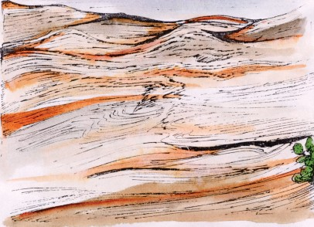

I would like to visit the desert/Iwould not like to visit the desert because
.............................................................................................................................
.................................................................................................................................
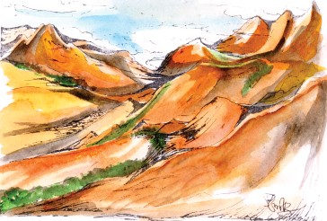
.................................................................................................................................
I would like to visit the mountains /I would not like to visit the mountains because
....................................................................................................................
.................................................................................................................................
.................................................................................................................................


I would like to visit the beach/ I would not like to visit the beach because
.............................................................................................................................
.................................................................................................................................
.................................................................................................................................

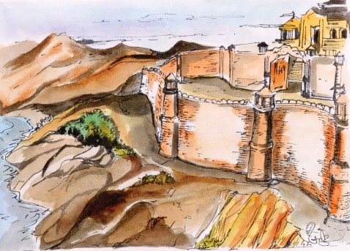

- would like to visit historical places/I would not like to visit historical places because.......................................................................................................................
.................................................................................................................................
.................................................................................................................................

A. Look at the railway time table given below. If you had to make a journey from Raipur to Delhi, use the time table to fill in the form:
Railway Reservation Time Table

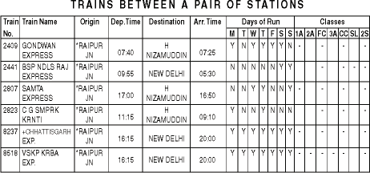

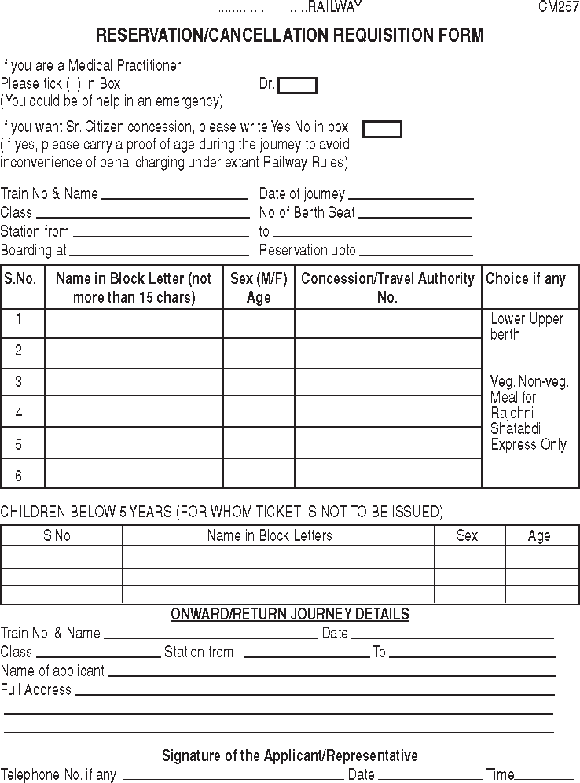

- Explain the important steps you used to fill up the reservation form:
....................................................................................................................
....................................................................................................................
....................................................................................................................
....................................................................................................................
....................................................................................................................
....................................................................................................................

Activity

1. Trace the route on the map that Satish and his family took:
See Appendix-1 Lesson-14

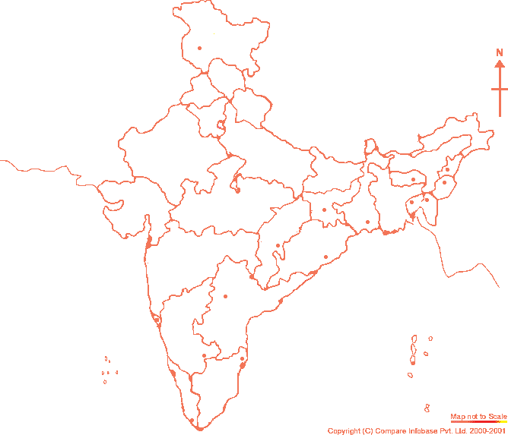
Delhi
Agra
Mumbai

Poona
Hyderabad
Chennai
Banglore
Cochin

- Complete the Table:

Place Visited (where) | Stayed with | Days spent

- You are travelling by train. You are going back home after a tour to Delhi. A person (co-passenger) and her family sitting near you is going to visit the place where you belong (your home town). That person would like to know about your home town. Work in groups and develop a conversation by greeting and introducing each other. The co-passenger will have many questions to ask about your home town-like the places worth seeing, the history, achievements and hotels:
Some useful expressions for developing the conversation:
  - Introducing
    - Hi ! I'm Ronita. b. Hello ! My name is Rahul.
c. Rahul, meet my sister, Rekha. d. This is my dad, Mr. C. L. Verma.
  - Responding to introductions
    - How do you do ? b. Nice, meeting you. (to meet you)
  - Asking for information
    - Can/could you tell me ?
    - Know anything about ?
    - Have you got any idea about ?
    - Could you please give me any information about ?
  - Responding to queries for information

a. Yeah ! sure ..... | b. | Yes ! of course .........
c. I'm not sure but ......... | d. | No idea
  - Parting :
    - Bye b. Good bye c. Had good company
Project
Maintain a diary
Note: Observe closely the diary given in the lesson. While writing a diary remember to write :
- the date.
- the events in sequence.
- your diary everyday.

Use the following proverb in your sentence. Meaning is given.
Proverb Meaning
Many hands make Light work. Work is quickly and easily
done when many people help.


15. The Birdman of India

Look at the title of this lesson and the pictures on this page. What, do you think, you will read in this lesson?
You must have seen people worshipping birds, trees and animals in many places. After observing this, you must have wondered as to ‘Why people worship nature'? An easy answer to this question is because our ancestors did it. A long long time ago, worshipping birds, trees and animals were ways devised by our ancestors to respect our ecology. This was also meant to prevent human greediness from destroying our natural wealth. Unfortunately, if we look at the
present situation, birds and their habitations have faced much destruction.

What are the two reasons given for worshiping nature?
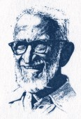
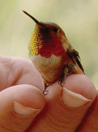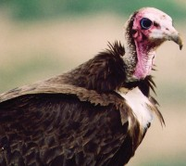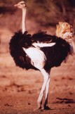There are about 9000 species of birds and their size varies from 5 cms to over 2.5 metres. The Humming Bird is one of the smallest species of birds and the Ostrich, which reaches a height of over 8 feet, is the largest bird on the planet. There are birds, which are known for their swiftness such as the Eagle and the Hawk; there are other birds
such as the Vulture, which are known for flying at high altitudes. There are also several birds, which have lost the power of flight such as the Ostrich, the Emu and the Kiwi.
Make a table showing specialites of the birds mentioned in the paragraph.
Birds are called winged bipeds. The body temperature of birds remains more or less constant.
Another interesting feature about birds is their feathers. Observing the feathers of a bird gives us an idea about the life that they lead. Birds have beaks. They have no teeth. Their main food consists of insects, food grains, and flesh. Like reptiles, birds too lay eggs. They have a keen sense of sight and hearing, but their sense of smell and taste is poor. Birds have the wonderful capacity of adjusting their vision quickly. As a result, they can shift their focus from a distant object to a nearby object in a fraction of a second.
Find the specialites of birds given in the paragraph.
In India, the world of ‘Birds’ was exposed to us by the great Salim Ali’s contribution. He is affectionately known as the ‘Bird-man of India’. Salim Ali was born on 12th November 1896. His maternal uncle Amiruddin Tyabji brought him up. His uncle was a hunter and a nature lover. Under his guidance, Salim learnt to hunt and appreciate the nature around him. As a child, Salim Ali shot a bird, which had a

yellow streak running below its neck. His uncle could not identify the species and advised him to contact the Bombay Natural History Society (BNHS) in Mumbai. Dr.
W.S. Millard, the honorary secretary of the BNHS identified the bird as a yellow- throated sparrow. He also showed Salim Ali the Society’s splendid collection of stuffed birds.
This single incident changed Salim Ali’s life and India got its best ornithologist as a result. Once Salim Ali said, “My chief interest in the study of birds has been the opportunity to observe the bird’s life history under natural conditions and not in the laboratory under a microscope. By travelling to remote uninhabited places, I can study the birds as they live and behave in their natural habitat”.
What do you like the most about Salim Ali?
Salim Ali received honours and medals from all over the world for his service including the J. Paul Getty International award, the Golden Ark of the International Union for conservation of nature, the golden medal of the British Ornithology Union (a rarity for non-British people) and Padmashree and Padma Vibhushan from the Indian Government.
His timely intervention saved the Bharatpur Bird Sanctuary and the Silent Valley National Park. His famous book “The Book of Indian Birds” is a bible for budding ornithologists. He passed away in 1987 at the age of 91. He is no more, but his legacy lives on. His dedication to ornithology has left behind committed groups of amateur
bird watchers all over India.
-Writers group
Word Meanings
forefathers (people releted to us who lived long-long
ago)
images of Gods/Goddesses
the scientific study of the pattern of relations of plants and animals in their natural environment
to live
family of animals or birds body part which help birds fly two legged animals
not changeable
a very large African bird with beautiful feathers, which runs very quickly but cannot fly
soft covering on a bird's body power to see
feelings (reactions)
a child who has lost his parents
ancestors

deities ecology

exist species wing bipeds constant ostrich

feather sight sensibility
orphan

the science of studying birds
attempt to save natural resources cold-blooded animal which lays eggs a safe natural environment for wildlife
degree given to a person by a university for extraordinary work (not following the usual rules) action of noticing or watching
to come in the way usually to do something good beginning
history (life history)
those who are not experts excellent
where people don't live
ornithlogy
conservation reptile sanctuary honorary

observation intervention budding legacy amateur splendid uninhabited
Reading Comprehension

Read the lesson again and complete the table:

No. | Names of Birds | Names of Persons | Names of Awards
1. | -------------------- | -------------------- | --------------------
2. | -------------------- | -------------------- | --------------------
3. | -------------------- | -------------------- | --------------------
4. | -------------------- | -------------------- | --------------------

  - Answer to the following questions:
    - Why is Salim Ali called the Bird-man of India?
    - What do ‘feathers’of birds tell us ?
    - “Looking at the beak of a bird, it is possible to understand its life cycle”. Explain.
    - What influenced Salim Ali to become an ornithologist?


Vocabulary

Fill in the blanks with appropriate words given below.
winged bipeds, reptiles, ornithology, budding, intervention, laboratory, identified

  - His .................saved the Bharatpur bird sanctury.
  - Dr. Salim Ali studied the life of birds in natural conditions not in the
..........................
  - The science of studying birds is known as .............................
  - The secretary ................. the sparrow as the yellow throated sparrow.
  - Animals that are able to change blood temperature and usually lay eggs are ...................
  - "The book of Indian Birds" is a bible for ornithologists.
(vii) Birds are called ............................

Match the column ‘A’ and ‘B’:

‘A’ | ‘B’
(1) ecology | given as an honour and not according to the usual rules
(2) deities | those who are not experts
(3) conservation | flowers, animals, birds in the environment
(4) amateur | images that we worship
(5) honorary | attempt to save natural resources

- Frame your own sentences using the word /phrases:

high attitudes, distant objects, nature lover, life history

Grammar

LOST and FOUND BOX
red pen, blue pencil, small purse, white paper, black book, brown doll,
green lunch box, pink bottle, yellow bag, purple sketch pen, orange ribbon

From the given lost and found box , pick up phrases and use in your sentences as given in the example:
Example: I lost my pen which is red.

Underline the part of the sentence which describes the object in exercise ‘A’:

Writing

  - 1. A picture of a very strange-looking and beautiful bird is given. Look at the picture very carefully and write a paragraph describing the bird's features.
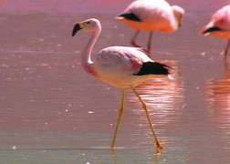

Some tips for writing the paragraph.
    - The bird's beak
    - The bird's colour and its feathers
    - Its neck and write what you have observed
    - The length of its neck
    - Height of the bird

An ornithologist (person who studies birds) requires certain tools to carry out his observation, Some of these tools are listed. You will have to explain why those tools are necessary for studying birds.
  - Binoculars
  - Tape-recorder and mike
  - Sample of bird feathers
  - Bird-tag

There is some interesting information about the feathers of birds. Read it and complete the notes given below it.
The feather is the one thing that makes a bird unique from all other animals- not flight, not eggs. All an animal needs is one feather and it is considered a bird. Feathers not only help birds fly, they also keep birds warm and dry. Feathers are excellent for birds to hide from enemies. Most birds use them to attract and

select a mate. Some other role that feathers serve are- balancing on the ground, in flight and as lining inside nests for incubation.
There are many kinds of feathers. They can be broadly divided into two types - body feathers and flight feathers.

1. Identity of a bird: .............................

Utility of feathers:
2.1 ................................... 2.2. ...................................
2.3. ................................... 2.4. ...................................
2.5. ................................... 2.6. ...................................
2.7. ...................................

Kinds of feathers:
3.1 ................................... 3.2. ...................................

Activity

Task I.
Look at the pictures carefully, Listen to the passage, recognise the nests and write the names of birds in the space given:
See Appendix-1 Lesson-15
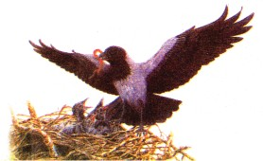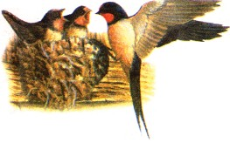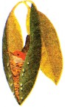

Task II.
Complete the table:
NESTS

Name of bird | Made of | Speciality
........................ | ........................  ........................ | Cup shaped
Swallow | ........................  ........................
........................ | Sticks bound by  mud and wool

  - Describe your favourite bird by completing the table given below:

Name  of Bird | Picture | Colour | Sound | Tail | Special  features
Now tell the class about your favourite bird.

Project


Collect information about Chhattisgarh Myna and write a paragraph about its unique features.
Use the following proverb in your sentence. Meaning is given.
Proverb Meaning
A rose is a rose is a rose Things and people are what they is a rose. are-you can not change their
nature.


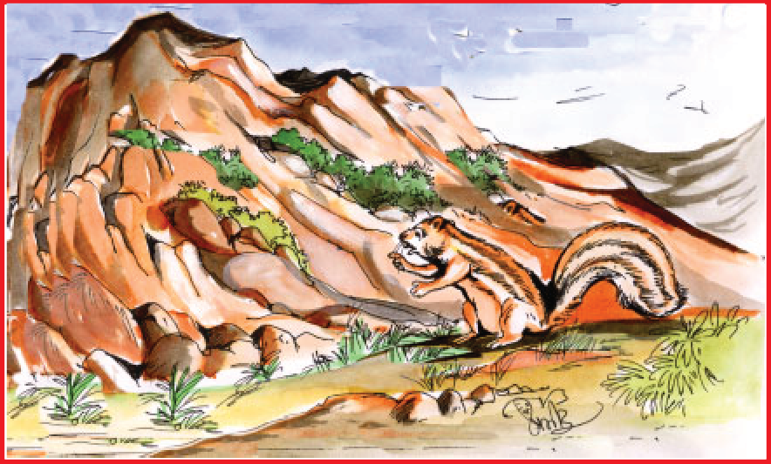
Recite any poem in your mother tongue about any animal and about nature.
16. The Mountain and the Squirrel

The mountain and the squirrel Had a quarrel,
And the former called the latter “Little prig.”
Bun replied,
“You are doubtless very big; But all sorts of things and weather
Must be taken in together To make up a year
And a sphere.
And I think it no disgrace To occupy my place.
If I’m not so large as you, You are not so small as I, And not half so spry;
I’ll not deny you make
A very pretty squirrel track, Talents differ; all is well and wisely put;
If I cannot carry forests on my back, Neither can you crack a nut.”

- Ralph Waldo Emerson

Word Meanings
Small animal with a long furry tail which climbs trees
and stores nuts to argue
first of two people mentioned second of two people mentioned
someone who is very careful about rules
refers to the squirrel as its hair seems to look like a ‘bun’
without doubt/certainity to bring shame
to move into and take possession active and quick in movement refuse to accept
special ability or skill
to have an opposite opinion showing good judgement
to break open
squirrel

quarrel former latter prig bun

doubtless disgrace occupy spry deny talent differ wisely crack
Reading Comprehension
- Tick (√) the correct Answer:
  - The quarrel between the mountain and the squirrel was about
    - length (b) size
(c) ability (d) strength.
  - The mountain is able to
    - carry a forest (b) crack a nut
(c) make a spry movement. (d) make up a year
  - The squrirrel is able to
    - make a sphere (b) crack a nut
(c) make up a year. (d) carry forests

Answer the follewing questions:

  - Why does the mountain call the squirrel ‘little prig’?
  - What qualities of the mountain does the squirrel appreciate ?
  - What tasks is the mountain unable to perform?

  - Do you like the squirrel’s reasoning? why?
Vocabulary
- Find out the meaning of these phrases and make sentences:
  - Little prig
  - All sorts of things

  - Make up a year
  - Occupy my place
  - All is well

Look for words and phrases which describe the qualities of the squirrel and the mountain. An example is done for you:

Mountain | Squirrel
eg. Big | eg. Little
(1) | (1)
(2) | (2)
(3) | (3)
(4) | (4)

Grammar


- Two or more Sentences are given below. Use ‘and’, ‘but’ to make a sentence which gives the entire meaning: Example:
Cameras capture light on photo film.
Digital cameras capture images on computer memory. Cameras capture light on photo film but digital cameras capture film on computer memory
- He read the text book.
He made notes from them.
- The average life span of a crocodile in the wild is 45 years. In captivity, they are known to live upto 80 years.
- A cricket is an insect which varies from 0.1 to 2 inches. It is an insect which has hind legs for jumping.
- You can pay your bill with cash.
You also have the option of paying by cheque.

With the help of the pictures given below and the given clue in the box try to describe the animals by comparing them:
heavy, big, tall, intelligent, long, good, slow, small

Example: The giraffe is taller than the elephant.

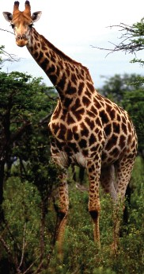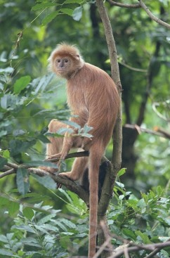
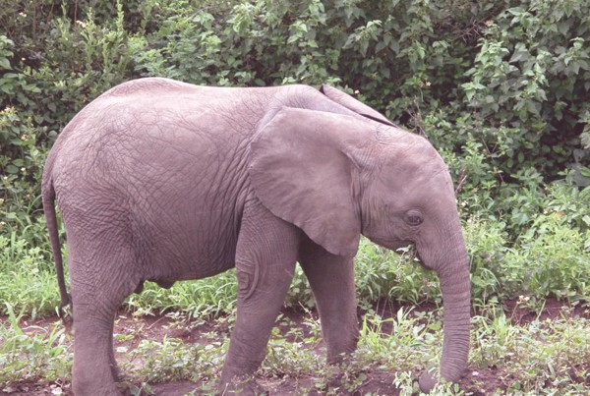

Writing

Write a paragraph to describe an animal or a bird that you find attrac- tive.
Activity

- Listen to the passage:
See Appendix-1 Lesson-16
Number the statements in the order that you hear.

Sr. No | Order | Number
(1) | Chilikha has been designated as a wetland of
 | international importance
(2) | Birds arrive from Baikal, Caspian Sea etc.
(3) | Long outer channel connects the lagoon to the Bay
 | of Bangal
(4) | It is located on the Eastern Coast of India.
(5) | Chilikha is a lagoon.

- Use ‘Can, may,would, could,’ and frame sentenes using hints in the questions: (Pair work)
  - You are in a new city and you want to reach the market. How would you ask for directions?
  - You want to take part in the Republic Day Parade. How would you ask your teacher?
  - Your brother is playing the tape recorder very loudly. You are disturbed and want to ask him to reduce it. How would you ask him?
  - The weather is cold and your friend does not have a sweater. How would you show your concern?
  - A school trip has been arranged. You need to ask your parents for permis- sion. How would you ask them?

Project


Describe the poem in your own language.

Can you name the person in the pictures?
17. Nothing but the Target

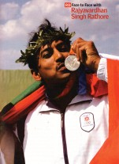Rajyavardhan Singh Rathore, a 34 year old armyman finished second in the men's double trap shooting event on Tuesday, the 17 August 2004 in the 28th Olympic games in Athens. This was Indian's first individual silver medal in Olympic history in shooting event . Lets read what he said
after he won the medal.

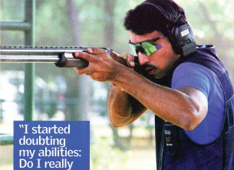Feelings while receiving the medals
It felt absolutely great.
It certainly feels good to win a medal for the country. And that makes it even more good because the country feels proud.

Feelings while draped in country's flag at the
presentation
It was a sense of relief that I was able to accomplish something for the country.
And the flags, I wanted something close to the symbol which represents the country. So the flag was the best thing, and I just wanted to wrap it
around myself.



Focus at the final point
I realised that I was missing because I was losing aggression. When you lose your aggression, you lose your natural way of shooting. I then told myself, I should go hard
at the target. That's how I made those last two. I was absolutely focussed on the target, I could see
nothing else but the
target.

Word Meanings

Preparations in the last few days
There was a mix of everything. There has to be a healthy balance. Whenever I felt that I was getting anxious, I would
relax, crack a joke or talk to somebody and make the environment lighter for myself. But whenever I needed focus, I would close my eyes and think of the target of how I would do, how my emotions would be, what is my game plan for the match and everything.
-Writers group

completely and definitely
covered or decorated with cloth
the act of showing something or giving something to somebody
to cover something or somebody a result that you try to achieve
feeling of anger and hatred that may result in threatening or violent behaviour
to succeed in doing or completing something
absolutely
draped presentations

wrap target aggression

accomplish
Reading Comprehension
- Answer the following questions:
  - What is special about Rajyavardhan Singh Rathore winning the silver medal in shooting ?
  - What makes the country feel proud ?

  - Why did he wrap the country's flag around himself at the presentation ?
  - What would he do whenever he needed to focus on the sport ?
  - Why is aggression important in a sport ?

Choose the correct alternative:
  - The 28th Olympic games were held in -
    - Sydney (b) Seoul (c) Athens (d) London
  - How did he feel when he received the silver medal -
    - absolutely great (b) happy (c) sense of relief (d) sense of pride
  - Whenever I felt that I was getting anxious I would -
    - sing a song (b) smile a bit
(c) think of the target (d) relax, crack a joke & talk to somebody.


Vocabulary

Use the words given below in your sentences:
- Accomplish
- Aggression
- Target
- Draped

Grammar

Select the words from the box A and go round the class and ask the questions:
Question: Who knows what Kawardha is famous for?
Answer: I know that Kawardha is famous for Bhoramdev Temple.

(Select your answer from the Box B)

Box A | Box B
Kawardha (Kabirdham) | Jain temple
Champaran | Bhoramdev mandir
Rajim | caves
Kutumsar | fall
Chitrakoot | Iron-ore
Bella-Dilla | Steel plant
Bhilai | Mana Airport
Raipur | Rajiv Loachan temple
Bastar | Danteshwari temple

Bastar Dashera
Mahanadi Sanctuary Music and Arts Kosa silk Gangrel Dam
Dantewada
Dhamtari Sirpur
Janjgir-Champa Kanger Valley Khairagarh University

- Match the columns ‘A’ and ‘B’ and write the sentences as given in the example and underline ‘that’ clause:

A | B
Dhanraj Pillai | Football
Anju George | Cricket
Bhaichung Bhutia | Tennis
Mahendra Singh Dhoni | Hockey
Sania Mirza | Chess
Vishwanath Anand | Atheletics
Prakash Padukone | Long jump
P.T. Usha | Badminton

Example: I know that Sania Mirza is famous for Tennis.

Writing

Some famous games are given below. Identify one famous person who plays the game and explain in a paragraph what you like in that person's game.

(i) Tennis, | (ii) | Cricket, | (iii) | Football,
(iv) Badminton | (v) | Hockey.
- Consult the dictionary and find out the part of speech for the following words. The words may belong to more than one part of speech:
  - armyman
  - shooting
  - proud
  - accomplish
  - automatically
  - right

Activity

Use the names from the box to complete the information after listening to the passage:

See Appendix-1, Lesson-17
Task-1
Ghulam Ahmed, K.K. Birla, Serena Williams Imran Mirza.
SANIA MIRZA
Daughter of
Grand niece of
Opponent in Australian open (2005) third round
Recieved a cash prize
of Rs. 2 Lakhs from

Task-2
SANIA'S ACHIEVEMENTS

Name of events | Year
Won ITK womens singles and doubles
1st to the 3rd round of Australian open
Won WTA tour events
B. Role play :
Imagine that one student is a journalist working for a sports magazine. The journalist is interviewing Rajya Vardhan Singh Rathore on the day he won the silver medal in Olympics. The person playing the role of Rathore can answer questions based on the information in the lesson or his/her imagination.
The interviewer may ask questions about his other hobbies, family, practice of shooting, why he took up shooting, his message for the upcoming shooters, his experiences in the army, his feelings when he won the silver in Olympics, preparations for Olympics etc.

Project

Make a list of famous sports persons in your locality and describe why you admire them.

Use the following proverb in your sentence. Meaning is given.
Proverb Meaning
Better safe than sorry. It is wiser to be careful
than to take risk.

'Dancing may not be easy for the girl in the picture'. Discuss.
18. Dancing On
Alarippu, shabdam, varnam, padam - these were strange words for the audience in the packed auditorium in Washington. But as the
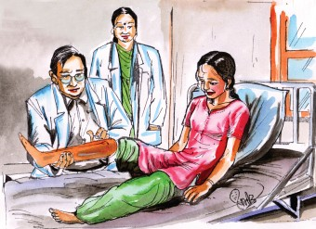young dancer from India, looking splendid in her traditional costume, explained each item before she began her dance,
they began to understand the bhava (emotion), raga (melody) and tala (rhythm) of Bharatanatyam.
About ten years ago, Sudha was a promising 17-year- old dancer with more than 80 performances behind her. And then one day, she was injured in a road accident about 25 kilometers from Tiruchirapalli, Tamil Nadu, where the family had gone for their annual
pilgrimage. Perhaps she was not treated properly at the local hospital where she was rushed. In any case, her injuries resulted in a gangrenous infection. When she was taken to Chennai, the doctors there tried hard to stop the growth of the infection. but finally they were forced to amputate her right leg from about eight centimeters below the knee.
In the terrible months that followed, Sudha's search began - to find a way of dancing again. "The day I met Dr. Pramod Sethi, I knew that my dream would come true," she says. Dr. Sethi had won the Magsaysay Award for his development of the ‘Jaipur Foot’ - an artificial limb made from vulcanized rubber filled with sponge. Sudha acquired a ‘Jaipur Foot’ and began her determined journey back to the world of Bharatanatyam, learning to balance, bend, stretch, walk, twist, turn and finally, dance. Her doctors, her physiotherapist, her parents and her guru were all a part of her passionate effort. On October 27, 1982, she gave a Gurudakshina (a traditional thanks giving recital) at the residence of her guru. It was truly a miracle.
What was the miracle?
On January 28, 1984, Sudha made a historic comeback by giving a public recital in Bombay (Mumbai). The performance was notable for its classical quality. Everyone warmly welcomed the return of the talented dancer.
Her father K.D. Chandran say, "After every performance, Sudha used to ask, 'How was it, Daddy?' and I used to tell her that she still had to improve a lot. But on January 28, when she asked me the usual question, I didn't say anything. I just touched her feet. It was my tribute to a great artist."

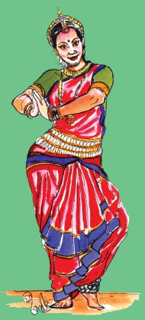Sudha's amazing success story took an interesting turn when a Hyderabad film producer decided to make a Telugu film not just based on her story but with her in the main lead. Mayuri's success encouraged him to dub the film in Tamil and Malayalam and remake it in Hindi as ‘Nache Mayuri’ - and Sudha Chandran had yet another birth, as a film star. She has since acted in some three dozen films in several languages, and has also just completed producing a Kannada film ‘Kalabhimani’ based on the true life of Balanna, a deaf artist who went on to become a great character actor. (Balanna, 74, has 400 Kannada films to his credit and is still in demand.)
Sudha says, "If Helen Keller could overcome her handicap so can I, is what I have always told myself."
Point out similarities between Helen Keller and Sudha Chandran.
That, Sudha remarks, is what she replied to her Indian fans who wrote to her in the thousands after the release of her films. "People wrote to say that they were inspired by my story and that it had given them new hope. I do feel thrilled that my message has got across."
And what is that message ?
"The seed of achievement lies in the human mind. When this realization comes, there is no looking back. Once I decided that my handicap was not going to stop me from dancing, that was it."

-Simplified from "Dancing On" by Shailaja Ganguly

Word Meanings
a place where an audience assembles
to cut off
treated with sulphur i.e. great heat to make rubber stronger an act or event that doesn't follow the laws of nature
a public performance of music or dance or poetry a gift that is intended to show your respect
a strong feeling of excitement or pleasure
imaginary power which has settled everything that is to happen
replace the sound track in a different language
auditorium
amputate vulcanized miracle recital tribute thrill
fate

dub

Reading Comprehension

Answer the following Questions :-
  - What were the strange words introduced to the audience in Washington?
  - What did Sudha always do before her performances?
  - How did Sudha lose her leg ?
  - Why did Sudha say "My dream will come true" when she met Dr. Pramod?
  - What was the turning point in Sudha's life ?
  - Sudha Chandran says towards the end of the lesson, "I do feel thrilled". Identify why she feels so ?
  - How did Sudha get the opportunity to act in films?

B. Write true or false against the statements:
(i) In a road accident Sudha lost her right hand | [ | ]
(ii) She again came back with her new dance item | [ | ]
(iii) She hasn't worked in any film | [ | ]
(iv) She has given performances only in foreign countries | [ | ]
(v) People wrote that they were not inspired by her success stories | [ | ]
- Choose the correct answer:
  - While performing, Sudha wore .
    - Modern costume
    - Traditional costume
    - Western costume
- She worked for the film .
  - Nache Mayuri
  - Arunima
  - Gajagamini
- Before Sudha was 17 years of age, she had given performances.
  - more than 70
  - less than 80
  - more than 80
- Sudha made a historic comeback on .
- 15 October 1983
- 1 January 1982
- 28 January 1984
- Sudha Chandran was inspired by .
  - Helen Keller
  - Elena John

  - Valentina Tereskova

Arrange the given sentences in a series as they appear in the lesson:
  - Sudha's right leg was amputated after a road accident.
  - Sudha explains each item to the audience before she begins her dance.
  - Sudha acquires a Jaipur foot and makes her comeback.
  - Sudha gives her first comeback recital in Mumbai.
  - Sudha receives a note of congratulations from a young girl after her performance in Washington.
  - Sudha acts in ‘Nache Mayuri’, a film based on her own life.
  - Sudha's father touched her feet as a token of respect.

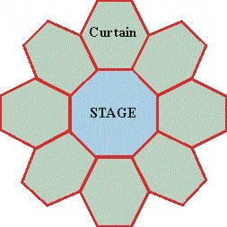Vocabulary

Make a word list related to the given word:

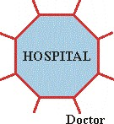

- Fill in the blanks with the words given in the box:
defeats, amputate, historical, miracle, costume
  - Rashmi wore a new for the party.
  - Rahim was injured and the doctors were forced to his right hand.
  - I visited many places in India.
  - The Indian team the South African team in the hockey match.
  - It is only a that Seema once again is able to see this beautiful world.

Complete a puzzle one is done for you:

Across: →
Example: (1) one who performs a dance on the stage [6 letters]
  - an act that doesnot follow the laws of nature. (7 letters)
  - completed successfully. (11 letters)
  - To cut off a part of the body (8 letters)

(5) ↓
(1)
(6) ↓
(7)
(2)
(3)
(4)
→

Down:
↓
→
T
A
A
A
M
T
R
E
C
N
A
D
  - people who come to see a performance (8 letters)
  - showing respect (7 letters)
  - surprizing (7 letters)

Make a correct match:
Modified to make simple
Clarified to correct
Simplified to free from impurities to make clear
Rectified to make pure
Certified to improve
Purified to attest formally.


Grammar

Raju is new in the village. He met a boy in the village street. He asked the following questions:
Read carefully the following questions and tell the class what

Raju asked as given in the example:

Which class do you study?
Where do you live?
What is your name?
I study ...............................
I live at .............................
My name is .......................

Example: Raju said to the boy, "what is your name?" Raju asked the boy what his name was.
How do you go to school?
Where is your school?
I go to school ...................
My school is near ............

Note:
Direct speech is in interrogative form.
Direct speech begins with interrogative pronouns.
Interrogative pronoun is used to join the direct and indirect speech. Interrogative sentence is changed into simple statement.
Present form of the verb is changed into the past form of the sentence.
•
•
•
•
•

Writing

- Read the short biography of Teejan Bai and complete the biodata given below:
Here is the story of the struggle of a village girl who dared to dream.
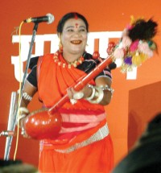Teejan Bai belonges to Paridhan adivasi community. She could hardly get two meals a day. As a child, her grandfather's music fascinated her. But her mother was ashamed because it was not
considered good for a girl to sing and dance in that community. She often beat Teejan to stop her from singing. But this only made her more adamant. The wide gap between what she wanted to do and what others expected her to do disturbed her. However, her father supported her. Her first concert, the one most memorable for her was at Chandrakhuri. Later she gave performances all over the world. She was honoured with Padmashri and Sangit Natak Acadamy Award. She was employed in the Bhilai

Steel Plant. She has many students. She hopes that they will spread Pandvani to all corners of the world.
Teejan Bai owes her success to God. The other force behind her success, she says was her mother. Teejan mother's resistance only made her more determined to pursue her interest.

1. Name : .....................................................................
2. Father's Name : .....................................................................
3. Date of Birth : .....................................................................
4. Place of Birth : .....................................................................
5. Specialisation : .....................................................................
6. Awards : 6.1 .....................................................................
6.2 .....................................................................
6.3 .....................................................................
6.4 .....................................................................

Character Sketch
What are the qualities of Teejan Bai that make her a successful person ?

Activity

- Listen to the passage carefully and answer the questions given below. Answer orally in one word only.
See Appendix-1 Lesson-18
- What was the colour of the puppy sitting in the corner?
- How many puppies were there in the shop?
- Why did the shopkeeper say that the white puppy was not for sale?
- For how much money did the boy buy the lame puppy? Mention the words that give you the clue.
- How much money did the boy bring from his mother?
- Why do you think the boy bought the lame puppy?


Project

Collect some pictures of famous artists in your own locality and make a list of names and their related art.


11th February
Dear D-L-L,
Who do you think is Daddy-Long-Legs. Imagine and draw a picture of Daddy Long Legs.
19. Dear Daddy-Long-Legs

Don’t be insulted because this is so short. It isn’t a
letter, it is just a line to say that I am going to write a letter pretty soon when examinations are over. It is not only necessary that I pass, but pass WELL. I have a scholarship to live up to.
Yours, studying hard J.A.

December 19th
Dear Daddy L.L.,
You never answered my question and it was very important. Are you bald? I have it planned exactly what you look like very satisfactorily until I reach the top of your head and then I am stuck. I can’t decide whether you have white hair or black hair or sort of springy grey hair or may be none at all. Here is your portrait.
But the problem is, shall I add some hair? Would you like to know what colour your eyes are? They are grey and your eyebrows are like a porch roof and your mouth is a straight line with a tendency to turn down at the corners. Oh, you see, I know you are a snappy old thing with a temper.
Jerusha Abbott

9th June
Dear Daddy - Long - Legs,
Happy Day! I have just finished my last examination physiology. And now three months on a farm! I don’t know what kind of a thing a farm is? I have never been on one in my life. I have never ever looked at one (except from the car window) but I know I am going to love it, and I am going to love being free.
I am not used to being outside the John Grier Home. Whenever I think of it excited little thrills chase up and down my back. I feel as though I must run faster and faster and keep looking after my shoulder, to make sure that Mrs. Lippett is not after me with her arm stretched out to grab me back.
Yours, with love Jerusha Abbott
-Jean Webster

Word Meanings
who gives money for a good purpose
without hair comfortably
to take decision/to come to conclusion spring like
painting nature
quick and full of zest nature
as soon as possible
aid to the students to continue their study
the name of the orphan’s house (Anathalaya) follow
catch
benefactor
bald satisfactorily decide springy portrait tendency snappy temper pretty soon scholarship
John Grier Home chase up
grab
Reading Comprehension

A. | Tick the correct answer;
 | 1. J.A. is used for-
 | a. Jerusha and Abbott | b. Jerusha Abbott
 | c. Jean Abbott | d. Jean L Jerusha
 | 2. Jerusha Abbott is a-
 | a. a bald man | b. a naughty boy
 | c. an orphan student | d. a farm girl
 | 3. Mrs Lippett may be-
 | a. Jerusha’s mother | b. Incharge of John Grier Home
 | c. Teacher of Jerusha | d. Wife of Daddy Long Legs
 | 4. ‘Are you bald?’ is written to-
 | a. John Grier | b. Mrs Lippett
 | c. Daddy Long Legs | d. Jerusha Abbott
- Answer in Yes/No to the following questions:
  - Is the writer happy to go on a trip to a farm?
  - Is the home in the lesson same as your home?
  - Does the writer love Daddy Long Legs?
  - Has she finished her examination?
  - Has Daddy Long Legs answered her questions?

Answer the following questions in short:
  - What is the promise made in the first letter?
  - Why does the writer say that this is not a letter?
  - Why is the writer happy to go on a trip?

  - Why does the writer say ‘I am going to love being free’?
  - What is the name of the home the writer lives in?
  - What is the feeling you have for the writer?


Vocabulary

Look at the pictures carefully. Choose the appropriate word and write it under the related picture:

happy | sad | smiling | shy
angry | satisfied | confused

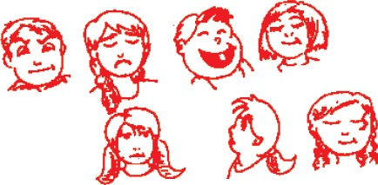
Grammar

- The gram panchayat of your village is going to do the following things, listed in the box, in the next five years. Select the things and frame your sentences as given in the example:

Example: Our grampanchayat is going to open two new schools in the village.
build roads dig tube wells
build market place establish dairy farm establish cottage industry build community hall start health centre provide playground
open public library

Remember ‘going to' + verb’ is used to talk about definite plans in future.

- Raju wants to interview a doctor for a magazine 'Health club' but the Doctor is very busy. He looks into his diary and explains to Raju why he can't see him.
Complete the dialogues using 'going to'.

Visitors Time 7.30-9.00 am.
Monday | - | Health conference
Tuesday | - | Operation Theatre
Wednesday | - | Hospital inspection
Thursday | - | eye camp
Friday | - | attend a marriage
Saturday | - | medical college students

Raju : Can I see you on Monday ?
Doctor : Sorry, I........................... (attend) a health conference. Raju : What about Tuesday, then ?
Doctor : Oh, That day ? .............. (operate) a patient for heart disease. Raju : Then can I see you on Wednesday ?
Doctor : That day, sorry, I ..................... (have) a hospital inspection. Raju : How about Thursday, then ?
Doctor : Oh ! no, that day, I.............................. (work) in an eye camp. Raju : Oh! Then I think Friday will be OK.
Doctor : Sorry, That day I........................ (attend) a marriage. Raju : Can I come on Saturday, then ?
Doctor : I think that day I. (teach) medical students at medical
college
Raju : Oh! I think Sunday will be your day of rest. I would catch up with you later then.

Writing

Read the following description of Fizza based on her features given in the box:

Fizza is a teacher. She is 21 years old. She has black hair and black eyes.
Name: Fizza Age: 21 years Hair: black Eyes: black Height: 5’2’’ Build: slim
Complexion: wheatish Dress: saree Profession: teacher Goes to school: by bus
She is 5’2’’(five feet and two inch tall.) She is slim. She has wheatish complexion She wears saree. She goes to school by bus.

With the help of the words given in the box , write a brief description of any one of your friends:

thin, slim, plump, fair, pale, stout, brown blue, pink, long, curly, thick, smart, beautiful

- Read carefully the e-mail given below.

From : chelsi.sahu309@gmail.com
To : kamleshsahu2078@gmail.com
Subject - Happy Birthday
Dear Daddy
Wish you a happy birthday.
Your loving daughter Chelsi
Find the following information from the e-mail.
  - Who is the sender of this e-mail?
  - Who is the receiver of this e-mail?
  - What is the subject of the e-mail?
Write an e-mail to your friend wishing him/her a happy new year.

Activity
- You will listen to your teacher describing some people. Can you identify them? Write the names under the pictures
See Appendix-1 Lesson-19
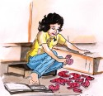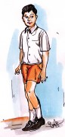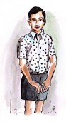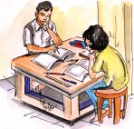
- Work in pairs and practice the dialogues based on the information given in the box:

A |  | B  Expected answers
 | given a speech?
Have you ever | visited Bastar mela? visited Kutumssar caves? climbed a mountain?  won a race? cooked food?  white washed your house? lost money? | Yes, I have. No, I have not.
 |  | decorated your class?

Project
Describe an interesting person whom you like the most and tell the class why you like him/her. Prepare a character sketch of the person. Mention how that person is special.


We generally think that a person who can see is always better off than one who cannot see. But this is not always true. There are some occasions when a blind person has an advantage over one who can see.
20. Fog

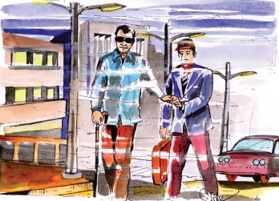

I saw the fog grow thick,
Which soon made blind my ken, It made tall men of boys
And giants of tall men.

It clutched my throat, I coughed, Nothing was in my head
Except two heavy eyes Like balls of burning lead.

And when it grew so black, That I could know no place I lost all judgement then,
Of distance and of space.

The street lamps, and the lights Upon the halted cars,
Could either be on earth Or be the heavenly stars.

A man passed by me close, I asked my way, he said,
'Come follow me, my friend-' I followed where he led.

He rapped the stones in front, 'Trust me', he said, 'and come.' I followed like a child-
A blind man led me home.

W. H. Davies

Word Meanings
thick cloud like formation which makes it difficult to see
things
range of knowledge or sight to have no knowledge
held tightly
not able to make a decision hit lightly
a metal
fog

ken
made blind clutched
lost all judgement rapped
lead
Reading Comprehension
- Answer the following Questions:
  - What does 'I' refer to in the poem ?
  - How does the poet's eyes look like in the fog ?
  - Why did the poet lose his judgement and why?
  - Who was the man who passed by the poet ?
  - How did the poet reach home ?
  - Which word indicates to us that the second man was blind ?
  - What message do you get from this poem ?

Write true or false against the given statements:
  - The man was able to see everything in the fog.
  - In the fog, his eyes looked like burning lead.
  - He imagines that the lamps, light and cars are heavenly stars.
  - The blind man helped him to cross the road.
  - The poet reached his home safely.

Write the stanza number whixh gives the folowing sense:
  - The person reached his home safely with the help of a blind man.
  - The man was helpless and was not able to decide where he was.
  - It is not possible to see anything during fog.
  - He imagines the lights to be like stars.
  - The person compares the eyes with burning lead.

Vocabulary
- A. Complete the word web:

Situation when you Cough

B. Two seasons in which you can see fog:
............................... ...............................

Give three rhyming words for the word given below:
head ............................... ............................... ...............................
place ............................... ............................... ...............................
cars ............................... ............................... ...............................

Use the following words in sentences: (Don't use words in isolation, Give situations)
  - wrap
  - lead
  - judgement

Grammar


Your teacher often uses some sentences in the class.
“Write your name on the board” “Come here”
“Bring your note book here” “Please, give me your pen” “Stand up on the bench” “Please, take your seat” “Clean the board”
“Call him here” “Don't be late”

Write the sentences as given in the example:
The teacher said, “Write your name on the board.”

Rewrite your sentences again to explain to your mother at home what you were made to do. An example is given below:
Note: The teacher ordered/requested me to write my name on the board.
  - Direct speech has imperative sentences.
  - Use ‘to’ before the ‘verb’ of the reported speech.
  - Change ‘said’ into ordered/requested if necessary.

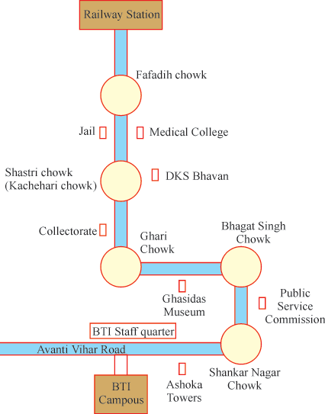
Study the following map carefully. Give instructions to your friend Ramesh who is new to the city to reach BTI campus from the Railway Station, Raipur:

BTI
Campus

Writing

  - 1. You must have noticed that visually impaired (blind) people use some aids to carry out normal activities. Some of the things that they use are:
    - Cane or walking stick
    - Dark Glasses
    - Tape Recorder

Write why you think these aids are necessary for visually impaired people. Add some more tools you have seen them use.
2. Fog affects visibility and this causes accidents. Think about why this happens. Write any incident in a paragraph that you have read/heard.
  - Consult the dictionary and find two meanings for the given words:
- lead 6. follow
- pan 7. trust
- fog 8. blind
- place 9. dumb
- judgement 10. patient

Activity

I. Listen to the story carefully and order the pictures according to the story sequence.
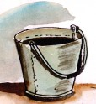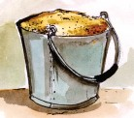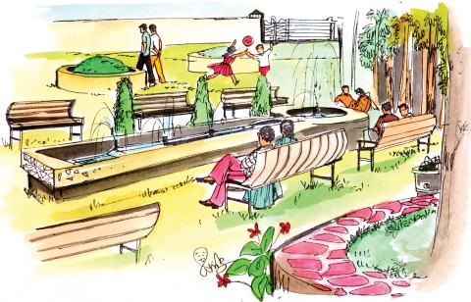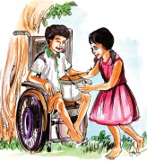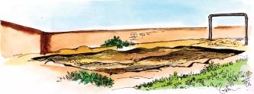See Appendix-1 Lesson-20

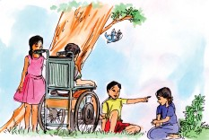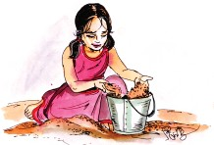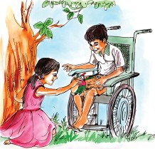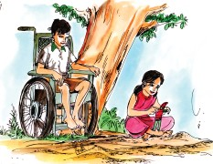
- Fill in the blanks with appropriate words.
  - The girl noticed a boy in a .....................
2. The girl went to a local ..........................
3. The girl played in the .............................
- The girl filled tha bucket with .........................
- The girl dumped the sand in the boys ................
- The ................. put some toys in the boy's lap
- The .................. said he couldn't play
- The girl asked the “Could you play with me ?”

I. Instructions for the activity: (Language Game)
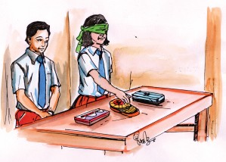Divide the class into to groups. Let two students from each group stand near the teacher's table by turns. Blindfold one of them. Keep two pencil boxes or two bags or two tiffin boxes on the teacher's table. The student who is not blindfolded will describe one of the two pencil boxes/bags/ tiffin boxes kept on the table. The blind folded student will touch and feel one of the similar items kept on the table and then guess which of them has been described.

To describe, you could talk about the shape, material, size etc. Some useful words/phrases:
big, long, plastic, small, thin, metal, slender

Note : 1. This game could be done as a whole class, group or even in pairs.
  - Set time limit (30 to 60 seconds) for giving hints and allowing to guess.
  - Give marks and declare the winner.

Project

Some disabilities are given below. Think about difficulties faced by people with this disabilities:

Disabilities | Difficulties
(1) visually impaired | (1) .......................................  .......................................
(2) hearing impaired | (2) .......................................  .......................................
(3) polio affected | (3) .......................................  .......................................
(4) mental disorder | (4) .......................................  .......................................

Use the following proverb in your sentence. Meaning is given.
Proverb Meaning
A stitch in time saves nine. Quick action to solve a small problem saves
a great problem.

Find Thailand in the given map.
21. The Flavours of Thailand
Litle Doi Swan welcomed us at the gate of the neat looking guesthouse with
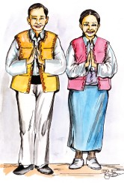folded hands. This standard Thai gesture of greeting is called the ‘Wai’. Flowers, colourful dresses, beautiful Buddha statues and temples introduce us to this unique country in South East Asia.
Thai people are warm-hearted, courteous, ever smiling and their hardworking nature is inspiring. Our stay in Thailand was enriching and very exciting.
Thailand is bordered by Laos and Cambodia on the East, the Gulf of Thailand and Malaysia on the South and the Andaman Sea on the West. In ‘Thai’ language, the word ‘Thai’ means ‘freedom’. Thailand's official
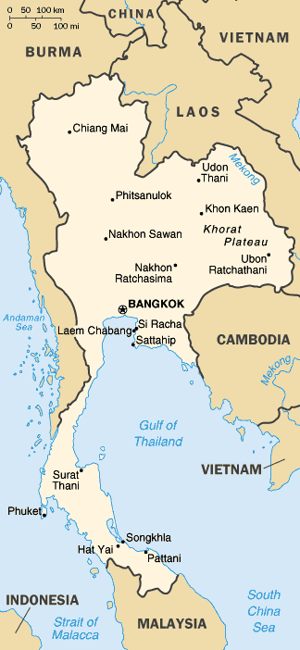name till May 11,
1949 was ‘Siam’, which is still used by many Thais, especially the Chinese-speaking minority.
We sat in the open terrace of the guesthouse in the morning sun. Being a November morning, the weather was quite cold. Chui Bahadwe, our caretaker at the guesthouse brought us hot coffee and spiced potato chips. He was very busy but we managed to pull him to a chair, to sit with us and tell us about the history of Thailand.
Chui Bahadwe then took us to small and rather old museum a furlong away from the guesthouse where many coins, vessels, metal weapons and records of history were kept. My father pointed at the Thai official calendar on the wall based on the Buddhist era. Interestingly, the Thai calender is 543 years ahead of the western calendar. This means the year 2005 A.D. will be considered as 2548 A.D. according to the Buddhist calendar.
We had planned to go out and see the riverbanks of Mekong and the flowers of the Chao Praya river valley, but suddenly it started raining. We were disappointed because we had to cancel our trip but Chui Bahadwe kept us engaged. He showed us photographs of the lovely Khorat Plateau and the highest peak of

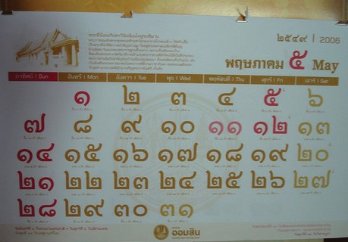
The History of Thailand
- Originated from the Sukhothai kingdom founded in 1238
- Next larger kingdom ‘Ayuthaya’, established in mid 14th century
- Culture greatly influenced by India and China
- Never colonized by any European power

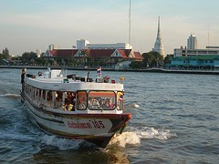Thailand ‘Doi Intharion’ which is 2576 metres high situated in the North of the country. The beautiful Chao Praya River runs into the Gulf of Thailand and the narrower Kra Isthmus flows into the Malay Peninsula.
By that time, the delicious Thai cuisine cooked for us had made us feel hungry indeed. Thai cuisine is known for its balance of five basic flavours in every dish - hot (spicy), sour, sweet, salty and bitter tastes. One of the
important ingredient is the “Nampla” - very aromatic and strong tasting fish sauce.
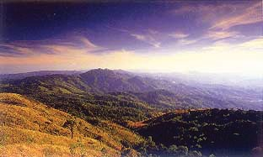
- Thailand's climate is tropical with frequent rains.
- Southern Thailand is hotter and more humid.
- May and September-warm and cloudy.
- November to mid-March-cool, dry and pleasant.
- North-East monsoon always prevails.
A typical meal consists of sweet-smelling Jasmine rice (quite costly!). Lovely smelling curries, stir-fried items and other dishes cooked with large quantities of chilly, lime juice and lemon grass.

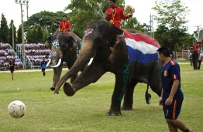Bahadwe also talked about noodles that made my mouth water. But at lunch, I realized that the Thais call it “Pad Thai”. I insisted that I must have some in the evening.
Mummy was happy to collect Thai specialities for her kitchen such as basil, galangas, ginger, Thai eggplant, tamarind, palm, coconut milk and coconut sugar.
In the afternoon we travelled to
Bangkok, the capital city. My brother noted the names of other important cities from the tourist guide - Nakhon, Rat Chasima, Udon Thai, Kakhon Sawan, Chiang Mai, Surat Thani, Phuket, Hat Yai (songkhla)... such difficult names!
Chui Bahadwe suggested that we go and see the Loikrathang Festival, held usually in the month of November in which candle-lit floats are cast into running water to bring good fortune for the coming year. We were lucky to see the ‘Elephant Round Up’ in Surin where Pachyderms (thick skinned animals) play football (soccer). Wasn't
that great!

-Writers group

Word Meanings
to improve quality by adding something
a person whose job is to look after a property section of people who are small in number compared to total population
to happen at regular intervals smell of fruits, flowers, food climate which is hot and humid
hot weather which results in sweating food
items that go into making a special food tulsi
uniform
feeling when task is not achieved.
enriching
caretaker minority

frequent aromatic tropical humid cuisine ingredients basil standard disappointed
Reading Comprehension
- 1. Where is Thailand situated?
- What is interesting about the Thai Calendar?
- Write about some famous places in Thailand?
- What is unique about ‘Thai’ food?

- What does a ‘Thai’ meal consist of?
- Name some of the important towns in Thailand?
- What happens during the Elephant Round-up?
- Who was Litlle Doi Swan?
- Solve the quiz:
  - Four letter word which means 'freedom' in Thai

  - Thai greeting

  - The year 2006 according to Buddhist Calendar would be 2006 +

=

  - The river that runs into gulf of Thailand

  - Another name for Intharion Mountain of

  - Kra Isthmus flows into

  - Elephants are also called

in Surin.

Vocabulary
peninsula.

and play


Look at the following phrases and frame 10 more phrases:
neat looking guesthouse ever smiling nature

Use the following words in your own sentences:
courteous, managed, riverbanks, disappointed, aromatic, museum.

Grammar

Use the information given below in box ‘A’ and ‘B’ and complete the sentences. Use (had + III verb):
One is done for you.

Example: The childen had left the class before the teacher came.
station, the class room, home work a doll, lunch, the trees, purse, the sun, the newspaper, bath
B
reach, leave, finish, make start, set, take, cut, steal, tear
A

1. The children ..................................... before the teacher came.
2. The train ........................... at the ....................... before we arrived there.
3. We ............................... our ......................... before our father came home. 4. My daughter .................... ................. before we came back home.
5. They ............................... ..................... before we joined them.
6. The ................................. ..................... before she returned home.
7. My father ........................ .................... before I got up.
8. Someone ................... ................... before the forest guard arrived.
9. Someone .................. .................... before the passenger came back.
10. The baby ................... ................... before his grand father read it.

Complete the table:

Regular verbs |  |  | Irregular verbs
I | II | III | I | II | III
reach | reached | reached | leave | left | left
finish | finished | ................ | make | ................ | ................
................ | started | ................ | set | ................ | set
look | ................ | looked | read | ................ | ................
................ | climbed | ................ | steal | stole | ................
hear | ................ | ................ | tear | tore | ................
listen | ................ | ................ | eat | ate | ................
................ | touched | ................ | weep | ................ | wept
play | ................ | ................ | fall | fell | ................
................ | ................ | looked | drink | drank | ................
clean | ................ | ................ | ................ | spoke | ................
................ | painted | ................ | ................ | saw | ................
................ | wash | ................ | ................ | ................ | risen

Writing


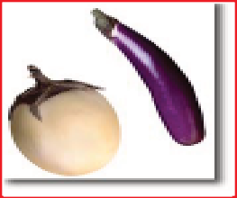
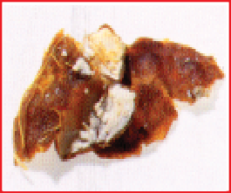
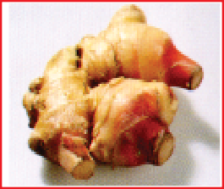
Look at the pictures given below and the title. Explain in your own words what dish requires the ingredient:
Basil Eggplant Tamarind Ginger

Think of some favourite dish that you like. List the ingredients that go into making the dish. List some instructions on how to prepare the dish. Name your dish:

1. ...........................................
Instructions.
Ingredients

2. ...........................................

3. ...........................................

4. ...........................................

5. ...........................................

6. ...........................................

7. ...........................................

8. ...........................................
Step1
............................................................
............................................................
Step2
............................................................
............................................................
Step3
............................................................
............................................................
Step4
............................................................
............................................................
Step5
............................................................
............................................................
Step 6
............................................................
............................................................

Consult a dictionary to find out the Hindi word or the words in the local language for the following words:
(1) cucmber [khjk (2) garlic ................................
(3) ginger ............................ (4) brinjal ................................
(5) coconut ............................ (6) fig ................................
(7) chillies ............................ (8) lime ................................
(9) cumin seeds ............................ (10) tomato ................................

Find from a dictionary the English word for the following Hindi words:
(1) jeera ................................ (2) haldi ................................
(3) dhaniya ................................ (4) kalimirch ................................
(5) methi ................................ (6) rai/sarson ................................
(7) chhoti elachi ........................... (8) long ................................
(9) kesar ................................ (10) dalchini ................................

Activity

Listen to the passage and complete the task:
See Appendix-1 Lesson-21

Year | What happened

- Tell the class what you like the most about Thailand. You can use sentences like:

1. I like .............................................. the most.
2. What I like the most is ......................................... .
3. .................................... impresses me the most.

Project

Make a list of describing words occuring in the lesson. Example: neat



 22. The Photograp
h
The boy in the picture is looking at a photograph. Whose photograph is it ? Guess.
I was ten years old. My grandmother sat on the string bed, under
the mango tree. It was late summer and there were sunflowers in the garden and a warm wind in the trees. My grandmother was knitting a woollen scarf for the winter months. She was very old, dressed in a plain white sari; her eyes were not very strong
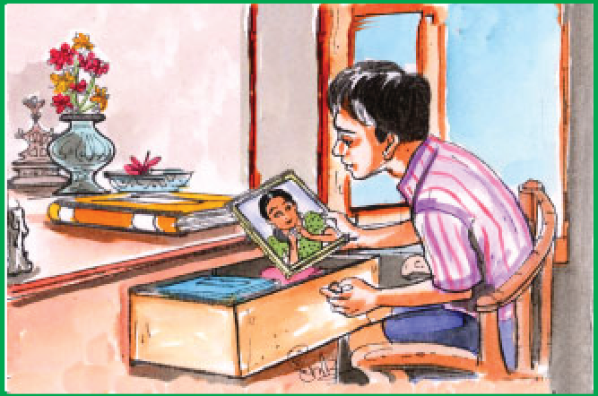
now, but her fingers moved quickly with the needles, and the needles kept clicking all afternoon. Grandmother had white hair, but there were very few wrinkles on her skin.
I had come home after playing cricket on the maidan. I had taken my meal, and now I was rummaging in a box of old books and family heirlooms that had just been brought out of the attic by my mother. Nothing in the box
interested me very much, except for a book with colourful pictures of birds and butterflies. I was going through the book, looking at the pictures, when I found a small photograph between the pages. It was a faded picture, a little yellow and foggy; it was a picture of a girl standing against a wall, and behind the wall there was nothing but sky; but from the other side a pair of hands reached up, as though someone was going to climb the wall. There were flowers growing near the girl, but I couldn’t tell what they were; there was a creeper too, but it was just a creeper.
I ran out into the garden ‘Granny!’ I shouted. ‘Look at this picture! I found it in the box of old things. Whose picture is it ?’
I jumped on the bed beside my grandmother, and she walloped me on the bottom and said, ‘Now I’ve lost count of my stitches, and the next time you do that I’ll make you finish the scarf yourself.’
Granny was always threatening to teach me how to knit, which I thought was a disgraceful thing for a boy to do; it was a good deterrent for keeping me out of mischief. Once I had torn the drawing room curtains, and Granny had put a needle and thread in my hand and made me stitch the curtain together, even though I made long, two-inch stitches, which had to be taken out by my mother and done again.
She took the photograph from my hand, and we both stared at it for quite a long time. The girl had long, loose hair, and she wore a long dress that nearly covered her ankles, and sleeves that reached her wrists, and there were a lot of bangles on her hands; but, despite all this drapery, the girl appeared to be full of freedom and movement; she stood with her legs apart and her hands on her hips, and she had a wide, almost devilish smile on her face.
‘Whose picture is it ?’ I asked.

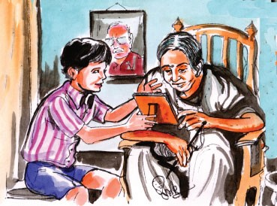‘A little girl’s, of course,’ said Grandmother. ‘Can’t you tell?’

girl?’
‘Yes, but did you know the

‘Yes, I knew her,’ said

granny, ‘but she was a very wicked girl and I shouldn’t tell you about her. But I’ll tell you about the photograph. It was taken in your grandfather’s house, about sixty years ago and that’s the garden wall, and on the other side of the wall there was a road going to town.’
‘Whose hands are they,’ I asked, ‘coming up from the other side?’ Grandmother squinted and looked closely at the picture, and shook her head.
‘It’s the first time I’ve noticed,’ she said. ‘That must have been the sweeper boy’s. Or may be they were your grandfather’s.’
‘They don’t look like grandfather’s hands,’ I said. ‘His hands are all bony.’ ‘Yes, but this was sixty years ago.’
‘Didn’t he climb up the wall, after the photo?’
‘No, nobody climbed up. At least, I don’t remember.’
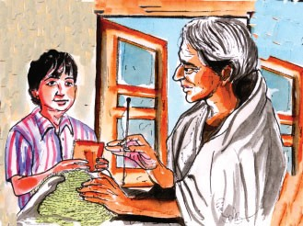‘And you remember well, Granny.’
‘Come on, Granny,’ I said, ‘tell me, tell me.’
But Grandmother shook her head and carried on with the knitting; I held the photograph in my hand looking from it to my grandmother and back again, trying to find points in common between the old lady and the little pig-tailed girl. A lemon- coloured butterfly settled on the end of Grandmother’s knitting needle, and
stayed there while the needles clicked away. I made a grab at the butterfly, and it flew off in a dipping flight and settled on a sunflower.
‘I wonder whose hands they were,’ whispered Grandmother to herself, with her head bowed, and her needles clicking away in the soft warm silence of that summer afternoon.
Whose Photograph, do you think it was ?

Word Meanings
process of making woolen clothes using needles
sound that we hear when metal touches against metal folding on skin that happens at old age
searching through material
jewellery passed on from earlier generations top most room in a house, under the roof lose birightness, colour, strength, freshness cloudy
a plant which requires support to grow to discourage
curtains and other hanging material naughty and mischievous
to look with almost closed eyes
knitting
clicking wrinkles rummaging heirlooms attic
faded foggy creeper deterrent drapery
devilish smile squinted
Reading Comprehension

Tick (√) the correct answer and crass (x) the wrong one:
  - The grandmother sat on the flower bed.
  - The boy was ten years old.
  - The grandmother was not very old.
  - She had grey hair.
  - The boy was interested to see a book with colourful pictures of birds and butterflies.
  - The small photograph was in the box.
  - The photograph was taken about 40 years ago.
  - She used to go swimming in a muddy pool.
  - A lemon coloured butterfuly settled on the nose of the grandmother.
  - There was similarity between the photograph and the grandmother

Answer the following questions:
  - What was the boy doing after taking his meal ?
  - How was the photograph?
  - Who was in the photograph ?

  - How can you say that the photograph was colourful ?
  - Did the boy know who was in the photograph?

Vocabulary
Correct the spellings of the underlined words:
- Kniting a woolen scarf requires patience.
- The lady received a beautiful ring which was part of the familys hirlooms
- The money - plant is a criper which requires support to grow as its stem is weak.

- It was good attempt for keeping me out of mischeaf.
- Since it was a sunny day , Tapan had to skwint his eyes to look at the ripe mangoes in the tree.


Grammar

On Raju’s sister’s birthday, the following things were done. Arrange the actions in sequence and write ‘who asked Raju to do what’? Take the help with words given in the box:
Example: His mother made him clean the room.
mother, father, brother, aunt, uncle, grandfather, grandmother

With the help of the exercise ‘A’ write about yourself, what you do at home and who asked you to do that:
Example: My father made me sow seeds in the field.

Writing

Look at your grandmother or any old person known to you. Now describe how she/he looks and what she/he does in a paragraph.
- Arrange these words as you find them in the dictionary.
wrinkles, heirlooms, creeper, deterrent, drapery, attic

Activity

- Listen to the Passage on ‘Camera’ and circle the right answers: See Appendix-1 Lesson 22 (The Photograph)

- A camera is a device that captures still pictures/moving pictures.
- A camera captures images on video film/photographic film.
- The most important parts of a camera are batteries/film roll/shutter/lens/ autofocus.
- The scene is captured at the front of the camera/back of the camera.
- The people who improved the process of making photographs are Max Knoll/ Louis Pasteur/Louis Daguerre/William Fox.

Look at the pictures given below. Explain to your friend, what you think is happening in the picture.

Example:

  - 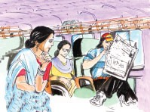A woman is sitting in the bus
  - She is wearing a saree.
  - A man with long hair is sitting across her
  - He is reading a newspaper.

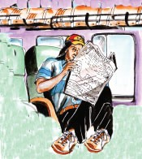(1) ................................................................
(2) ................................................................
(3) ................................................................
(4) ................................................................

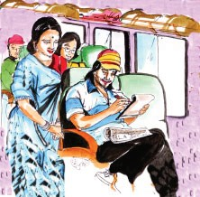(1) ................................................................
(2) ................................................................
(3) ................................................................
(4) ................................................................

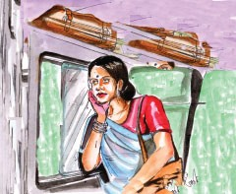(1) ................................................................
(2) ................................................................
(3) ................................................................
(4) ................................................................

Project


Narrate the story in your own words before the class.
Use the following proverb in your sentence. Meaning is given.
Proverb Meaning
Well begun is half done. Make a good start and you will
complete the task easily.

 23. Where the Mind is without Fear
What according to you is 'freedom'?
Where the mind is without fear and the head is held high; Where knowledge is free;
Where the world has not been broken up into fragments by
narrow domestic walls; Where words come out from the depth of truth;
Where tireless striving stretches its arms towards perfection;
Where the clear stream of reason has not lost its way into the
dreary desert sand of dead habit;
Where the mind is led forward by Thee into ever-widening
thought and action...
Into that heaven of freedom, my Father, let my country awake.

Word Meanings
-Rabindranath Tagore

a person's way of thinking
the bad feeling that you have when you are in danger small pieces
limited
the strength and power of feeling sincere effort to do something that makes you feel sad or dull knowing something
mind
fear fragments narrow depth striving dreary aware
Reading Comprehension

- Match the expressious given in column ‘B’ to ‘A’: ‘A’ ‘B’
the mind is without fear we feel proud
the head is held high freedom to express our thinking and ideas
knowledge is free with own interest
broken up into fragments a society with all types of creed, caste
and religious, but not united
narrow domestic walls every one has the right to get the knowledge according to his/her own interest

tireless striving stretches to be truthful, honest and sincere its arms toword perfection
clear stream of reason follow bad customs and traditions dreary desert sand of dead habit think logically
the mind is led forward by Thee feeling of freedom into ever widening thought and
action
heaven of freedom let my country be free
let my country awake request to God for gifting us broad thinking and work accordingly.
- Answer the following question:

  - Make a list of the qualities found in the 'Heaven of Freedom'.
  - Who does the poet address when he says ‘My Father’?
  - What type of society does the poet dream about ?
  - Where should the mind be led ?
  - How can people move towards perfection ?
  - What does the poet mean when he says “let my country awake”?
  - What are the factors which are barriers for a good society?
  - In what sense is 'Heaven of Freedom' used ?
  - What type of freedom helps us to make our country heaven ?
  - Make a list of bad customs you find in your society.

Vocabulary


- I. Use the words given in brackets to frame your sentences: free-freedom, high-height, know-knowledge, deep-depth, perfect-perfection, act-action.

II. Match the columns: (opposite words) 'A' 'B'
ever whole
high shallow
fragments fold
narrow found
deep cheerful
stretch greenery
lost hell
dreary low
desert broad
heaven never

Use the following phrases in your own sentences:
broken up, depth of truth, lost itsway, dreary desert

Grammar


Pick up the phrases from the box and answer the question as given in the example:
Where do you want to go in the summer vacation?
Example: I would like to go to a place where there is a lot of greenery.

peace, cool water, no riots, waterfall, enough food, freedom, dense forest, beautiful gardens, beautiful mountains, gentle people, a lot of greenery.

Write the sentences in your note book and underline the part of the sentences beginning with 'Where':

Writing

Look at the table given below. On the left are given some questions that we often ask ourselves. Write your opinion in the box given on the right hand side:
Questions that we ask ourselves.... | When do you feel so ?
When is your mind free | --------------------------------------
from fear? | --------------------------------------
When do you feel proud of | --------------------------------------
your actions ? | --------------------------------------
When would you feel satisfied | --------------------------------------
with the work that you have | --------------------------------------
done? | --------------------------------------

Activity
    - Select two statements that match the belief/action of persons in the story:
See Appendix-1 Lesson-23

A | B
- Wise Man  - Intelligent Man  - Man who believed in fate | - thought that no one can stop things from happening  - took action after careful thought  - left the place  - removed his belongings  - came up with solutions to problems  - continued to stay

    - Think of five things you could do to fulfill Rabindranath Tagore's dream for India as given in his poem 'Where the mind is without Fear':

You could begin your statements with the following expressions. I am determined to ..............
I've decided to .....................
I'm going to ....................
I intend to ....................
I'm planning to ................

Project

Frame some phrases with the help of the given words. An example is given: Example:
Clear Stream Sky
Voice
bright

beautiful

huge

little


Use the following proverb in your sentence. Meaning is given.
Proverb Meaning
The first step is the hardest. Making a start is the most difficult part of an action.

Appendix - I
Listening Passages

Lesson 1 - Water’s for...
English-8
I painted a face that was angry.
I painted a head no hair at all.
I painted a face that was happy.
I painted the eyes large and bright.
I painted a face that was sad.
I painted a head that's upside down.

Lesson 2 - The Shoemaker and the Elves

The Ant and the Grasshopper

One summer's day, a grasshopper was singing and dancing, while an ant was dragging an ear of wheat along to her ant hill. It was so heavy that she could hardly move it. "Why not forget your work and have fun with me instead ?" said the Grasshopper.
"I am storing food for the winter," replied the Ant," and you should do so too". "But I've enough food for today," said the Grasshopper, and off he went.
In the winter, the ant had plenty of food in their ant hill, but the grasshopper had no food and was dying of hunger.

Lesson 3 - Measure for Measure

Shaikh Mohammad Hanif, a peon at Mumbai Churchgate Railway Station, saw a bag lying at a gate outside his workplace. For ten minutes, Hanif waited to see if anyone would claim for it. He then took the bag to his office and opened it. Inside was a veritable treasure- a cellphone, a camcorder, three watches, traveller's cheques worth $ 25,000 and $ 40,000 in cash. There was also the Saudi passport of a man called Ashraf.
Hanif immediately took the bag to his boss. Shortly thereafter, the two men informed the station master's office, and an announcement about the find was made on the station’s public address system. Half an hour later, Ashraf, the bag's owner, came to claim for it and pressed Hanif to accept $ 4000 as a reward. But Hanif refused. "I won't take anything that doesn't belong to me", he said, "or else, how will I face Allah ?"

Lesson 4 - The Tree that Never Stopped Giving

What do we plant when we plant the tree? We plant a ship which will cross the sea.
We plant the houses for you and me. A thousand things that we daily see.
We plant the shade from the hot sun to be safe. We plant all these when we plant a tree.

Lesson 5 - Alice in Wonderland

ice-cream jalebi
cricket football
kheer nadipahad
potato musical chair
gillidanada noodles
paratha roti

hockey volleyball
samosa rasgulla
kabaddi cream-roll
antakshari alu poha
puri basketball

Lesson 6 - From a Railway Carriage

Sheela is going to her grandparent’s house with her mother in a train. On her way she crossed many places. First of all she saw a train and then she saw many farms. As the train moved further she saw a small village and many cows and buffalloes. Then came a pond with many ducks. She saw children playing and some women carrying water. After that, she saw a school and a small bridge. And after that they came across a grove of mango trees. And before they reached the railway station she saw a bazaar.

Lesson 7 - Everyday Heroes

Walter Hudson, who had died at Hampstead, New York aged 46 was once listed in the Guinness Book of World Records as the heaviest man on earth.
Walter Hudson was born at Brooklyn in 1945. In 1970 when his family moved to Hampstead, he was transported by motor-car. He then weighed 266 kg. and broke the seat. He could not come out of it.
He generally started his day with a breakfast of two pounds of meat, a dozen eggs, a loaf of bread, jam and coffee.
For lunch, Hudson favoured four very big bowls of rice, 8 boxes of fried potatoes, six large bottles of coca-cola and four double cheese burgers.
For dinner, he would eat six roasted corns, another six or seven baked potatoes. Between these meals be would eat a chicken or two, followed by noodles, six bottles of soda, sandwiches and ice-cream.
“All I cared”, he recalled, “was food, food, food!”

Lesson 8 - At School

Subhash Chandra Bose, popularly known as Netaji, was one of the greatest freedom fighters of India. He was born in Cuttack (Orissa) in 1897. Bose was educated at the universities of Calcutta and Cambridge. He returned to India in 1920 and became active in the non-co-operation movement of Gandhiji. In 1924 he was arrested by the British and he spent most of the next few years in jail. In 1938 he was elected the president of Indian National Congress. He was again arrested in 1940, but this time he escaped to Germany. Then he raised his Indian National Army. In 1943, with the support of the Japanese his army advanced from Rangoon into India but was defeated. Nothing is known for certain about how Netaji met his end, but it is reported that in 1945 he was killed in a plane crash in Taiwan.

Lesson 9 - Beats in Memoir

Albert Einstein was born on March 14, 1879 in the German city of Ulm. There was nothing great about Einstein as a child. Children found him boring and he played by himself much of the time.
The young Einstein loved playing with mechanical toys. Infact, when his sister Maya was born, he was supposed to have asked “where are her wheels?”
The world knows Einstein as a physics legend. When young, he was a good student but did not like the strictness of his school. This is why people considered him to be a bad boy.
Albert Einstein's first job was as a teacher. He also gave private tuitions. He later secured a job in a private company in Bern. It was here that he started developing his ideas in secret.
This boy later on developed the ‘Theory of Relativity’ and ‘The Photo Electric Effect’. He won the Nobel Prize for Physics for his achievements.

Lesson 10 - A Place fit for Gods to Marry

Listen to an announcement at a Madai Mela.
Anouncement-1: Welcome to the 3-day Madai Mela at Baloda.
Enjoy the Chhattisgarhi folk songs by D.K. orchestra group on the first day from 07:00 p.m. onwards. On 17th August there will be a dance performance by Sweta group from 08:00 p.m. onwards. On the last day we will have a Pandavani by 'Kavita Pandavani Music Mandali' from 09:00 p.m. onwards. Have a nice time.
Anouncement-2: The Madai Mela organizers request all visitors to use dustbins to keep the venue neat. Please park your vehicles in the parking space only.

Lesson 11- Sympathy

Bholu is a small dog. In the morning, Bholu goes for a long walk with Shalu. He accompanies Shalu and her friends to school. Shalu's friends bring rotis for Bholu. On his way back from school, Bholu stops at the hotel in the street corner. Mohan Lal, the hotel manager gives Bholu something to eat everyday. Bholu sleeps there for sometime. When the children return from school, Bholu follows them back home. He finally spends the remaining time in Shalu's house. In the afternoon, he sits in Shalu's garden and watches people and birds. In the evening, Bholu, Shalu and her sister. Anu play with a ball in the garden. Bholu sleeps in the garden on the chair in Shalu's home.

Lesson 12 - Children Ask Kalam

Kitchen Cures

Plants, spices and fruits have good healing properties. They have been used by people over hundreds of years. Let us look at some common items used in the kitchen that can help you feel better.

Ginger : Ginger is known to reduce vomiting sensation. If you suffer from travel sickness, it would be good to take a one cm slice of fresh ginger at least 20 minutes before you start your travel.
Mustard: Mustard is known to help those suffering from a cold or slight fever. Soaking your feet in hot water with a little mustard powder can treat cold, re- duce a fever and sooth a headache.
Lemon : The vitamin C in lemons boosts the capacity of the body to heal wounds. It might hurt a bit, but squeezing lemon juice on a wound helps to heal it faster. Also lemons help in erasing scar marks. Applying it on pimples make it heal faster.

Lesson 13 - Syani



Lesson 14 - Craze

We reached India on 2nd of December. We landed at Bombay at 3.30 early in the morning. We stayed with my aunt in Bombay for two days, and visited the Elephanta caves, Gatewey of India and Juhu Beach. Early in the morning on the 4th we drove to Poona where my mother's parents live. We stayed with them for three days and on the night of 6th we took a train to Hyderabad. We reached Hyderabad early in the morning on the 7th. We spent nearly a week in Hyderabad. On 12th afternoon we went to Bangalore, where my father's eldest brother lives. We spent three days in Bangalore. On the 16th, early in the morning, all of us started off for Cochin. The next day we went to Chennai.
We reached Chennai on 18th morning. My mother's brother lives in Chennai. We spent three days with them.
We took an early morning flight to Delhi on the 22nd. In Delhi we stayed in a hotel. Then on 23rd we went to Agra. On 24th morning we returned to Delhi. Our tickets back to New York were booked for 26th. We took the flight from Delhi on the 26th .
Mr & Mrs. Rao and their two children Meena & Satish live in the United States of America. Last year, they spent a month touring India.

Lesson 15- The Bird-man of India

All birds make soft nests to lay their eggs. They build them in safe places, away from enemies.
The swallows build cup-shaped mud nests on the walls.
The Indian tailor bird makes its nest by sewing leaves together with silk. The silk is obtained from spider's web.
Crows build big, untidy, nests on tree tops. The nests are made of sticks bound together with mud and moss. The nests are lined with soft wool or hair.

Lesson 16 - The Mountain and the Squirrel

The Chilikha lagoon is on the Eastern Coast of India covering an area of 1100 Sq. k.m. A 35 km., long, outer channel connects the lagoon to the Bay of Bengal.
215 species of fish and 350 species of plants are found here. Chilikha has been designated as a wetland of international importance.

Chilikha supports some of the largest flocks of migratory birds in the country during winter.
Migratory birds arrive from as far away as Caspian Sea, Lake Baihal Aral Sea, Mongolia etc.

Lesson 17 - Nothing but the Target

12 Feb 2005, the tennis sensation from Hyderabad, Sania Mirza, became the first Indian woman to win a WTA tour event in Hyderabad. Daughter of Imran Mirza, who played cricket for Bombay and Hyderabad and grand niece of Ghulam Ahmed, former Indian cricket captain; has sports in her blood.
Mr. K.K. Birla, president of Birla Foundation and former president of all India Tennis Association announced a cash prize of Rs 2 lakh apart from her $22,000 match award. She is also the first woman to make it to the third round in a grand slam in the Australian open 2005 against Serena Williams. She has the 2004 ITK women's single's and double's 2004 titles to her name.
Recently she has jumped up to 34th place according to WTA ranking; we wish her many more titles and hope that she makes India proud.

Lesson 18 - Dancing On

A boy went to a pet shop to buy a puppy. There were four puppies sitting together. The price of each of them was Rs. 50/-. There was one white puppy sitting alone in a corner.
Boy : ‘Is that white puppy for sale’? Shopkeeper : ‘It is lame, it's not for sale’. Boy : ‘What will you do with this one’?
Shopkeeper : ‘Nothing’
Boy : ‘Can I play with the puppy’?
Shopkeeper : ‘Sure’.
The boy played with the puppy for sometime. The puppy licked the boy and played with him and both of them became friends.
Boy : ‘Sir, I want to buy this puppy’.
Shopkeeper : ‘But that is not for sale’.
But the boy kept on repeating the same question. Finally the shopkeeper agreed. The boy checked his pockets. He had only Rs. 40/-. He ran to his mother to get the rest of the money.
Shopkeeper : ‘But, why don't you want to buy a good one for the same price’?

The boy didn't say anything. He lifted his left pant leg and showed it to the shopkeeper. He was wearing a brace. (A brace is a metal support that a person with weak legs wears to help him/her walk)
Lesson 19 - Dear Daddy-Long-Legs
- He is the oldest member of Deepu's family. He is bald. He wears glasses with a square frame. He doesn't wear a hat, but puts on a coat and tie.
- Nimmi has curly hair and is tall. She looks smart with her yellow T-shirt and blue jeans. She is very quick in solving puzzles.
- Pradeep is a thoughtful boy in a dotted shirt and grey trousers. He has neat hair and enjoys sitting in lonely places.
- Anuj is a naughty young boy. His elder sister gives him lessons in math- ematics. He wears brown half pants, white shirt and black shoes as his school uniform.

Lesson 20 - Fog
One day, when I was five I went to a local park with my mom. While I was playing in the sand box, I noticed a boy about my age in a wheel chair. I went over to him and asked if he could play with me. Since I was only five, I couldn't understand why he couldn't just get in the sand box and play with me. He told me he couldn't. I talked to him for a while longer, then I took my large bucket, filled up as much as I could and dumped it into his lap. Then I grabbed some toys and put them in his lap, too.
My mom rushed over and said, “Lucy, why did you do that’?
I looked at her and replied, “He couldn't play in the sand with me, so I brought the sand to him. Now we can play in the sand together’.

Lesson 21 - Flavours of Thailand
(Lucy Parker, age 11)

For more than four exhusting years, the Polish-born Marie Curie and her husband, Pierre, worked in a large wooden shed near their Paris Lodgings. It was there - later on a September night in 1902 that they finally discovered the radioactive element which they named Radium meaning ‘a ray’. Radium provided the first effective treatment for some types of cancer, destroying the diseased human cells by bombarding them with Radioactive particles.
The Curies had met in 1894 when Marie (who was born in Warsaw on Nov. 7, 1867) was studying in Paris. She had little money to spend on food. Unable to afford a laboratory of her own, she was invited by Pierre to share his workshop with him. They were married in July 1895.

After the discovery of Radium, Mary was convinced that by destroying diseased cells, the powerful rays could cure cancerous growth. In 1903 the Curies shared Nobel Prize for physics. In April 1906 Pierre was knocked down & killed by a horse-drawn wagon in Paris. Five years later Marie was awarded the Nobel Prize for chemistry for the discovery of radium & Polonium isolation of pure radium. Partly as a result of her long exposure to radiation she died on July 4, 1934.

Lesson 22 - The Photograph
A camera is a device used to take still photographs. Photographs are images of persons, things, scenes that are captured on photographic film. The most im- portant parts of a camera are its lens, shutter and film roll.
The lens gathers rays of light from the scene that the camera is pointed at and bends them so that all the rays meet at the same place at the back of the camera. By this method, a small copy of the scene is made. The shutter opens to allow light from the lens to reach the film. When the film is exposed to the right amount of light, a clear image on the film is created.
The earliest photograph was taken in France in 1827. Louis Daguerre and William Fox improved the process of taking photographs later

Lesson 23 - Where the Mind is Without Fear
There once lived three men who were good friends. However, they were very different in their thinking.
One was wise, he took action after careful thought. Another was intelligent. He used his brains to come up with solutions to problems. The third person relied on fate. He believed no one could stop things from happening.
All of them had houses on a river bank near which a dam was being built.
One day, the wise man overheard the conversation of a dam worker, that the gates were weak and houses on the river bank would be washed away.
Hearing this, the wise man immediately informed his friends.
The wise man said “I am leaving this place. It is better to go elsewhere than lose my life.”
The intelligent man said, “I will find a way to deal with the problem.” The third man said, “I have lived here all my life. I leave it all to fate.”
The gates of the dam broke. The wise man had left his house, so he was saved. The intelligent man had removed all his belonging, so he had nothing to lose. The man who believed in fate, remained, hoping that the gates would not break. He was swept away.

Appendix - II
About the Lessons

Lesson 1 : Water's for... :
Children are fascinated by water and love to play with it. The poem lists the different uses of water and the fun of indulging in water games.

Lesson 2 : The Shoemaker and the Elves :
The short story is about an old couple (cobblers : those who make shoes) who are helped by two elves during difficult times. The story combines fantasy with a human touch. An attempt has been made to arouse curiousity and imagination in children so that they may develop an interest to read good short stories in English.

Lesson 3 : Measure for Measure :
The Tenali Raman stories are hugely popular because of the element of wit and humour which touches our hearts. The selected story is an interesting tale in which Raman convinces the king about the necessity of appointing people on the basis of competence.

Lesson 4 : The Tree that Never Stopped Giving :
The lesson has been adapted from Shel Silverstein's “The Giving Tree”. It is a story about how man exploits nature for his advantage. The lesson is meant to make children conscious of the necessity for co- existing with the environment around us.

Lesson 5 : Alice in Wonderland
The lesson is a continuation of the dreamland story of Alice, an adaptation from the famous story by Lewis Carroll. The lesson aims at enhancing children’s imagination and curiosity while they read about Alice.

Lesson 6 : From a Railway Carriage :
The poem is by Robert Louis Stevenson. Stevenson manages to touch the child's imagination through a fascinating theme - “Train Journey”. The sights and sounds that we witness around us have been described beautifully and as we read the poem, we feel that the poet has managed to take us along on the train journey.

Lesson 7 : Everyday Heroes :
The lesson has been adapted from the Everyday Heroes series published by Reader's Digest. The stories selected are about people in different regions of India who have made important contributions to the society.

Lesson 8 : At School :
‘At School’ is an extract from Gandhi's autobiography - “My Experiment's with Truth”. The lesson gives us an insight about Gandhiji's experiences as a child. We also understand that the qualities of ‘truth’ and ‘sincerity’ that were so dear to him were also reflected in his early life.

Lesson 9 : Beats in Memoir :
The lesson introduces children to Devdas Banjare who was a great Panthi artiste. His dedication to the art and his contribution to Chhattisgarh culture is an inspiration for children and adults alike.

Lesson 10 : A Place fit for God's to Marry :
The lesson has been developed from a newspaper article on the city of Madurai published in the Hindu. The article reveals the story behind the city's name and also the myths and legends associated with the ancient city.

Lesson 11 : Sympathy :
The poem is by M. Johnson.In the poem, the girl and the bird think very differently about each other. They admire their positions of advantage and feel pity of what the other does not have.

Lesson 12 : Children ask Kalam :
The President of India - Dr. Abdul Kalam is hugely popular with children. Hundreds of children write to him everyday and he tries to respond to all the letters. A selection of those letters has been made into a book - “Children Ask Kalam” from which some interesting questions asked by children have been used in this lesson. Some of the questions asked are personal and others deal with larger more complex issues.

Lesson 13 : Syani :
Syani Rani is the mascot of the Department of Consumer Affairs which released a series of public awareness advertisements in all major newspapers recently. Through Syani Rani's message, the consumer is made aware of his/her rights. The issues that Syani Rani addresses are the importance of buying ISI mark products, buying packaged goods, recognizing government hallmarks etc.
These issues are important for children and provide an opportunity to participate in consumer debates at an early age.

Lesson 14 : Craze :
Craze is a humorous essay about people who take long vacations to fulfill their urge to travel to distant places. The lesson exposes children to human behaviour and attitudes of people. Several places of tourist interest are also described in the lesson.

Lesson 15 : The Birdman of India :
The feature story exposes children to the wonderful world of birds through the eyes of the great ornithologist - Salim Ali. Several facts about birds and about Salim Ali's interesting life are represented in the lesson.

Lesson 16 : The Mountain and the Squirrel :
The poem is by Ralph Waldo Emerson, a famous American poet and thinker. Here, in this poem he gives the message that every individual's

talents are different and cannot be compared with the strengths of somebody else.

Lesson 17 : Nothing but the Target :
When Rajyavardhan Rathore became India's first individual silver medalist at the Olympic Games, the earliest interviews and stories were made available on the Internet much before newspapers were able to publish the story of his achievement. The lesson tries to capture his reactions after he had achieved the feat based on initial internet interviews and stories.

Lesson 18 : Dancing On :
The lesson is based on the life of Sudha Chandran written by Shailaja Ganguly. The story is about a young Bharatanatyam dancer who loses her leg as a result of an accident and her courageous comeback to the stage. Inspite of her handicap, Sudha Chandran learnt to perform with an artificial leg and won worldwide fame for her performances.

Lesson 19 : Dear Daddy-Long-Legs :
The lesson is based on the life of an orphan Jerusha Abbott who spent her childhood in an orphange. Her life changed wonderfully with new experiences-college, friends, social life because of a benefactor. The only condition that he had made was that she must never know who her benefactor was. However she wrote to him regularly about her school work. The letters are extracted from the book Dear Daddy-Long-Legs by Jean Webster.

Lesson 20 : Fog :
The poem is by W.H. Davies who takes us through the journey of a blind person. The author shows us that blind people have skills which can prove an advantage over people with vision which is explained through an incident.

Lesson 21 : Flavours of Thailand :
Thailand is one of the fast emerging South East Asian nations that has captured the imagination of the world. The lesson is meant to expose children to different geographies, culture, food and festivals.

Lesson 22 : The Photograph :
The Photograph is a short story by Ruskin Bond. The story is a journey down memory lane where the grandmother is reminded of her childhood because her grandson discovers an old photograph of her taken as a girl. The mystery of who the people in the photograph are is played out in the conversation between them.

Lesson 23 : Where the Mind is Without Fear :
The poem is by Rabindranath Tagore. Tagore tries to motivate people of India to participate in the creation of a society where every person can live without fear. It is a difficult thing to achieve, but the spirit of
nationalism is necessary to build a strong nation.

-161-

Glossary

absolutely | (अॅब्सलूट्ली) | निश्चित
abstaining | (ऐब्सटेनिंग) | अलग रहना, बचते रहना
addiction | (एडिक्शन) | नशीली वस्तुएं सेवन करने का आदी व्यक्ति
additives | (अॅडिटिव्स) | किसी प्राकृतिक पदार्थ में मिलाने वाला रंग
administration | (अडमिनिस्ट्रेशन) | शासन
advice | (एडवाइस) | सलाह, परामर्श
agonized | लेमेन्ट) | विलाप, शोक, खेद अभिव्यक्त
agreed | (अग्रीड) | सहमत
amateur | (अमेच्यर) | अकुशल
amazing | (अमेज़िंग) | अद्भुत
amputate | (अम्पयूटेट) | किसी अंग को काटना
ancestors | (अॅन्सेस्टर्स) | पूर्वज
anxious | (अॅड्.क्शस) | चिंतित
application | (अॅपलिकेशन) | आवेदन
aromatic | (अॅरोमेटिक) | सुगंधित
array | (अरे) | विभिन्न
attic | (अॅटीक) | कबाड़ रखने का कमरा
attitude | (एटिट्यूड) | मनोवृत्ति
at see | (ऐट सी) | असमंजस करना
audience | (ऑडिअन्स) | श्रोतागण
auditorium | (ऑडिटोरियम) | सभा-मण्डप
authentic | (ऑथेन्टिक) | विश्वसनीय, प्रामाणिक
aware | (अवेयर) | जागरुक
bald | (बॉल्ड) | गंजा
basil | (बॅसिल) | तुलसी
battle | (बैटल) | युद्ध
benefactor | (बेनिफक्टर) | आर्थिक मदद देने वाला
benefit | (बेनिफिट) | लाभ
bipeds | (बाईपेड्स) | दो पैरों वाले प्राणी
blemish | (ब्लेमिश) | दूषित करना
bliss | (ब्लिस) | परमानंद
boost | (बूस्ट) | पर उठाना

brambles | (ब्रैम्बल्ज़) | कांटेदार झाड़ियाँ
brilliant | (ब्रिलिअन्ट) | विद्वान
budding | (बडिड.ग्) | आरंभिक स्थिति
bun | (बन्) | झबरी दुम वाला
bystanders | (बायस्टैंडर्स) | दर्शक
caretaker | (केयरटेकर) | देखभाल करने वाला
chase | अप) | पीछा करना
chauffeur | (शोफर) | मोटर चालक
claim | (क्लेम) | दावा
clash | (क्लैश) | टकराने का शब्द करना, झगड़ना
clicking | (क्लिकिंग) | धातु की वस्तुओं की टकराहट से होने वाली ध्वनि
clung | (क्लंग) | चिपका हुआ
clutched | (क्लच्ट) | जकड़ा हुआ
cold | (कोल्ड) | ठंड
collapsed | (कोलेप्स्ड) | ढहना
colleague | (कलीग) | सहकर्मी
compost | (कम्पोस्ट) | खाद
concentrate | (कन्सन्ट्रेट) | (ध्यान) एकत्र करना
concertina | (कन्सरटिना) | एक प्रकार का ग्रामाफोन
conservation | (कंजर्वेशन) | सुरक्षा
constant | (कॉन्सटैंट) | स्थिर
consumer | (कंज्यूमर) | उपभोक्ता
corporal | पनिशमेंट) | देह संबंधी दंड (शारीरिक)
costume | (कॉसट्यूम) | वेशभूषा
courage | (करेज़) | वीरता/साहस
credit | (क्रेडिट) | साख
creeper | (क्रीपर) | लता/बेल जो जमीन पर फैलती है
crown | (क्राउन) | मुकुट, ताज
cuisine | (क्वीज़ीन) | भोजन पकाने की शैली
curriculum | (करिक्य्लम) | पाठ्यक्रम
curtain | (कर्ट्न) | परदा
daisy | (डेजी) | गुलबहार का फूल
dart | (डार्ट) | तीव्र गति
dead | हबिट) | औचित्यहीन परम्परा
deceive | (डिसीव) | धोखा देना
decide | (डिसाइड) | र्निणय करना
declare | (डिक्लेअर) | घोषणा करना
dedication | (डैडिकेशन) | कार्य के प्रति समर्पण
defeat | (डिफीट) | हराना
deities | (डीटिज़) | देवी देवताओं की मूर्ति
delight | (डिलाइट) | आनंद/आनंद लेना
depth | ट्रूथ) | सच्चाई की ताकत
desert | (डजर्ट) | मरूस्थल
deterrent | (डिटरेन्ट) | मनाही
devilish | स्माइल) | शैतानी भरी मुस्कराहट
disappoint | (डिसअपाइंट) | निराश
disciplinarian | (डिसिप्लिनेरियन) | नियम स्थापित करने वाला या पालन करने वाला
disaster | (डिजास्टर) | बहुत बुरी दुर्घटना, प्राकृतिक दुर्घटना
disgrace | (डिस्ग्रेस) | शर्मनाक
distaste | (डिसटेस्ट) | अरुचि
domestic | वाल) | भिन्न भिन्न क्षेत्रों के व्यक्तियों जातियों, धर्मों एवम् रीति
dormitory | (डोरमीटरी) | विशाल शयनागार (सोने का बड़ा कमरा)
drapery | (ड्रेपरी) | पर्दा लगाने की सामग्री/सजाने की सामग्री रिवाजों की  कुप्रथाएं
dreary | (ड्रअरी) | उदास
dunce | (डन्स) | मूर्ख
ecology | (इकलॉजी) | पर्यावरण
edge | (एज) | किनारा
effort | (एफर्ट) | प्रयास
eggplant | (एगप्लांट) | बैंगन
elves | (एल्वस) | छोटी आकृति वाला नर पक्षी
embankment | (एम्बैकमेंट) | पानी रोकने का बांध
encourage | (एनकरेज) | प्रेरित करना, प्रोत्साहित करना
endeavour | (इन्डेवर) | प्रयत्न/प्रयास
enough | (इनफ) | पर्याप्त
enriching | (इनरीचिंग) | गुणवत्ता बढ़ाना
ensure | (इनशुअर) | निश्चित कर लेना
etched | (एच्ड) | पतली प्लेट पर अम्ल की सहायता से चित्र बनाना
euclid's proposition | (प्रोपोजिशन) | गणित/ ज्यामिति का एक प्रमेय
excellent | (एक्सीलेण्ट) | शानदार
excited | (एक्साइटेड) | उत्तेजित
experience | (एक्सपीरिअन्स) | अनुभव
exist | (इगजिस्ट) | अस्तित्व
faded | (फेडिड) | धुंधला
faithful | (फेथफुल) | भरोसेमंद, ईमानदार
false | (फॉल्सनोशन) | गलत धारणा
feather | (फैदर) | पंख
feast | (फीस्ट) | भोज, उत्सव
fog | (फाग) | धुंध
former | वितउमत | पूर्व का
foundation | (फाउन्डेशन) | न्यास, आधार
frequent | (फ्रीक्वेंट) | बार-बार
galore | (गैलोर) | बहुत अधिक
gangrenous | (गेंगरेनस) | अवसाद युक्त/एक प्रकार की बीमारी
gaze | (गेज) | टकटकी लगाकर देखना
generous | (जनरस) | दयालु, विनम्र
grab | (ग्रैब) | जकड़ना
gradually | (ग्रेजुअली) | क्रमशः/ धीरे-धीरे
giants | (जाइन्ट) | विशालकाय
ginger | (जिंजर) | अदरक
grievance | (ग्रिवान्स) | शिकायत/फरियाद
gymnastics | (जिमनेस्टिक) | व्यायाम संबंधी
hack | (हैक) | आघात करना
hallmark | (हॉलमार्क) | गुणवत्ता का चिन्ह
hasty | (हेस्टी) | शीघ्रता, जल्दी
harvest | (हार्वेस्ट) | फसल/उपज
haunt | (हॉन्ट) | सदा साथ रहना
heirlooms | (एलूम) | एक पीढ़ी से दूसरी पीढ़ी को हस्तांतरित
hesitate | (हैज़िटेट) | हिचकिचाना
historic | (हिस्टॉरिक) | ऐतिहासिक
honorary | (ऑनररी) | सम्मानार्थ दी गई उपाधि
humid | (ह्यूमिड) | नम
implemented | (इम्प्लीमेंटेड) | प्रयोग करना
impression | (इंप्रेशन) | प्रभाव/निशान
incident | (इन्सिडएण्ट) | घटना
incompetent | (इनकम्पिटेन्ट) | असमर्थ, अयोग्य
indelible | (इनडेलिबल) | जो मिटाया न जा सके
indigenous | (इंडिजिनस) | देशी
individual | (इंडीविज्युल) | व्यक्तिगत
ingredients | (इन्ग्रेज्यिेंट) | तत्व
insist | (इनसिस्ट) | विनती करना/जोर देना
inspire | (इन्सपायर) | प्रोत्साहित करना
instead | (इन्सटेड) | स्थान में/बदले में/के अलावा
intervention | (इंटरवेन्शन) | हस्तक्षेप
invocation | (इनवोकेशन) | भगवान को पुकारना
knitting | (निटिंग) | स्वेटर बुनना
land | स्लाइड) | किसी चट्टान या पहाड़ के टुकड़े का टूटकर नीचे
lapse | टाइम) | समय का अंतराल
large | (लार्ज) | बड़ा
latter | (लैटर) | बाद का
lead | (लैड) | एक प्रकार की धातु, सीसा
legacy | (लेगसि) | वसीयत के अनुसार प्राप्त
literally | (लिट्रली) | यथाशब्द
majestic | (मैजेस्टिक) | प्रभावशाली
maroon | (मरुन) | निर्जन स्थान में
manufacturer | (मैनुफैक्चरर) | बाजार में वितरण करने हेतु उत्पादन करने वाला
meadows | (मिडोस) | हरा-भरा मैदान
mediocre | (मीडिओकर) | सामान्य
memory | (मेमोरी) | स्मरण शक्ति
minority | (मायनरटी) | अल्पसंख्यक
miracle | (मिराकल) | चमत्कार
morsel | (मॉर्सल) | भोजन का ग्रास, निवाला
mound | (माउंड) | मिट्टी का टीला
my | फादर) | ईश्वर के लिए प्रयोग किया गया है।
network | (नेटवर्क) | जाल
noteworthy | (नोटवर्दी) | महत्वर्पूण
observation | (ऑबजर्वेशन) | सावधानीर्पूण निरीक्षण
occupy | (ऑक्यूपाई) | स्थान लेना
ordeal | (ओरडियल) | कठिन परीक्षा
ornithologist | (ऑरनीथोलॉजिस्ट) | पक्षी वैज्ञानिक
patronage | (पेट्रनेज) | सहायता
penalised | (पेनलाइज्ड) | दण्ड
persistent | (परसिस्टेन्ट) | अस्तित्व बनाए रखना
perfect | (परफेक्ट) | पूर्ण/अखंड/निपुण
perfection | (पर्फेक्शन) | सर्म्पूणता
physical | ट्रेनिंग) | शारीरिक प्रशिक्षण
pie | (पाई) | एक प्रकार की खाने की वस्तु
piteous | (पिटियस) | करुणा योग्य
plump | (प्लम्प) | स्थूल, मोटा
poke | ऐट) | मजाक उडाना
portrait | (पोर्ट्रेट) | चित्र
pot | हॉल्स) | सड़क में बने गड्ढे
pretend | (प्रिटेन्ड) | बहाना बनाना
preventive | (प्रिवेन्टिव) | प्रतिबन्धक, हटाने वाला
prig | (प्रिग) | अपने आप को दूसरों से बडा समझना
priority | (प्रायॉरिटी) | प्राथमिकता
proud | (प्राउड) | अभिमान
rag | (रैग) | वस्त्र/कपड़ा का टुकड़ा
ransom | (रान्सम) | फिरौती
rap | (रैप) | ठोकर मारना
realization | (रियलाइजेशन) | प्रत्यक्षीकरण
rebuke | (रीब्युक) | डांटना
recall | (रीकाल) | वापस बुलाना
recollect | (रीकलेक्ट) | याद करना
reminiscence | (रिमिनिसेन्स) | स्मरण किया हुआ विषय
research | (रिसर्च) | अनुसंधान
resign | (रिजाइन) | किसी कार्य को छोड़ना, त्यागना
rigorous | (रिगरस) | बहुत कोशिश
rummaging | (रमिजिंग) | किसी वस्तु को उलट-पुलट करना
sanctuary | (सैंक्चुरी) | अभ्यारण
satisfactorily | (सैटिस्फैक्टरली) | संतोषजनक तरीके से
scarce | (स्कैर्स) | आवश्यकता से कम
scholar | (स्कॉलर) | विद्वान, छात्र
separate | (सेपरेट) | अलग करना
sew | (सिव) | सिलाई करना
shiver | (शिवर) | काँपना
showcase | (शोकेस) | प्रदर्शन पटल
sleet | (स्लीट) | वर्षा के साथ बर्फबारी होना
smash | (स्मैश) | टुकड़े टुकड़े करना
snappy | (स्नैपी) | फैशन परस्त
soaking | (सोकिंग) | भिगोना/सोखना
sole | (सोल) | पैर का तलबा
species | (स्पीसीज) | प्रजातियाँ
spirit | (स्पीरिट) | उत्साह
splendid | (स्पैंलिंडिड) | शानदार/भव्य
springy | (स्प्रिंगी) | घुंघराले
spry | (स्प्राइ) | तेज हरकत
squirrel | (स्क्वीरल) | गिलहरी
squirting | (स्कवर्टिंग) | पिचकारी मारना
squinted | (स्क्विन्टिड) | सिकड़ी आँखे, भैंगा
standard | (स्टैंडर्ड) | मानक
stream | रीजन) | विचारधारा/तर्क
stretched | (स्ट्रैच्ड) | फैला हुआ
stripped | (स्ट्रीपड) | छाल हटाना, छिलका उतारना
string | (स्ट्रिंड.) | पतली रस्सी (धागा)
struggle | (स्ट्रगल) | संघर्ष करना
stump | (स्टम्प) | पेड का ठूँठ
sub-urban | (सब-अरबन) | उपनगरीय
sullen | (सलन) | हठी, उदास, चिड़चिड़ा
surprize | (सरप्राइज) | आश्चयर्/अचंभित होना
symptom | (सिम्टम) | लक्षण
synthetic | (सिंथैटिक) | बनावटी
taken | टास्क) | डाँटना
talents | (टेलेंट्स) | योग्यता
tamarind | (टमरिड) | इमली
telecast | (टेलीकॉस्ट) | दूरदर्शन पर प्रसारण करना
temper | (टेंपर) | व्यवहार
tendency | (टैंडेसी) | व्यवहार/आदत/प्रवृत्ति
terrible | (टरिबल) | भयंकर
thrill | (थ्रिल) | स्फूर्ति
thoughtless | (थॉटलेस) | बिना सोचे समझे कार्य करना
thunderous | (थन्डरस) | गड़गड़ाहट उत्पन्न करने वाला
tireless | (टायरलेस) | बिना थके
to paddle | (पैडल) | पानी में चलना
to rinse | (रिंज) | पानी में डुबोकर कपड़े से साबुन हटाना
to scrub | (स्क्रब) | कसकर रगड़ना, घिसना
to splash | (स्पलैश) | पानी का छींटा देना
track | (टैªक) | रास्ता
traditional | (ट्रेडिशनल) | परम्परागत
tribute | (ट्रिब्यूट) | उपहार देना या प्रशंसा करना
tropical | (ट्रोपिकल) | भूमध्यरेखीय
unconscious | (अन्कान्शस) | अचेत
uncrushable | (अनक्रशेबल) | चूरा न करने योग्य/जिसे पराजित न किया जा सके
uninhabited | (अनइनहैबिटिड) | निर्जन
urge | (अर्ज) | प्रेरित करना
variety | (वॅरायटी) | विविधता
venture | (वेन्चर) | साहसिक कार्य
victim | (विक्टिम) | पीड़ित व्यक्ति

victimize | (विक्टिमाइज) | शिकार बनाना
weather | (वेदर) | मौसम
wellies | (वेलीज़) | डबरा
widen | (वाइड्न) | चौड़ा करना
wink | (विंक) | पलक झपकना

LESSONWISE-SYLLABUS
English-8

